

Department of Computer Science and Mathematics

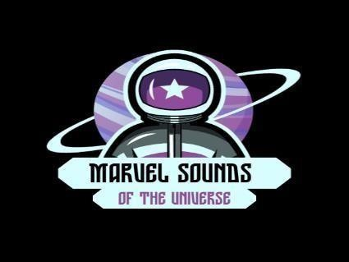

# A Database Design for the Marvel Galactic Radio Station Company

By

MARVEL DATA GUARDIANS

**Aya Kenaan** (aya.kenaan@lau.edu)

# Dana Hamade (Group Leader) (dana.hamade@lau.edu)

**Mohamad Abdallah** (mohammad.abdallah04@lau.edu)

**Nour Sleem** (nour.sleem03@lau.edu)

**Hiba Sleiman** ( hiba.sleiman01@lau.edu)

A REPORT

Submitted to Dr. Ramzi Haraty in partial fulfillment of the requirements of Phase 3 of the database

project for the course CSC/BIF 375 – Database Management Systems

# Table of Contents

1. **Introduction…………………………………………………………………………………… 1**
2. **Tools used to draw the ER…………………………………………………………………….. 1**
3. **System Description & Requirements…………………………………………………………. 1**
4. **Legend of ER Diagram Symbols……………………………………………………………… 2**
5. **Complete old ER Diagram for “Marvel Sounds of the Universe”………………………….. 3**
6. **New Complete Amended ER Diagram for “Marvel Sounds of the Universe”……………... 4** 
   1. **Entity Types & Their Attributes………………………………………………………….. 5**
   2. **Elaboration on Relationships……………………………………………………………. 22**
7. **ER to Relational Mapping…………………………………………………………………….. 27** 
   1. **– Step 1- Mapping Strong Entity Types………………………………………………… 27**
   2. **– Step 2 – Mapping of Weak Entity Types………………………………………………. 31**
   3. **– Step 3 – Mapping of Binary 1:1 Relationship Types………………………………….. 31**
   4. **– Step 4 – Mapping of Binary 1:M Relationship Types……………………………….. 32**
   5. **– Step 5 – Mapping of Binary M:N Relationship Types………………………………. 34**
   6. **– Step 6 – Mapping of multivalued attributes………………………………………….. 39**
   7. **– Step 7 – Mapping of N-ary attributes………………………………………………… 41**
   8. **– Step 8 – Mapping aggregation, specialization relationships…………………………. 41**
8. **Final Display…………………………………………………………………………………… 43**
9. **Table States ……………………………………………………………………………….......… 47**
10. **Edited ER Diagram for phase III …………………………………………………….............. 65**
11. **Database Creation and Queries for “Marvel Sounds of the Universe” database …………. 65** 
    1. **Creation of the Database Tables and their Descriptions ……………………………. 66**  1**1.2. Insertion of Data into the Database Tables …………………………………………… 81** **11.3. Complex Queries ……………………………………………………………................ 105**

## 12. Normalization until the BCNF Normal Formal ………………………………………….. 112

### 12.1. Normalization for each relation …………………………………………….. 113

**12.2. Relation Schemas without non-prime attributes …………………………... 126**

Marvel Galactic Radio Station is a unique and innovative addition to the world of radio broadcasting. It is a cutting-edge radio station that combines elements of entertainment, education, and imagination such as space-themed music, original radio dramas, educational programs and space exploration, and interviews with experts in various fields. It's an interstellar journey through the universe from the moment you tune in, you are transported to a world where you can explore distant galaxies, encounter alien species, and witness celestial events, all through the power of sound.

1. **Introduction:**

Radio stations are broadcast media organizations that transmit audio content over the airwaves to a wide and diverse audience. Radio has been a significant invention of communication and entertainment for decades, offering news, music, talk shows, and various other forms of content. They also have a diverse audience, with listeners of various ages and backgrounds. Our project intends to create a MARVELOUS database design for Galactic Marvel Radio Station.

1. **Tool(s) used to draw the ER:**

We utilized Microsoft Visio to create our ER model.

1. **System Description:**

The Marvel Galactic Radio Station operates as a dynamic and engaging platform, where various entities collaborate seamlessly to offer a rich and diverse experience. Galactic Programs, at the heart of the station, are promoted extensively through various Excelsior Social Media, ensuring their broad reach. Super-World Radio Hosts play a central role by curating and presenting content and can feature multiple unique mixtapes, enhancing the variety of offerings. Also, they are all supported by the diverse skill sets and services offered by some Miraculous Employees. Iconic Music Service provides access to these mixtapes through a well-organized distribution system. To make the programs more interactive and captivating, Harmonic Live Streaming is employed, allowing multiple Super-World Radio Hosts to actively participate, and diverse live-streaming events can include a mix of hosts, thereby ensuring an engaging experience. Celestial Marvel Events, covered by Harmonic Live Streaming, become truly unique, with each event complemented by a dedicated harmonic live-streaming session. Effective promotion of these events is achieved through a comprehensive approach, as multiple advertisements are associated with a single event, ensuring broad awareness and interest. Adventurous News updates, shared across various programs, keep the audience well-informed. The radio station maintains efficient operations through the collaboration of Hyperdimensional Equipment and Spaceships, which transport equipment reliably and swiftly. This streamlined process guarantees the seamless operation of the station. Excelsior Social Media platforms foster a strong sense of community among Star-Born Listeners, who can actively engage across multiple platforms, resulting in a highly interactive online environment. The station promotes diversity and the exchange of ideas by connecting Star-Born Listeners of various

1

Galactic Civilizations, creating a vibrant and interconnected community. The gaming aspect of the radio station is enhanced by Marvel AI Assistants, suggesting a variety of Marvelous Quests, thereby keeping players entertained and engaged where all these quests are included in some Dynamic Shows. Each Galactic Program boasts its unique Broadcast Schedule, ensuring listeners can easily follow their favorite shows and stay informed. This integrated system functions cohesively, delivering diverse content, efficient operations, and a strong sense of community, offering a rich and engaging experience to the audience.

1. **Legend of ER diagram symbols:**

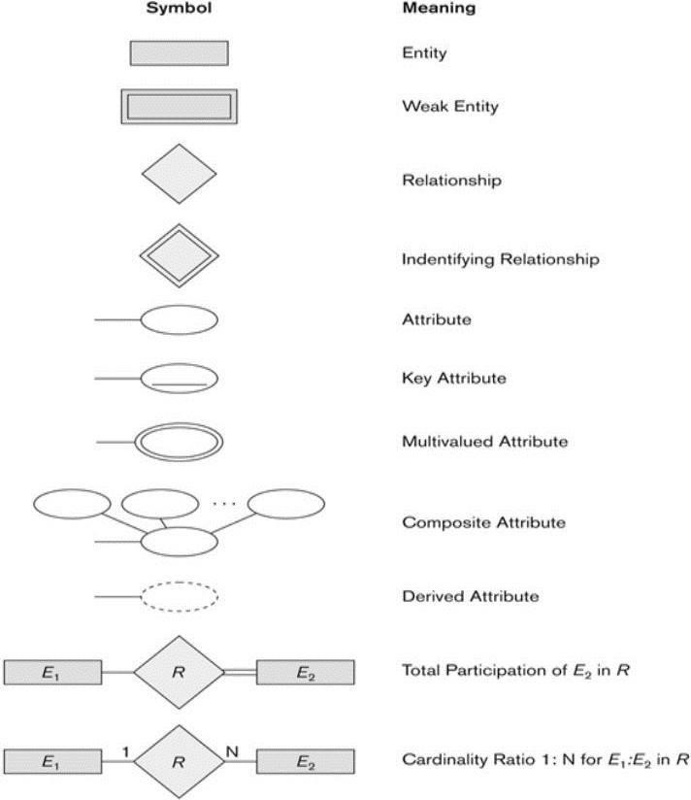

## 5. Complete old ER Diagram for “Galactic Marvel Radio Station”

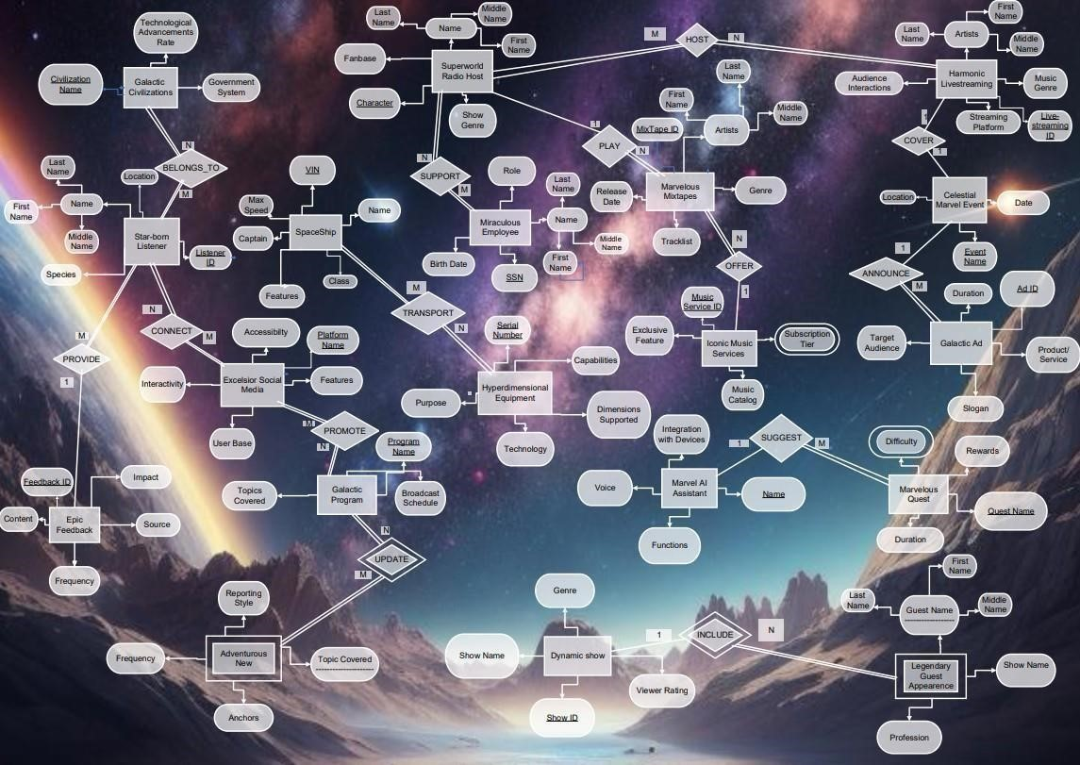

## 6. New Complete Amended ER Diagram for “Galactic Marvel Radio Station”

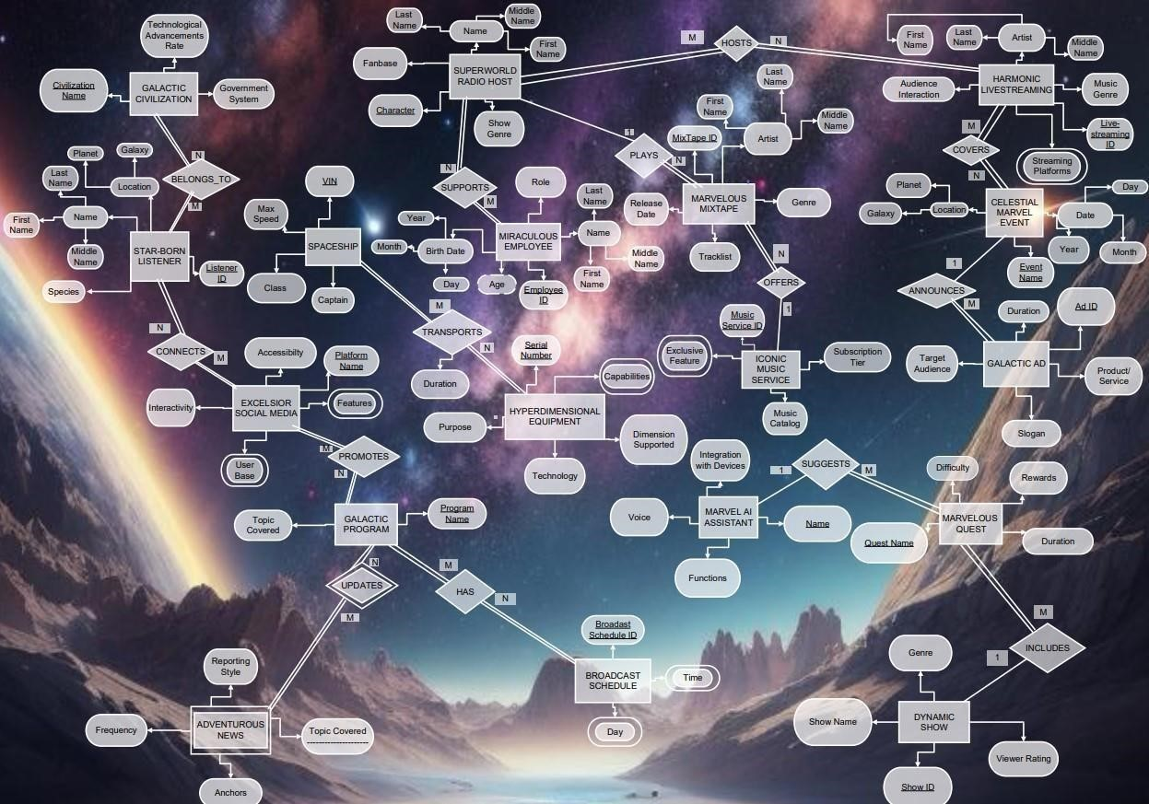

### 6.1. Entity Types & Their Attributes

**6.1.1. HARMONIC LIVESTREAMING**

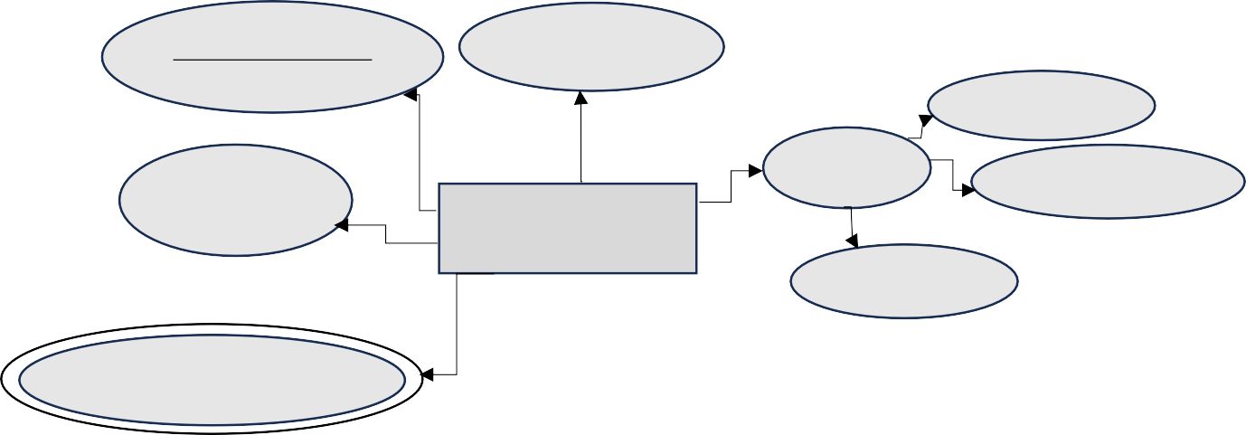

Live



Streaming



Music



Last



Audienc



e



Artis



Middle



HARMONIC



LIVESTREAMI



First



Streaming



Harmonic livestreaming is an immersive form of online content delivery that blends the world of music and realtime audience interaction. It creates an engaging experience where artists a1.nd audiences come together in a harmonious fusion of music, and shared moments.

**Attributes:**

1. **Livestreaming ID (Key attribute):** acts as a unique identifier of a live stream.
2. **Music Genre:** The music genre attribute defines the style, mood, and musical direction of the livestream. **c- Artist:** The artist attribute lists the performer, band, or musical act involved in the livestream.
3. **Audience Interaction:** The audience interaction attribute describes the level of engagement and participation allowed for the viewers.
4. **Streaming Platforms (Multi-valued attribute):** The streaming platforms attribute specify the online platform where the harmonic livestream takes place. This could be via dedicated music streaming services, social media platforms, or a specialized live-streaming websites.

6.1.2. **MARVELOUS MIXTAPE:**

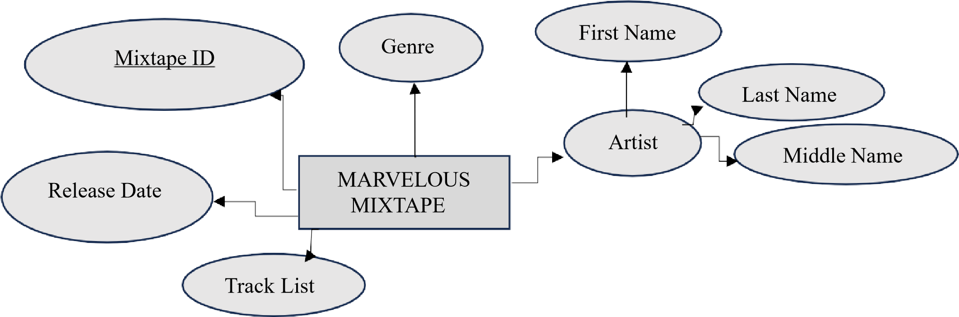

As part of its music offerings, the station features a series of MARVELOUS MIXTAPE each with a unique cosmic theme. These mixtapes are carefully curated to create immersive musical experiences, making them a highlight of the station's programming.

**Attributes:**

1. **Mixtape ID (key attribute):** it is Mixtape’s unique identifier.
2. **Genre:** The genre attribute of a mixtape helps classify the type of music contained within.

Genres can range from classical, jazz, and rock to more specific cosmic or interstellar themes.

This attribute sets the musical tone and expectations for the listener.

1. **Artist (Composite attribute):** This attribute in a mix tape refers to the musicians included, it consists of the first, middle and last name of the artist.
2. **Release Date:** The release date provides context to the mixtape.
3. **Track List:** It is a sequential list of the songs featured in the mix, determining the order in which the songs are presented.

**6.1.3.**

**GALACTIC PROGRAM:**



Program



Name



Topic



Covered



GALACTIC



PROGRAM



Each program offers a diverse range of content under a certain topic, from space science to imaginative storytelling, and other genres in which they serve as a source of education, inspiration, and entertainment for listeners.

**Attributes:**

1. **Program Name (Key attribute):** The program name is the program's unique identifier.
2. **Topic Covered:** Topic covered tackles the subject matter of the program. A Galactic Program explores various themes, including space exploration, astronomy, astrobiology, fictional space, and adventures. This attribute defines the program content and value. (Ex: under the topic sports, we can explore different themes including Sports in Space, Sports and Education, Covering Sports Games...)



Broadcast



Schedule



ID



Day



BROADCAST



SCHEDULE



6.1.4.



**BROADCAST**



**SCHEDULE:**



Time



The broadcast schedule provides details on how frequently the program airs. This entity ensures the listeners can tune in at the right time with their favorite programs.

**Attributes: a- Broadcast Schedule ID (Key attribute):** This attribute is the broadcast schedule unique identifier.

**b- Day (Multi-valued attribute):** This attribute is to specify on which day a program is aired.

A program could be aired on several days. **c- Time (Multi-valued attribute):** This attribute is to specify at what time a program is aired.

A program could be aired several times.

6.1.5. **SUPER-WORLD RADIO HOST:**

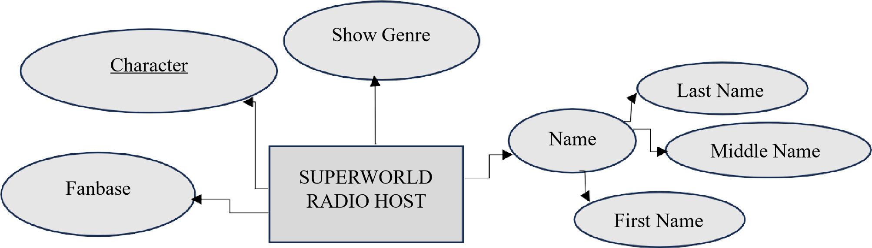

Each host of this radio station is special ones; each is a unique character of Marvel World!

**Attributes: a- Character (Key attribute):** Character is a unique defining attribute of radio hosts. Each host is a unique character in the Marvel world. (Ex: Spiderman, Hulk, Thor…)

1. **Name (Composite attribute):** The name of each of the radio hosts identifies them. It is usually consisting of their first, middle and last names.
2. **Show Genre:** Show genre defines the type of content a radio host presents. In other words, this attribute dictates the style, theme, and content of the show.
3. **Fanbase:** The fanbase attribute represents the loyal audience that follows a specific radio host. Hosts with a strong fan base often engage with their listeners through social media and live events.

6.1.6. **HYPERDIMENSIONAL EQUIPMENT:**

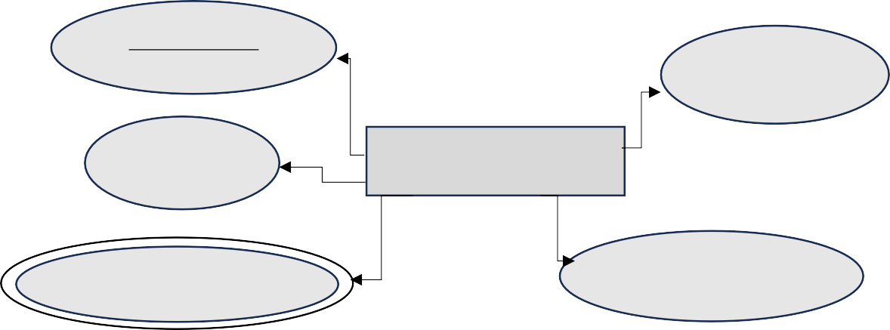

Serial



Number



Technology



Purpose



HYPERDIMENSIONAL



EQUIPMENT



Capability



Dimension



Supported



Hyperdimensional equipment represents the technology that allows for traversing multiple dimensions and exploring existence beyond traditional boundaries. These advanced devices open the door to a world of interdimensional possibilities.

**Attributes:**

1. **Serial Number (Key Attribute):** The serial number attribute provides a unique identification code for each equipment.
2. **Purpose:** The purpose attribute of hyperdimensional equipment defines its primary function which includes interdimensional travel and exploration to research, communication, or even experimental applications. Each piece of equipment serves a specific purpose.
3. **Technology:** The technological attribute outlines the scientific principles and advanced technologies that enable hyperdimensional equipment to function. It may include quantum mechanics, string theory, or other scientific concepts. This attribute represents the sophistication of the equipment's design.
4. **Capability (Multi-valued attribute):** The capabilities of hyperdimensional equipment describe what it can achieve. This may involve traveling through alternate realities, accessing parallel universes, or conducting experiments in dimensions beyond the conventional understanding of space and time. The capabilities attribute defines the equipment's potential and what makes it extraordinary.
5. **Dimension Supported:** The dimensions supported attribute specifies the number and types of dimensions that the equipment can interact with or explore. This attribute outlines the scope of the equipment's reach into the multiverse.

6.1.7. **SPACESHIP:**





VIN



SPACESHIP



Max



Speed



Captain



Class



A spaceship represents the interstellar transportation of the radio station’s equipment. This advanced vessel is designed for traveling through space.

**Attributes:**

**a- Vehicle Verification Number (VIN) (Key Attribute):** The VIN attribute provides a unique identification code for each spaceship. This alphanumeric or numerical code serves as a specific reference for tracking and identifying the ship within the interstellar community. **b- Class:** The class attribute categorizes spaceships based on their size, capabilities, and intended use. Classes can vary based on the distance that is needed to be covered by the ship. **c- Captain:** The captain attribute identifies the individual responsible for leading and operating the spaceship. Captains are skilled and experienced individuals who ensure the safety and success of transportation missions.

**d- Max Speed:** The max speed attribute quantifies the vessel's top velocity. It is a critical factor in determining the ship's efficiency in reaching its destination within a reasonable timeframe.

Speed may vary significantly between different spaceship classes.

6.1.8. **STAR-BORN LISTENER:**

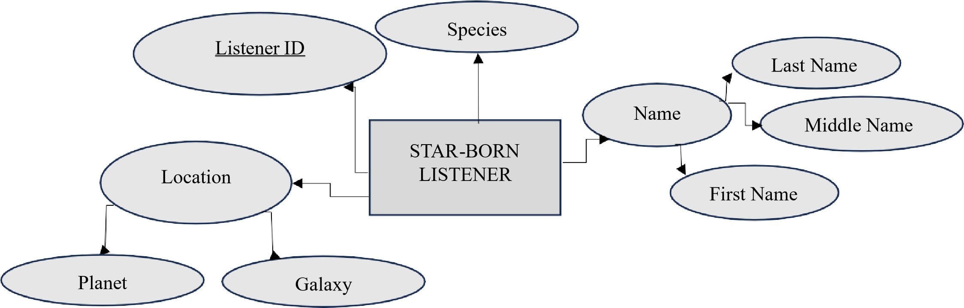

The star-born listener is a unique individual with a deep and innate connection to music.

**Attributes:**

1. **ID (key attribute):** The ID attribute provides a unique identification code for the star-born listener which refers to tracking and managing the listener's interactions.
2. **Name (Composite attribute):** The name attribute acts as one of the individual's identifiers. It includes a listener’s first, middle and last names. **c- Species:** The species attribute identifies the cosmic species or origin of the star-born listener.

This attribute reflects the listener's background or race.

**d- Location (Composite attribute):** The location attribute specifies the specific celestial location whether they are an Earth-based observer or positioned on a different planet or even galaxy. So, it includes the galaxy and the planet of the listener.

**6.1.9. CELESTIAL MARVEL EVENT:**



**CELESTIAL**



**MARVEL**



**EVENT**



E



vent Name



D



ate



L



ocation



Ga



la



xy



Planet



Celestial marvel event is an extraordinary occurrence in the universe that catches the attention of various galactical civilizations. These events capture a wide range of astronomical phenomena such as eclipses and cometary appearances. A celestial event provides opportunities for observation, study, and wonder.

**Attributes:**

1. **Event Name (Key attribute):** The event name is a unique identifier for the celestial event. It often reflects the nature or significance of the event, allowing attendees to easily recognize and refer to it.
2. **Date:** The date attribute specifies the date when the celestial event is set to occur.
3. **Location (Composite attribute):** The location attribute outlines the geographic or celestial position from which the event can be best observed. It may be a specific region on Earth, a particular point in the sky, or any other planet or galaxy where the event might be visible. So, it includes the galaxy and the planet of the event.

**6.1.10. GALACTIC AD:**

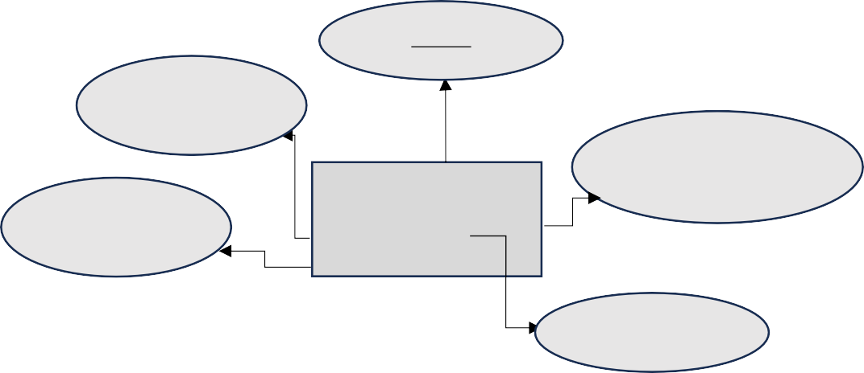

Ad



ID



Target



Audience



Product/Service



Slogan



GALACTIC



AD



Duration



Galactic ads are promotional materials or campaigns designed for interstellar and extragalactic audiences. They aim to reach potential customers or consumers across vast cosmic distances and offer products, services, or experiences.

**Attributes:**

* 1. **Ad ID (Key attribute):** This is the unique identifier of each ad.
  2. **Product/Service:** The product or service attribute identifies what the ad is promoting. It could vary between advanced technology, cosmic tourism, or any other offering.
  3. **Target Audience:** It is any group or individual that might be interested in the advertised offer.
  4. **Slogan:** The slogan attribute is a catchy or memorable phrase used in the ad to capture the attention and imagination of potential customers.
  5. **Duration:** The duration attribute refers to the length of time the ad campaign will run.



GALACTIC



CIVILIZATION



Civilization



Name



**6.1.11.**



**GALACTIC**



**CIVILIZATION:**



Technological



Advancements



Rate



Government



System



A galactic civilization represents an advanced and diverse society that has expanded beyond its home planets to establish interstellar or even intergalactic communities. These civilizations are characterized by their technological prowess, species diversity, and a collective commitment to exploring. **Attributes:**  **a- Civilization Name (Key attribute):** Civilization’s name is its unique identifier.

**b- Government System:** The government system attribute defines the political structure that governs the galactic civilization. It may be a democratic alliance, a council of species, an empire, or any other form of governance suitable for governing a vast interstellar domain. **c- Technological Advancement Rate:** The technological advancements rate attribute describes

the level of technological progress achieved by civilization in fields such as space travel, energy sources, communication, and scientific achievements.

**6.1.12. MARVEL AI ASSISTANT:**



MARVEL



AI



ASSISTANT



Function



Voice



Integration



with



Device



Name



The Marvel AI Assistant is a design that assists individuals in their exploration of the cosmos and provides valuable insights into the marvels of the universe. This advanced AI is integrated into various devices and systems, serving as an invaluable resource for space- related inquiries and exploration.

**Attributes:**

* + - * 1. **Name (Key attribute):** The name attribute is the unique identifier for the Marvel AI Assistant. It provides a distinct and recognizable nickname for the AI, making it more relatable and memorable to users.
        2. **Function:** The function attribute outlines the various tasks and capabilities that the AI can perform. These functions may include language support, recommendations, and suggesting Marvel Quest.
        3. **Voice:** The voice attribute specifies the AI's vocal characteristics, such as tone, pitch, and style. It helps in creating a personalized and user-friendly interaction experience. **d- Integration with Device:** The integration with devices attribute describes the compatibility of the Marvel AI Assistant with a hardware or software platform. It may

be integrated into a spacesuit, spacecraft control system, or other space-related device to offer access to its function.



**6.1.13.**

**MARVELOUS QUEST:**



MARVELOUS



QUEST



Difficulty



Duration



Rewards



Quest



Name



The marvelous quest for participants is a captivating cosmic adventure designed to challenge, inspire, and entertain those who embark on these extraordinary missions. These quests offer participants the opportunity to immerse themselves in exploration, overcome obstacles, and experience the wonders of the universe.

**Attributes: a- Quest Name (Key attribute):** The quest name serves as the unique identifier for the adventure. It encapsulates the objectives of the quest, making it easily recognizable for those who seek exploration.

* 1. **Difficulty:** The difficulty attribute assesses the level of challenge participants will face during the quest. Quests are categorized as easy, moderate, difficult, or epic, allowing participants to choose adventures that match their skill and determination.
  2. **Reward:** The reward attribute outlines the incentives and experiences that await participants upon successful quest completion.
  3. **Duration:** The duration attribute specifies the expected time frame for participants to complete the quest.

**6.1.14. ADVENTEROUS NEW (Weak entity):**



Topic



Covered



Reporting



Style



Anchor



Frequency



ADVENTOROUS



NEW



Adventurous new is a captivating form of reporting that brings thrilling and extraordinary stories related to space exploration, discoveries, and interstellar adventures to audiences. It provides a fresh perspective on events and developments, offering education, excitement, and wonder.

**Attributes:**

* + - 1. **Topic Covered (Partial key):** The topic covered attribute defines the unique range of subjects and themes featured in adventurous new. This may include space missions, celestial phenomena, astronaut experiences, and cosmic research.
      2. **Reporting Style:** The reporting style attribute describes the tone and approach used in presenting adventurous news. It may be characterized as informative, exploratory, enthusiastic, or even dramatic, depending on the storytelling style.
      3. **Frequency:** The frequency attribute outlines how often adventurous news is published or broadcast. It may vary from daily updates to periodic features, depending on the news outlet's schedule.
      4. **Anchor:** The anchor attribute provides the presenter, reporter, or host who deliver s adventurous news. These individuals are often well-versed in cosmic topics and play a key role in conveying the excitement and wonder of space-related stories.

**6.1.15. MIRACULOUS EMPLOYEE:**



MIRACULOUS



EMPLOYEE



Employee ID



Name



First Name



Middle



Name



Last Name



Bir



t



hdate



Role



Age



A Miraculous Employee is a member of the radio team, known for their exceptional contributions to the station's success. This individual plays a major role in ensuring the station's continued growth, captivating content, and operations.

**Attributes:**

* + - 1. **Employee ID (Key attribute):** This attribute represents the unique identifier assigned to the employee for administrative and official purposes within the Marvel Radio Station. It is vital for maintaining records and ensuring compliance with legal and financial regulations.
      2. **Name (Composite attribute):** The name attribute identifies the employee by their given first, middle and last names.
      3. **Role:** The role attribute outlines the specific responsibilities and duties held by the Miraculous Employee within the radio station. This role may encompass content creation, production, or management.
      4. **Birthdate:** The birthdate attribute signifies the day, month, and year on which the employee was born.
      5. **Age (Derived attribute):** It is additional vital information about the employee and can be calculated from the Birth Date attribute.

**6.1.16. EXCELSIOR SOCIAL MEDIA:**

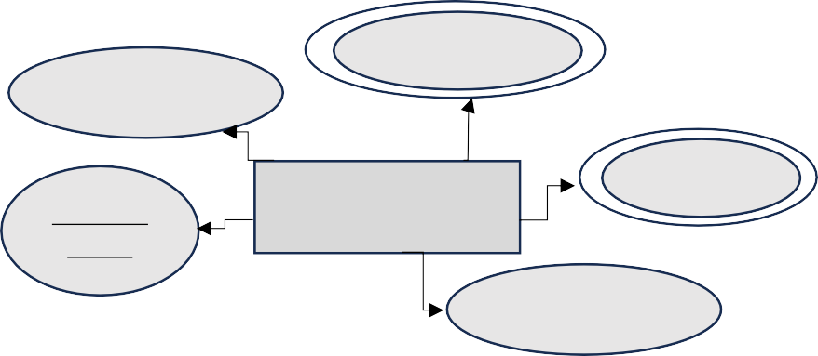

User



Base



Accessibility



Platform



Name



EXCELSIOR



SOCIAL



MEDIA



Feature



Interactivity



Excelsior social media is a space-themed social networking platform that offers a unique service for listeners, audience, and those who follow the Marvel Radio Station to connect, engage, and discuss with uploaded posts, stories, and posts.

**Attributes:**

* + - * 1. **Platform Name (Key attribute):** Each platform has its unique name that can act as a unique identifier to the Excelsior social media.
        2. **Feature (Multi-valued attribute):** The platform offers an array of features to create a space-centric experience. Users can customize avatars, set interactive cosmic backgrounds, share space-related content, participate in discussion forums, and engage in live space events.
        3. **User Base (Multi-valued attribute):** Excelsior social media has attracted a diverse user base, including space enthusiasts, scientists, and sci-fi fans. This community contributes to rich discussions and interactions, fostering a sense of unity among those passionate about music.
        4. **Interactivity:** The platform thrives on user interaction, with space-themed groups, live chats, webinars, and virtual space events. This interactivity enhances the user experience, providing opportunities for learning and engagement.
        5. **Accessibility:** Excelsior social media prioritizes accessibility, ensuring that users from various galaxies and regions can easily connect. It is compatible with multiple devices, features an intuitive interface, and promotes universal connectivity, and unites individuals from across the universe.

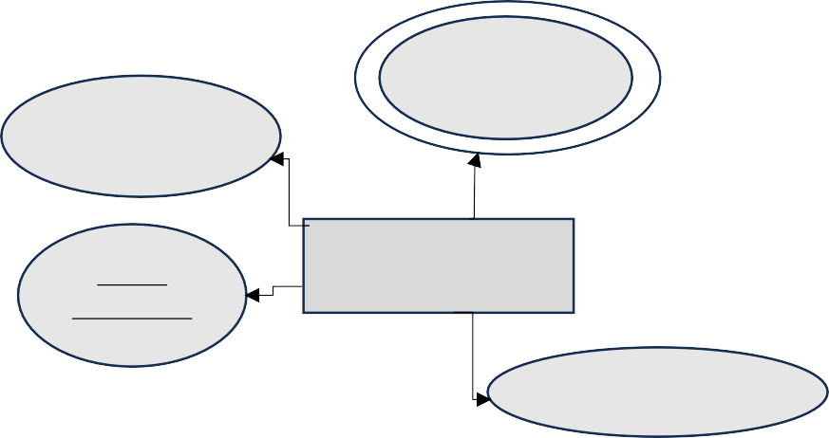

**6.1.17.**



**ICONIC**



**MUSIC**



**SERVICE:**



Subscription



Tier



Exclusive



Feature



Music



Catalog



Music



Service ID



ICONIC MUSIC



SERVICE



Iconic Music Service is a leading unique interstellar music streaming service that has redefined the way audiences across the galaxy discover, enjoy, and engage with music. It offers a selection of music, innovative features, and an interactive music ecosystem that transcends traditional audio experiences for special subscribers on the radio station.

**Attributes:**

1. **Music Service ID (key attribute):** it is a Music Service unique identifier.
2. **Music Catalog:** It provides an extensive library of tracks that cover a wide range of musical preferences.
3. **Exclusive Feature (Multi-valued attribute):** Iconic Music Service goes beyond standard music streaming with its exclusive features which include personalized playlists according to user preferences, AI recommendations based on a user's listening history, immersive audio for those who appreciate more than just the sounds

of the music where listeners can enjoy 3D audio, surround sound, and spatial audio to

enhance the overall listening experience.

1. **Subscription Tier:** Iconic Music Service understands that users have diverse preferences and requirements, which is why it offers a tiered subscription model (Ex: Standard Tier, Premium Tier, Platinum Tier)

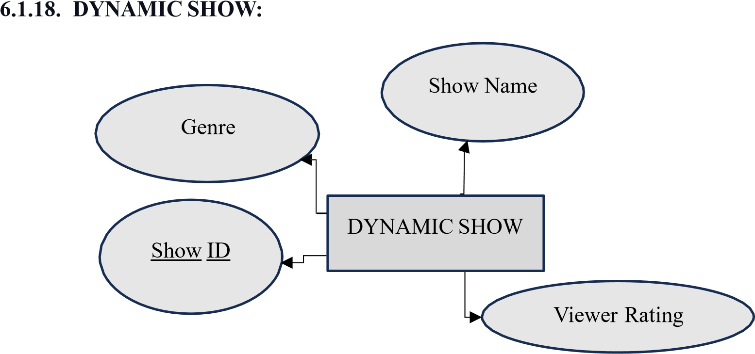

Dynamic Show would be a category of entertainment programs that offer a wide range of genres, and interactivity. These shows are designed to engage and captivate audiences, often incorporating real-time elements and interactive features to enhance the viewing experience.

**Attributes:**

* + - * 1. **Show ID (Key attribute):** Each Dynamic Show is assigned a unique identifier, known as the "Show ID." This identifier helps in tracking, organizing, and differentiating between various shows in a broadcasting network. It is a fundamental element in show management and content scheduling.
        2. **Show Name:** The "Show Name" is the title or designation of the Dynamic Show. It represents the identity and branding of the program, often reflecting its genre, theme, or content. The show's name is an essential element in marketing and audience recognition, serving as the primary way viewers identify and refer to the program. **c- Genre:** Dynamic Shows encompass a diverse array of genres, catering to a wide range of interests. These may include science fiction, space exploration, adventure, comedy, drama, and more. The choice of genre varies based on the show's theme and target audience.

**d- Viewer Rating:** Viewer ratings are a measure of a show's popularity and impact. These ratings reflect the audience's feedback, reviews, and responses, which are crucial in evaluating a show's success and helping producers make improvements based on audience preferences.

**6.2. Elaboration on Relationships:**



M



N



PROMOTES



GALACTIC



PROGRAM



EXCELSIOR



SOCIAL



MEDIA



* + - The "PROMOTES" relationship between **"EXCELSIOR SOCIAL**

**MEDIA"** and **"GALACTIC PROGRAM"** is a many-to-many relationship with total

participation of both entities. It means that many social media platforms promote galactic

programs, and many galactic programs are being promoted by social media. It allows for a flexible and dynamic promotion strategy where both the programs and social media platforms can have multiple associations with each other. This relationship facilitates the promotion and outreach of galactic programs through various social media channels.



1



N



PLAYS



MARVELOUS



MIXTAPE



SUPER



-



WORLD



RADIO



HOST



* + - The "PLAYS" relationship between **"SUPER-WORLD RADIO HOST**" and

"**MARVELOUS MIXTAPE**" is a one-to-many relationship with total participation of the marvelous mixtape and partial participation of the super-world radio host. In this context, it means that a single super radio host can play multiple mix tapes, but each mix tape is played by only one super radio host. This relationship reflects the fact that a super radio host can curate and play various mix tapes during the radio shows, and each mix tape is associated with a specific radio host. It allows for a diverse selection of mixtapes to be featured on the radio station, with each host having their own unique set of mix tapes to share with the audience.



•



1



N



OFFERS



MARVELOUS



MIXTAPE



ICONIC



MUSIC



SERVICE



* + - The "OFFERS" relationship between "**ICONIC MUSIC SERVICE**" and **" MARVELOUS**

**MIXTAPE**" is a one-to-many relationship with total participation of the marvelous mixtape and partial participation of the iconic music service. In this context, it signifies that a single music service can provide access to multiple mix tapes, ensuring a broad and varied collection of mix tapes available through a single service. Each mix tape is linked to a specific music service, creating a platform for the distribution of mix tapes to a wide audience. This relationship enables users to explore and enjoy an extensive range of mix tapes, each conveniently offered by their respective music service.



M



N



HOSTS



HARMONIC



LIVESTRAMING



SUPERWORLD



RADIO HOST



* + - The “HOSTS” relationship between "**SUPERWORLD RADIO HOST**" and "**HARMONIC LIVESTREAMING**" is a many-to-many relationship with total

participation of both entities. In this context, it signifies that multiple Super World Radio

hosts can participate in various live-streaming events, and at the same time, each live- streaming event can involve several Super World Radio hosts. This relationship reflects the dynamic nature of Super World Radio, where numerous hosts collaborate to bring live- streaming content to their audience and live-streaming events can feature a mix of hosts with diverse styles and shows.



M



N



COVERS



CELESTIAL



MARVEL



EVENT



HARMONIC



LIVESTREAMI



NG



* + - The “COVERS” relationship between "**HARMONIC LIVE STREAMING**" and **"CELESTIAL MARVEL EVENT"** is a many-to-many relationship with partial

participation of both entities. In this context, it signifies that many harmonic live-streaming

sessions are dedicated for many events, and conversely, many events are complemented by different live-streaming sessions. This relationship is instrumental in ensuring that many events have different harmonic live-streaming performances, enhancing the overall experience for event attendees. It allows for a seamless connection between live music and event participation, making each event distinctive and musically vibrant.

•



M



ANNOUNCES



CELESTIAL



MARVEL



EVENT



GALACTIC



AD



1



* + - The "ANNOUNCES" relationship between “**CELESTIAL MARVEL EVENT**” and

“**GALACTIC AD**” with partial participation of the celestial marvel event and total participation of the galactic ad. is a many-to-one relationship. In this context, it indicates that multiple advertisements (ads) can be associated with a single event. These advertisements serve to promote and announce the event to a wider audience. This relationship enables event organizers to use various ads to create awareness and generate interest in their events. It ensures that the event is effectively publicized through multiple advertisements.



•



M



N



UPDATES



GALACTIC



PROGRAM



ADVENTOROUS



NEW



* + - The "UPDATES" relationship between **“ADVENTOROUS NEW”** and “**GALACTIC**

**PROGRAM**” is a many-to-many relationship with total participation of both entities. This means that news updates can be associated with multiple programs, and various programs can feature the same news update. This dynamic connection allows news updates to be shared across a range of programs, ensuring that the latest information is delivered to a diverse audience. It also offers the flexibility for programs to choose specific news updates to share with their audience.



•



M



N



TRANSPORTS



SPACESHIP



HYPERDIMENSIONAL



EQUIPMENT



Duration



The "TRANSPORTS" relationship between “**HYPERDIMENSIONAL**

**EQUIPMENT”** and “**SPACESHIP**” is a many-to-many relationship with total participation of both entities. Many spaceships transport radio station equipment and many equipment is transported by many spaceships. Its has an attribute **duration**, to indicate the average duration that a spaceship takes to transport hyperdimensional equipment. Spaceships serve as a reliable means of transporting a wide array of radio station equipment, ensuring that different tools, devices, and supplies are efficiently delivered to their intended destinations.



•



M



N



CONNECTS



STAR



-



BORN



LISTENER



EXCELSIOR



SOCIAL



MEDIA



* + - The “CONNECTS” relationship between “**EXCELSIOR SOCIAL MEDIA**” and “**STAR- BORN LISTENER”** is a many-to-many connection with total participation of both entities. It means that listeners can connect and engage across multiple social media platforms, and social media serves as a bridge for numerous listeners to interact with one another. This allows listeners to actively participate in discussions, share content, and stay connected with the online community. It also provides social media platforms with a broad and engaged audience, creating an interactive online environment.



M



N



BELONGS_



TO



GALACTIC



CIVILIZATION



STAR



-



BORN



LISTENER



* + - The “BELONGS_TO” relationship between **“STAR-BORN LISTENER”** and “**GALACTIC CIVILIZATION**” is a dynamic many-to-many relationship with total participation of both entities. This signifies that listeners can be part of multiple civilizations, and different civilizations can include various listeners. This flexibility encourages a diverse exchange of ideas and cultures, creating a lively and interconnected community of individuals and civilizations.



MARVELOUS

QUEST



•



M



N



MARVEL



AI



ASSISTANT



SUGGESTS

* + - The "SUGGESTS" relationship between “**MARVEL AI ASSISTANT”** and

“**MARVELOUS QUEST**” is a one-to-many relationship with partial participation of both entities. In this setup, an AI assistant can provide suggestions for multiple quests, making it easier for players to discover exciting challenges and adventures. This feature enhances the gaming experience by offering a variety of quest options, all while keeping players engaged and entertained.

BROADCAST

SCHEDULE



M



N



HAS



GALACTIC

PROGRAM



* + - The “HAS” relationship between **“GALACTIC PROGRAM”** and **“BROADCAST**

**SCHEDULE”** is a many-to-many relationship with total participation of galactic program and partial participation of broadcast schedule. is a one-to-one relationship with total participation of both entities. Where each galactic program has its own unique broadcast schedule and all galactic programs must have a broadcast schedule, also all broadcast schedules are related to galactic programs.



1



N



INCLUDES



MARVELOUS



QUEST



DYNAMIC



SHOW



* + - The “INCLUDES” relationship between “**DYNAMIC SHOW**” and “**MARVELOUS**

**QUEST**” is a one-to-many connection with partial participation of dynamic show and total participation of marvelous quest. In this context, it means that a dynamic show can incorporate multiple quests, enhancing the show's interactivity and entertainment value. Each quest represents a set of questions or challenges that the dynamic show incorporates, making it engaging for the audience.



•



M



N



SUPPORTS



SUPERWORLD



RADIO



HOST



MIRACULOUS



EMPLOYEE



* + - The "SUPPORTS" relationship between **"MIRACULOUS EMPLOYEE"** and

**"SUPERWORLD RADIO HOST"** is a many-to-many collaboration with the total

participation of the super-world radio host and partial participation of the miraculousemployee. This relationship embodies the essential support system within the radio station.

Super-World Radio Hosts are at the forefront of delivering captivating content, and Miraculous Employees play a pivotal role in ensuring the hosts have the necessary resources, assistance, and support for their shows.

## 7. ER to Relational Mapping

### 7.1 - Step1 – Mapping Strong Entity Types

As a first step, a separate relation must be created for each regular entity type represented in our ER. This relation will hold all the simple attributes that the regular entity includes. Only one of the key attributes will be chosen as a primary key, which will be evident by an underline. In the case of a composite attribute, the simple attributes composing it will be included in the relation rather than the attribute itself. If the primary key happens to be composite, the simple attributes together will form the underlined primary key of the mentioned relation. Additionally, all derived attributes will be considered as simple ones in our relational schema, however, computation would be done automatically in the database.

# HARMONIC LIVESTREAMING

|  |  |  |  |  |  |
| --- | --- | --- | --- | --- | --- |
| **Live streaming ID** | **Music Genre** | **Audience interaction** | **Last Name** | **Middle Name** | **First name** |

The HARMONIC LIVESTREAMING entity contains simple, composite, and multivalued attributes. The multivalued attribute *Streaming Platform* is not represented in this relation. This relation only includes all simple attributes and the primary key ***Live Streaming ID*** which is underlined. The HARMONIC LIVESTREAMING entity has *Artist* as a composite attribute of which only the simple attributes *FirstName*, *LastName*, and *Middle Name* are included in the relation.

# 7.1.1. GALACTIC CIVILIZATION

|  |  |  |
| --- | --- | --- |
| **Civilization Name** | **Technological Advancement**  **Rate** | **Government System** |

The GALACTIC CIVILIZATION entity contains simple attributes one of them is the primary key

***Civilization Name*** which is underlined.

# 7.1.2. STAR BORN LISTENER

|  |  |  |  |  |  |  |
| --- | --- | --- | --- | --- | --- | --- |
| **Listener ID** | **Galaxy** | **Planet** | **Last Name** | **Middle Name** | **First Name** | **Species** |

The STAR BORN LISTENER entity contains simple, and composite attributes. This relation only includes all simple attributes and the primary key ***Listener ID*** which is underlined. The STAR BORN LISTENER entity has *Name* as composite attributes of which only the simple attributes *FirstName*, *LastName*, and *Middle Name* are included in the relation. Another composite attribute which is *Location* having simple attributes which are *Galaxy* and *Planet* are included in the relation.

# 7.1.3. EXELSIOR SOCIAL MEDIA

|  |  |  |
| --- | --- | --- |
| **Platform Name** | **Accessibility** | **Interactivity** |

The EXELSIOR SOCIAL MEDIA entity contains simple, and multivalued attributes. The multivalued attribute *Features* and *User Base* are not represented in this relation. This relation only includes all simple attributes and the primary key ***Platform Name*** which is underlined.

# 7.1.4. GALACTIC PROGRAM

|  |  |
| --- | --- |
| **Program Name** | **Topic Covered** |

The GALACTIC SOCIAL MEDIA entity contains simple attributes one of them is the primary key

***Program Name*** which is underlined.

# 7.1.5. SHAPESHIP

|  |  |  |  |
| --- | --- | --- | --- |
| **VIN** | **Max Speed** | **Class** | **Captain** |

The SHAPESHIP entity contains simple attributes one of them is the primary key ***VIN*** which is underlined.

# 7.1.6. SUPERWORLD RADIO HOST

|  |  |  |  |  |  |
| --- | --- | --- | --- | --- | --- |
| **Character** | **Fanbase** | **Show Genre** | **First Name** | **Middle Name** | **Last Name** |

The SUPERWORLD RADIO HOST entity contains simple, and composite attributes. This relation only includes all simple attributes and the primary key ***Character*** which is underlined. The SUPERWORLD

RADIO HOST entity has *Name* as composite attributes of which only the simple attributes *FirstName*, *LastName*, and *Middle Name* are included in the relation.

# 7.1.7. MIRACULOUS EMPLOYEE

|  |  |  |  |  |  |
| --- | --- | --- | --- | --- | --- |
| **Employee ID** | **First Name** | **Middle Name** | **Last Name** | **Role** | **Date** |

The MIRACULOUS EMPLOYEE entity contains simple, derived, and composite attributes. The derived attribute *Age* and the composite attributes *Name and Birth Date* are not represented in this relation. This relation only includes all simple attributes and the primary key ***Employee ID*** which is underlined. The MIRACULOUS EMPLOYEE entity has *Name* as a composite attribute of which only the simple attributes *FirstName*, *LastName*, and *MI* are included in the relation. Another composite attribute which is *Birth Date* having simple attributes which are *Day, Year,* and *Month* are included in the relation.

# 7.1.8. HYPERDIMENSIONAL EQUIPMENT

|  |  |  |  |
| --- | --- | --- | --- |
| **Serial Number** | **Purpose** | **Technology** | **Dimension Supported** |

The HYPERDIMENSIONAL EQUIPMENT entity contains simple, and multivalued attributes. The multivalued attribute *CAPABILITY* IS not represented in this relation. This relation only includes all simple attributes and the primary key ***Serial Number*** which is underlined.

# 7.1.9. MARVELOUS MIXTAPE

|  |  |  |  |  |  |  |
| --- | --- | --- | --- | --- | --- | --- |
| **Mixtape ID** | **First Name** | **Middle**  **Name** | **Last Name** | **Genre** | **Track list** | **Release**  **Date** |

The MARVELOUS MIXTAPE entity contains simple, and composite attributes. This relation only includes all simple attributes and the primary key ***Mixtape ID*** which is underlined. The MARVELOUS

MIXTAPES entity has *Artist* as composite attributes of which only the simple attributes *FirstName*, *LastName*, and *Middle Name* are included in the relation.

# 7.1.10. BROADCAST SCHEDULE

## Broadcast schedule ID

The BROADCAST SCHEDULE entity contains simple, and multivalued attributes. The multivalued attribute *Time* and *Day* are not represented in this relation. This relation only includes all simple attributes and the primary key ***Broadcast schedule ID*** which is underlined.

# 7.1.11. ICONIC MUSIC SERVICE

|  |  |  |
| --- | --- | --- |
| **Music Service ID** | **Subscription Teir** | **Music Catalog** |

The BROADCAST SCHEDULE entity contains simple, and multivalued attributes. The multivalued attribute *Exclusive feature* is not represented in this relation. This relation only includes all simple attributes and the primary key ***Music Service ID*** which is underlined.

# 7.1.12. MARVEL AI ASSISTANT

|  |  |  |  |
| --- | --- | --- | --- |
| **Name** | **Integration With Device** | **Voice** | **Function** |

The MARVEL AI ASSISTANT entity contains simple attributes one of them is the primary key

***Name*** which is underlined.

# 7.1.13. MARVELOUS QUEST

|  |  |  |
| --- | --- | --- |
| **Quest Name** | **Reward** | **Duration** |

The MARVELOUS QUEST entity contains simple, and multivalued attributes. The multivalued attribute *Difficulty* is not represented in this relation. This relation only includes all simple attributes and the primary key ***Quest Name*** which is underlined.

# 7.1.14. GALACTIC AD

|  |  |  |  |  |
| --- | --- | --- | --- | --- |
| **Ad ID** | **Product/Service** | **Slogan** | **Target Audience** | **Duration** |

The GALACTIC AD entity contains simple attributes one of them is the primary key ***Ad ID*** which is underlined.

# 7.1.15. CELESTIAL MARVEL EVENT

|  |  |  |  |
| --- | --- | --- | --- |
| **Event Name** | **Planet** | **Galaxy** | **Date** |

The CELESTIAL MARVEL EVENT entity contains simple, and composite attributes. This relation only includes simple and composite attributes, and the primary key ***Event Name*** which is underlined. The CELESTIAL MARVEL EVENT entity has *Date* as composite attributes of which only the simple attributes *Day, Month, and Year* are included in the relation. Another composite attribute which is *Location* having simple attributes which are *Planet,* and *Galaxy* are included in the relation.

# 7.1.16. DYNAMIC SHOW

|  |  |  |  |
| --- | --- | --- | --- |
| **Show ID** | **Viewer Rating** | **Genre** | **Show Name** |

The DYNAMIC SHOW entity contains simple attributes one of them is the primary key ***Show ID*** which is underlined.

## 7.2 – Step 2 – Mapping of Weak Entity Types

Each weak entity type in our ER model necessitates its own table. This table should include all the individual attributes of the weak entity. In cases where there are composite attributes, the constituent simple attributes should be included in the table. Additionally, the primary key of the owning entity type should be included in the table of the corresponding weak entity as a foreign key. This results in the combined primary key of the weak entity's partial key and the owner entity's primary key being used as the primary key for the weak entity in its table.

**ADVENTEROUS NEW:**

|  |  |  |  |  |
| --- | --- | --- | --- | --- |
| **Program_Name** | **Topic Covered** | **Reporting Style** | **Frequency** | **Anchor** |

The weak entity type ADVENTEROUS NEW includes both a partial, a foreign key. The simple attribute Topic Covered is underlined as it represents the partial key of this entity type.

Additionally, the Program Name represents the key attribute of **GALACTIC PROGRAM** and serves as foreign key that references the **GALACTIC PROGRAM**. Thus, both attributes are underlined as they together form the primary key of this relation. The other attributes included as simple attributes.

## 7.3 – Step 3 – Mapping of Binary 1:1 Relationship Types

During this phase, each binary 1:1 relationship can be handled using one of three methods. The first method is the foreign key approach, where we extract the primary key from one of the participating entities and insert it as a foreign key in the other entity's table. Generally, it's preferable to include the foreign key in the table of the entity that fully participates in the relationship.

The second method is the merged relation approach, where a new table is created by combining both entity types and their relationship. This method is useful when both entities have a total participation in the relationship.

The third method is the cross-reference approach, which involves creating an additional table that crossreferences the corresponding primary keys from the participating entities.

Our ER diagram did not encompass any 1:1 relationship type, thus this step wasn’t implemented.

## 7.4 – Step 4 – Mapping of Binary 1:N Relationship Types

As for this step, each binary 1:N relationship is mapped by a precise method. To map the mentioned relationship, we’ll include in the relation of the participating entity type at the N-side of the relationship, the primary key of the relation of the participating entity type at the 1-side of the relationship. The mentioned key will represent the foreign key. The relationship’s derived attributes will also be included in the relation of the participating entity at the N-side of the relationship.

**7.4.1. INCLUDES:**

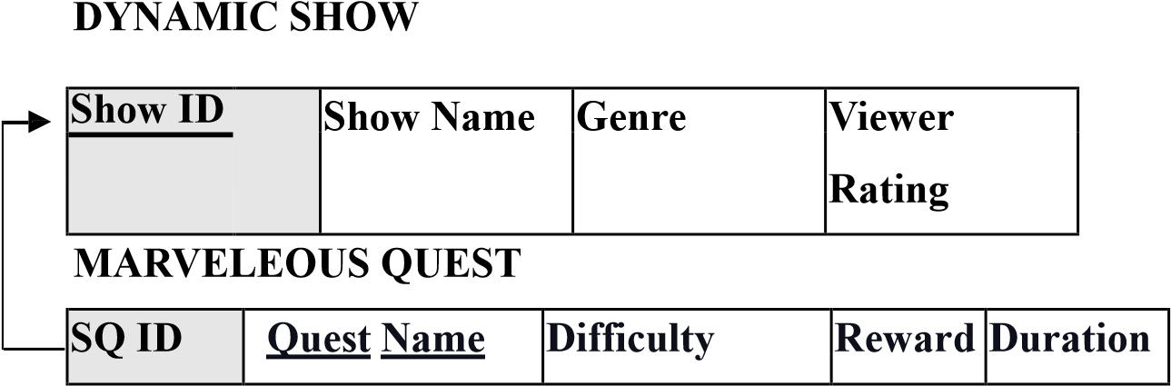

The INCLUDES relationship relates DYNAMIC_SHOW entity and MARVELEOUS_QUEST entity. A DYNAMIC_SHOW can have many MARVELEOUS_QUEST, but a

MARVELEOUS_QUEST can work in only one DYNAMIC_SHOW. Then the

MARVELEOUS_QUEST entity is on the N (many) side. Therefore, the primary key of the

DYNAMIC_SHOW entity (Show_ID) is placed in the MARVELEOUS_QUEST relation as a foreign key, with an attribute name of SQ_ID.

**7.4.2. SUGGESTS:**

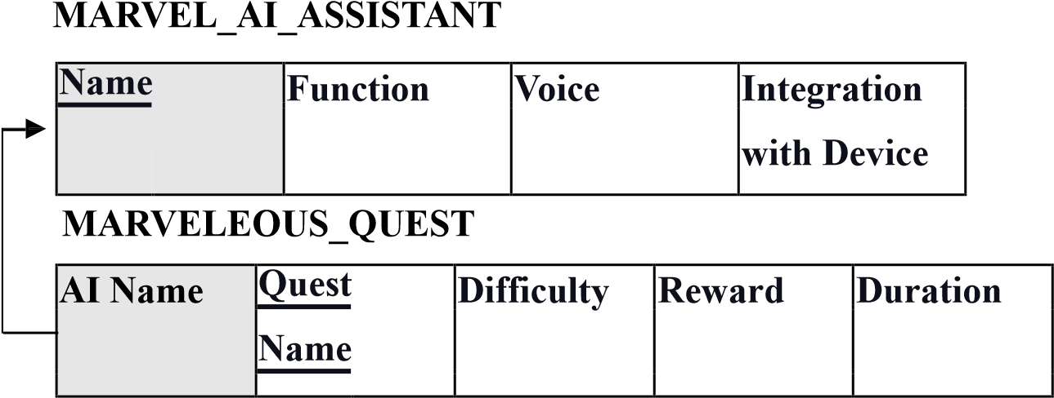

The SUGGESTS relationship relates MARVEL_AI_ASSISTANT entity and

MARVELEOUS_QUEST entity. A MARVEL_AI_ASSISTANT can have many

MARVELEOUS_QUEST, but a MARVELOUS_QUEST can work in only one

MARVEL_AI_ASSISTANT. Then the MARVELEOUS_QUEST entity is on the N (many) side.

Therefore, the primary key of the MARVEL_AI_ASSISTANT entity (Name) is placed in the MARVELEOUS_QUEST relation as a foreign key, with an attribute name of AI Name.

**7.4.3 ANNOUNCES:**

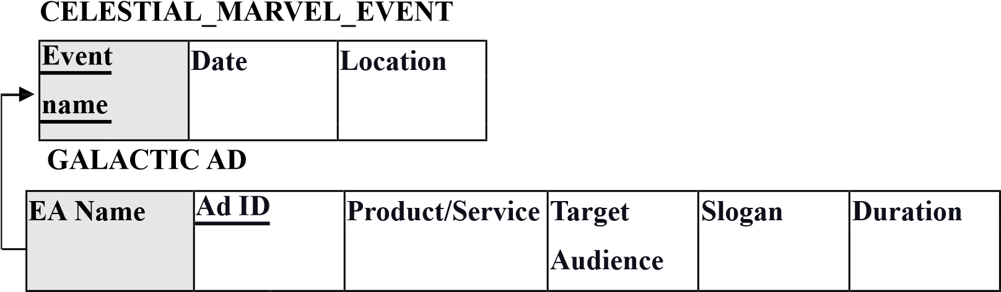

The ANNOUNCES relationship relates CELESTIAL_MARVEL_EVENT entity and GALACTIC

AD entity. A CELESTIAL_MARVEL_EVENT can have many GALACTIC_AD, but a GALACTIC_AD can work in only one CELESTIAL_MARVEL_EVENT. Then the GALACTIC_AD entity is on the N (many) side. Therefore, the primary key of the

CELESTIAL_MARVEL_EVENT entity (Event Name) is placed in the GALACTIC_AD relation as a foreign key, with an attribute name of EA Name.

**7.4.4 PLAYS:**

|  |  |  |  |
| --- | --- | --- | --- |
| **Character** | **Name** | **Show Genre** | **Fanbase** |

|  |  |  |  |  |  |
| --- | --- | --- | --- | --- | --- |
| **CharM** | **Mixtape ID** | **Genre** | **Artist** | **Release Date** | **Track List** |

# SUPERWORLD_RADIO_HOST MARVELEOUS_MIXTAPE

The PLAYS relationship relates SUPERWORLD_RADIO_HOST entity and

MARVELOUS_MIXTAPE entity. A SUPERWORLD_RADIO_HOST can have many

MARVELOUS_MIXTAPE, but an MARVELEOUS_MIXTAPE can be play by only one

SUPERWORLD_RADIO_HOST. Then the MARVELEOUS_MIXTAPE entity is on the N

(many) side. Therefore, the primary key of the SUPERWORLD_RADIO_HOST entity

(Character) is placed in the MARVELOUS_MIXTAPE relation as a foreign key, with an attribute name of CharM.

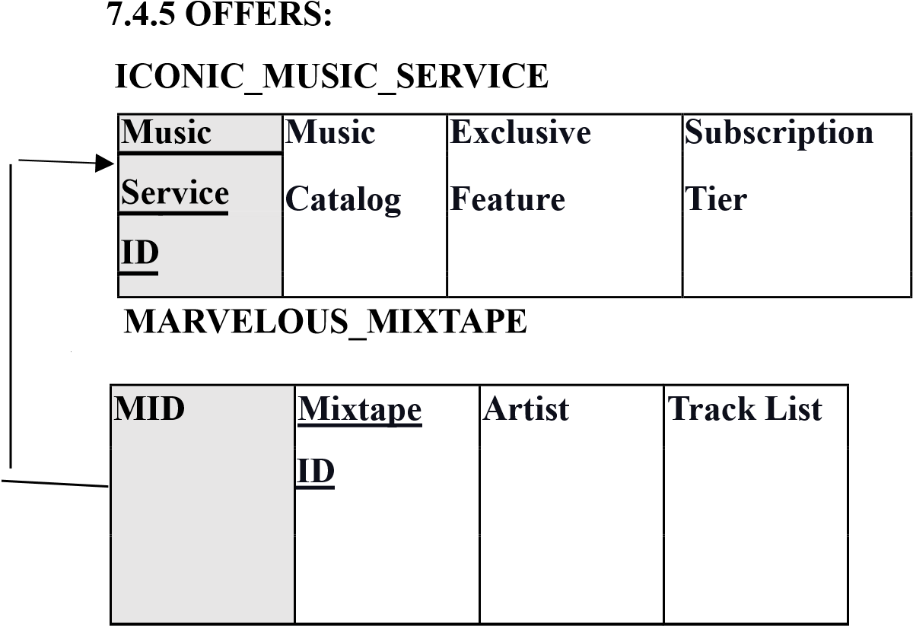

The OFFERS relationship relates ICONIC_MUSIC_SERVICE entity and

MARVELOUS_MIXTAPE entity. An ICONIC_MUSIC_SERVICE can have many

MARVELOUS_MIXTAPE, but a MARVELOUS_MIXTAPE can work in only one

ICONIC_MUSIC_SERVICE. Then the MARVELOUS_MIXTAPE entity is on the N (many) side. Therefore, the primary key of the ICONIC_MUSIC_SERVICE entity (Music Service ID) is placed in the MARVELOUS_MIXTAPE relation as a foreign key, with an attribute name of MID.

## 7.5 – Step 5 - Mapping of Binary M: N Relationship Types

Mapping N to M binary relationships is the only relationship type requiring the creation of a whole new relation (table) which will include as a foreign key both primary keys of the relations of the two participating entities. The relationship’s derived attributes will also be included in the relation.

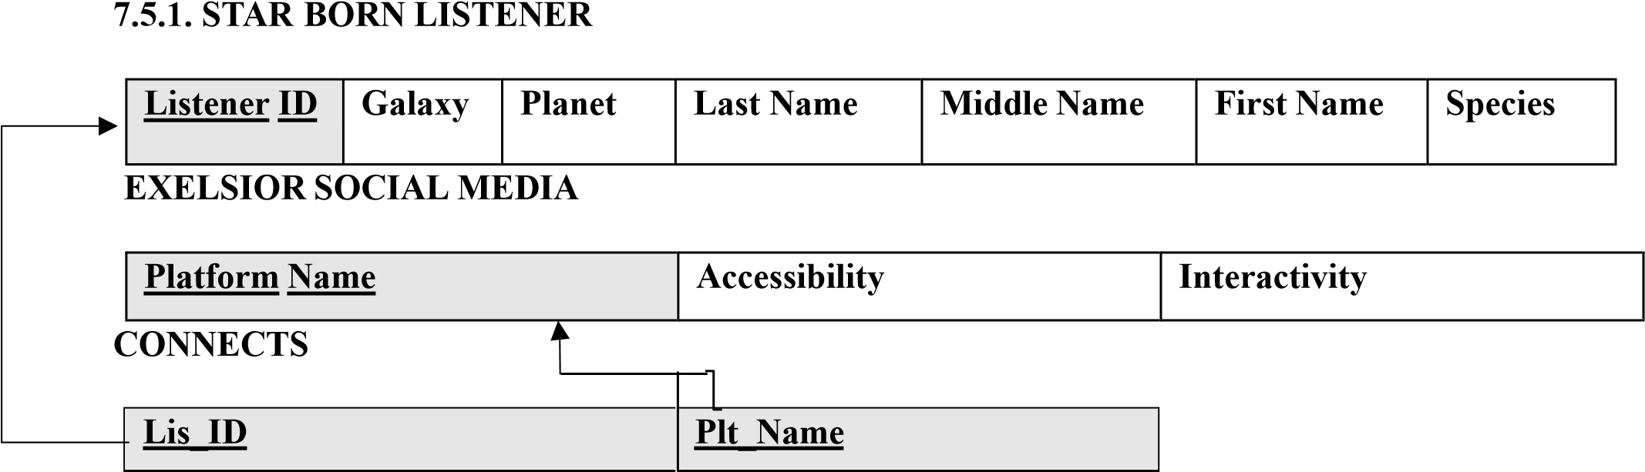

Excelsior social media connects many stars born listeners. Hence, the relationship CONNECTS srequires the creation of a new relation, where both the primary keys of the two participating are included as two foreign keys. We added the primary key of the EXCELSIOR SOCIAL MEDIA entity

(Platform Name) and renamed it (Plt_Name), as well as the primary key of the STARS BORN LISTENER entity (Listener ID) and renamed it (Lis_ID). The combination of both foreign keys represents the primary key of the relation hence both are underlined.

**7.5.2.**

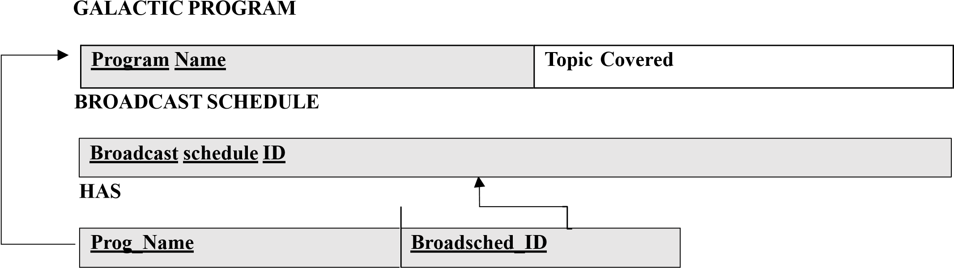

Many galactic programs have many broadcast schedules. Hence, the relationship HAS requires the creation of a new relation, where both the primary keys of the two participating are included as two foreign keys. We added the primary key of the GALACTIC PROGRAM entity (Program Name) and renamed it (Prog_Name), as well as the primary key of the BROADCAST SCHEDULE entity (Broadcast Schedule ID) and renamed it (Brodsched_ID). The combination of both foreign keys represents the primary key of the relation hence both are underline.

**7.5.3.**

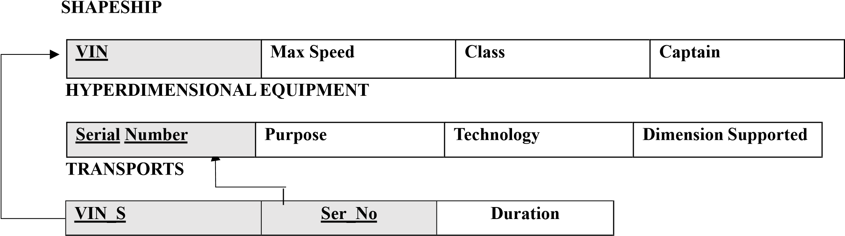

Many spaceships transport many hyperdimensional equipment. Hence, the relationship TRANSPORTS requires the creation of a new relation, where both the primary keys of the two participating are included as two foreign keys. We added the primary key of the SPACESHIP entity (VIN) and renamed it (VIN_S), as well as the primary key of the HYPERDIMENSIONAL EQUIPMENT Entity (Serial Number) and renamed it (Ser_No) in addition to that the table include duration as simple attribute of the transport relation. The combination of both foreign keys represents the primary key of the relation hence both are underlined.

**7.5.4.**

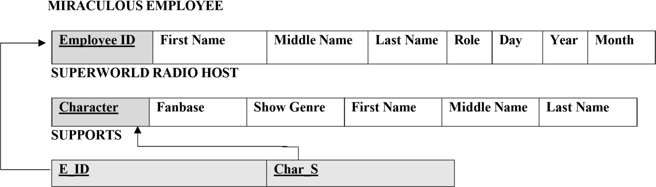

Many super-world radio hosts support many miraculous employees. Hence, the relationship SUPPORTS requires the creation of a new relation, where both the primary keys of the two participating are included as two foreign keys. We added the primary key of the SUPER- WORLD

RADIO HOST entity (Character) and renamed it (Char_ID), as well as the primary key of the

MIRACULOUS EMPLOYEE entity (Employee ID) and renamed it (E_ID). The combination of both foreign keys represents the primary key of the relation hence both are underlined.

**7.5.5.**

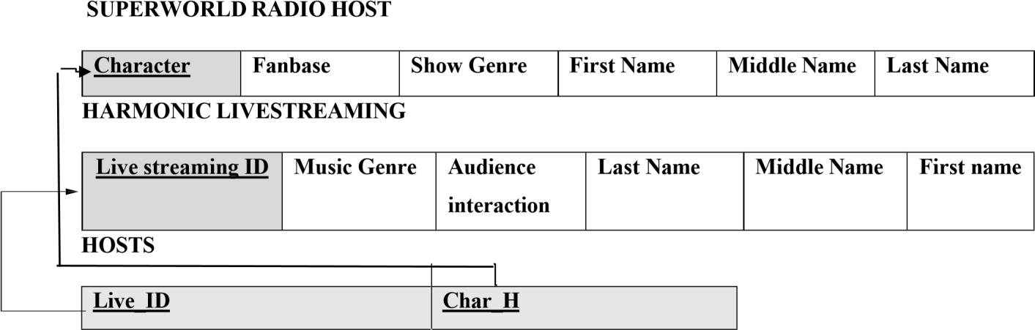

Many super-world radio hosts host many harmonic livestreaming many broadcast schedule. Hence, the relationship HOSTS requires the creation of a new relation, where both the primary keys of the two participating are included as two foreign keys. We added the primary key of the SUPER-WORLD RADIO HOST entity (Character) and renamed it (Char_H), as well as the primary key of the HARMONIC LIVESTREAMING entity (Livestreaming ID) and renamed it (Live_ID). The combination of both foreign keys represents the primary key of the relation hence both are underlined.

**7.5.6.**

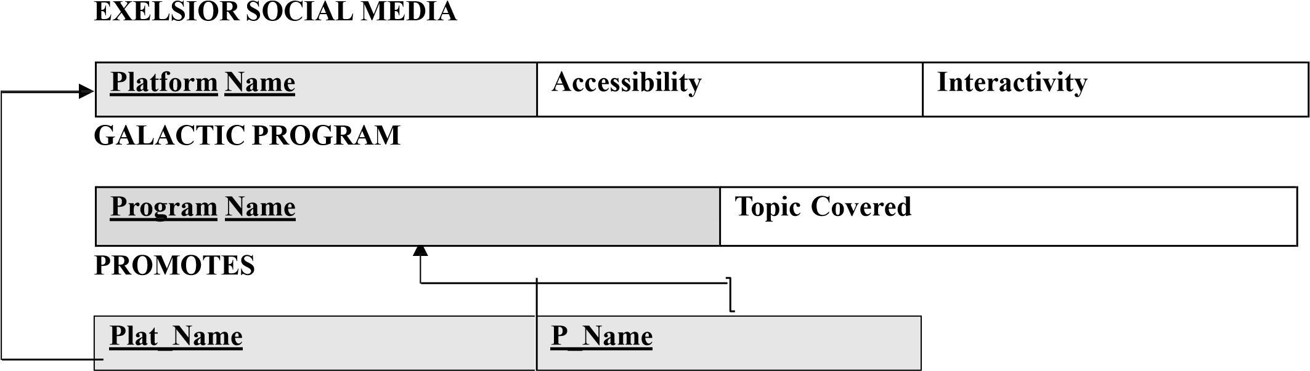

Excelsior social media promotes many galactic programs. Hence, the relationship PROMOTES requires the creation of a new relation, where both the primary keys of the two participating are included as two foreign keys. We added the primary key of the GALACTIC PROGRAM entity (Program Name) and renamed it (P_Name), as well as the primary key of the EXCELSIOR SOCIAL MEDIA entity (Platform Name) and renamed it (Plat_Name). The combination of both foreign keys represents the primary key of the relation hence both are underlined.

**7.5.7.**

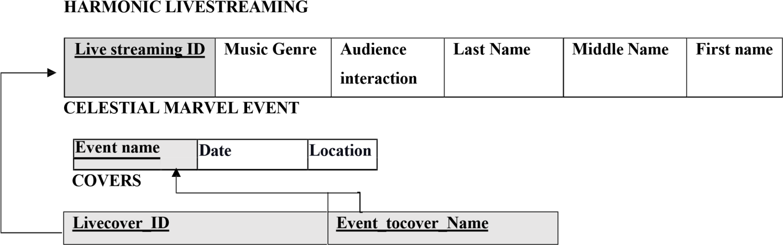

Many harmonic livestreaming covers many celestial marvel event. Hence, the relationship COVERS requires the creation of a new relation, where both the primary keys of the two participating are included as two foreign keys. We added the primary key of the CELESTIAL MARVEL EVENT entity (Event Name) and renamed it (Event_tocover_Name), as well as the primary key of the HARMONIC LIVESTREAMING entity (Livestreaming ID) and renamed it (Livecover_ID). The combination of both foreign keys represents the primary key of the relation hence both are underlined.

**7.5.8.**

# GALACTIC PROGRAM

|  |  |
| --- | --- |
| **Program Name** | **Topic Covered** |

**ADVENTEROUS NEW:**

|  |  |  |  |  |
| --- | --- | --- | --- | --- |
| **Program Name** | **Topic Covered** | **Reporting Style** | **Frequency** | **Anchor** |

# UPDATES

|  |  |
| --- | --- |
| **Adv_Prog_Name** | **TC** |

Many galactic programs update many adventurous news. Hence, the weak relationship

UPDATES requires the creation of a new relation, in which we include the primary key of Galactic Program entity and the partial key of the adventurous news weak entity included as two foreign keys in the table. We added the primary key of the Galactic Program entity (Program Name) and renamed it (Adv_Prog_Name), as well as the partial key of the Adventurous News weak entity (Topic Covered ) and renamed it (TC). The combination of both foreign keys represents the primary key of the relation hence both are underlined.

**7.5.9.**

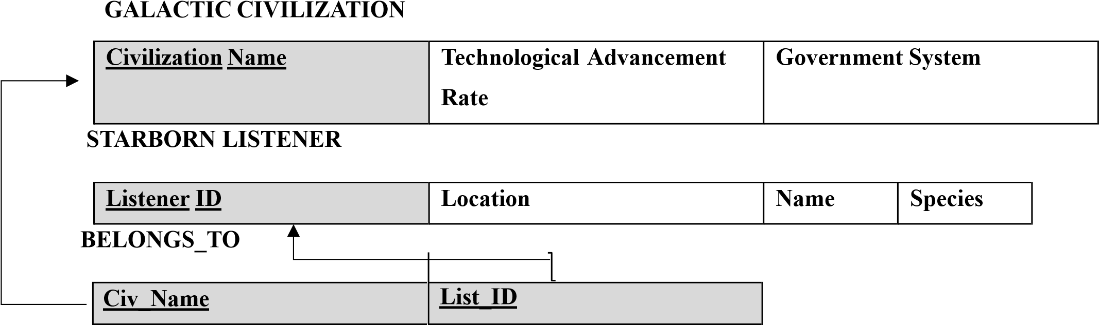

Many galactic civilizations belong to many stars born listener. Hence, the relationship BELONGS TO requires the creation of a new relation, where both the primary keys of the two participating are included as two foreign keys. We added the primary key of the Galactic Civilization entity

(Civilization Name) and renamed it (CivName), as well as the primary key of the STARS BORN LISTENER entity (Listener ID) and renamed it (Lis_ID). The combination of both foreign keys represents the primary key of the relation hence both are underlined.

## 7.6 – Step 6- Mapping of Multi-valued Attributes

Multivalued attributes are often managed by creating an independent table. This table incorporates the primary key of the main entity as a foreign key and stores the diverse attribute values. This process establishes a connection between multiple attribute values and the main entity, linking them to specific tuples through the foreign key.

# 7.6.1. Streaming Platforms

HARMONIC LIVE STREAMING:

|  |  |  |  |
| --- | --- | --- | --- |
| **Livestreaming ID** | **Music Genre** | **Artist** | **Audience Interaction** |

STREAMING PLATFORMS:

|  |  |
| --- | --- |
| **Livestreaming ID** | **Harmonic Streaming**  **Platform** |

The multivalued attribute Harmonic Streaming Platform belongs to the HARMONIC LIVE STREAMING entity. It is represented by creating a relation called **Streaming Platforms**. We added the primary key of the HARMONIC LIVE STREAMING entity as a foreign key (**Livestreaming ID** ).

**7.6.2. BROADCAST SCHEDULE _DAY, BROADCAST SCHEDULE _TIME:**

BROADCAST SCHEDULE:

**Broadcast Schedule ID**

BROADCAST SCHEDULE _DAY:

|  |  |
| --- | --- |
| **Broadcast Schedule ID** | B_day |

The multivalued attribute **BROADCAST SCHEDULE _DAY,** belongs to the HARMONIC

LIVE STREAMING entity. It is represented by creating a relation called **Streaming Platforms**.

We added the primary key of the HARMONIC LIVE STREAMING entity as a foreign key (**Livestreaming ID**).The multivalued attribute B_day belongs to the BROADCAST SCHEDULE entity. It is represented by creating a relation called BROADCAST SCHEDULE _DAY. We added the primary key of the BROADCAST SCHEDULE entity as a foreign key (**Broadcast Schedule ID**).

BROADCAST SCHEDULE _TIME:

|  |  |
| --- | --- |
| **Broadcast Schedule ID** | B_time |

The multivalued attribute B_time belongs to the **BROADCAST SCHEDULE** entity. It is represented by creating a relation called **BROADCAST SCHEDULE _TIME**. We added the primary key of the **BROADCAST SCHEDULE** entity as a foreign key (**Broadcast Schedule**

**ID**).

**7.6.3. EQUIPMENT CAPABILITY:**

**HYPERDIMENSIONAL EQUIPMENT:**

|  |  |  |  |
| --- | --- | --- | --- |
| **Serial Number** | **Purpose** | **Technology** | **Dimension Supported** |

**EQUIPMENT CAPABILITY**

|  |  |
| --- | --- |
| **Serial Number** | **Eq-Capability** |

The multivalued attribute **Eq-Capability** belongs to the **HYPERDIMENSIONAL EQUIPMENT**

entity. It is represented by creating a relation called **EQUIPMENT**

**CAPABILIT**. We added the primary key of the **HYPERDIMENSIONAL EQUIPMENT** entity as a foreign key (**Serial Number)**.

**7.6.4. EXCELSIOR _ FEATURE, EXCELSIOR _ USER BASE:**

**EXCELSIOR SOCIAL MEDIA:**

|  |  |  |
| --- | --- | --- |
| **Platform Name** | **Interactivity** | **Accessibility** |

**EXCELSIOR _ FEATURE:**

|  |  |
| --- | --- |
| **Platform Name** | **E_ Feature** |

The multivalued attribute **E_Feature** belongs to the **EXCELSIOR SOCIAL MEDIA** entity. It is represented by creating a relation called **EXCELSIOR _ FEATURE**. We added the primary key of the **EXCELSIOR SOCIAL MEDIA** entity as a foreign key (**Platform Name)**.

**EXCELSIOR _ USER BASE:**

|  |  |
| --- | --- |
| **Platform Name** | **E_ User Base** |

The multivalued attribute **E_ User Base** belongs to the **EXCELSIOR SOCIAL MEDIA** entity. It is represented by creating a relation called **EXCELSIOR _ USER BASE**. We added the primary key of the **EXCELSIOR SOCIAL MEDIA** entity as a foreign key (**Platform_Name)**.

**7.6.5. EXCLUSIVE FEATURE:**

**ICONIC MUSIC SERVICE:**

|  |  |  |
| --- | --- | --- |
| **Music Service ID** | **Music Catalog** | **Subscription Tier** |

**EXCLUSIVE FEATURE:**

|  |  |
| --- | --- |
| **Music Service ID** | **Exclusive Feature** |

The multivalued attribute **Exclusive Feature** belongs to the **ICONIC MUSIC SERVICE** entity. It is represented by creating a relation called **EXCLUSIVE FEATURE.** We added the primary key of the **ICONIC MUSIC SERVICE** entity as a foreign key (**Music Service ID)**.

## 7.7 – Step 7 – Mapping of N-ary attributes

In case a relationship encompasses more than two participating entities, a new relation must be created to represent it. The primary key of the relation of each participating entity type is included as a foreign key attribute in the new relation. The relation should also include any simple or composite attributes that the N-ary relationship type might have.

Our ER diagram did not require the implementation of any N-ary relationship types. Thus, this step was not used.

**7.8 – Step 8 – Mapping aggregation, specialization relationships**

We didn’t use this step in our mapping process.

# 8.Final Display – all tables HARMONIC LIVESTREAMING

|  |  |  |  |  |  |
| --- | --- | --- | --- | --- | --- |
| **Live streaming ID** | **Music**  **Genre** | **Audience interaction** | **Last Name** | **Middle Name** | **First name** |

# CELESTIAL MARVEL EVENT

|  |  |  |  |
| --- | --- | --- | --- |
| **Event name** | **Galaxy** | **Planet** | **Date** |
|  |

# HOSTS

|  |  |
| --- | --- |
| **Live ID** | **Char H** |



**COVERS**



**Livecove**

**r_ID**



**Event_tocover_**



**Name**



# STREAMING PLATFORM

|  |  |
| --- | --- |
| **Livestreaming ID** | **Harmonic Streaming Platform** |

# GALACTIC CIVILIZATION

|  |  |  |
| --- | --- | --- |
| **Civilization Name** | **Technological Advancement Rate** | **Government System** |

# BELONGS_TO

|  |  |
| --- | --- |
| **CIV_NAME** | **List _ID** |

# MARVELEOUS QUEST

|  |  |  |  |  |  |
| --- | --- | --- | --- | --- | --- |
| **SQ ID** | **Quest Name** | **Difficulty** | **Reward** | **Duration** | **AI_Name** |

# STAR BORN LISTENER

|  |  |  |  |  |  |  |
| --- | --- | --- | --- | --- | --- | --- |
| **Listener ID** | **Galaxy** | **Planet** | **Last Name** | **Middle Name** | **First Name** | **Species** |

# CONNECTS

|  |  |
| --- | --- |
| Lis_ID | Plt_Name |

# EXELSIOR SOCIAL MEDIA

|  |  |  |
| --- | --- | --- |
| **Platform Name** | **Accessibility** | **Interactivity** |

# PROMOTES

|  |  |
| --- | --- |
| Plat_Name | P_Name |

# GALACTIC PROGRAM

|  |  |
| --- | --- |
| **Program Name** | **Topic Covered** |

# UPDATES

|  |  |
| --- | --- |
| **Adv_Prog_Name** | **TC** |

# SHAPESHIP

|  |  |  |  |
| --- | --- | --- | --- |
| **VIN** | **Max Speed** | **Class** | **Captain** |

# TRANSPORTS

|  |  |  |
| --- | --- | --- |
| **Ser_NO** | **VIN_S** | **Duration** |

# SUPERWORLD RADIO HOST

|  |  |  |  |  |  |
| --- | --- | --- | --- | --- | --- |
| **Character** | **Fanbase** | **Show Genre** | **First Name** | **Middle Name** | **Last Name** |

# SUPPORTS

|  |  |
| --- | --- |
| **E_ID** | **Char_S** |

# MIRACULOUS EMPLOYEE

|  |  |  |  |  |  |
| --- | --- | --- | --- | --- | --- |
| **Employee ID** | **First**  **Name** | **Middle**  **Name** | **Last**  **Name** | **Role** | **Birthdate** |

# HYPERDIMENSIONAL EQUIPMENT

|  |  |  |  |
| --- | --- | --- | --- |
| **Serial Number** | **Purpose** | **Technology** | **Dimension Supported** |

# MARVELEOUS_MIXTAPE

|  |  |  |  |  |  |  |  |  |
| --- | --- | --- | --- | --- | --- | --- | --- | --- |
| **Mixtape ID** | **First Name** | **Middle**  **Name** | **Last Name** | **Genre** | **Track**  **list** | **Release**  **Date** | **MID** | **CharM** |

# BROADCAST SCHEDULE

**Broadcast schedule ID**

# HAS

|  |  |
| --- | --- |
| **Prog Name** | **Broadsched ID** |

# ICONIC MUSIC SERVICE

|  |  |  |
| --- | --- | --- |
| **Music Service ID** | **Subscription Teir** | **Music Catalog** |

# MARVEL AI ASSISTANT

|  |  |  |  |
| --- | --- | --- | --- |
| **Name** | **Integration With Device** | **Voice** | **Function** |

# GALACTIC AD

|  |  |  |  |  |  |
| --- | --- | --- | --- | --- | --- |
| **EA Name** | **Ad ID** | **Product/Service** | **Target**  **Audience** | **Slogan** | **Duration** |

# DYNAMIC SHOW

|  |  |  |  |
| --- | --- | --- | --- |
| **Show ID** | **Viewer Rating** | **Genre** | **Show Name** |

**ADVENTEROUS NEW**

|  |  |  |  |  |
| --- | --- | --- | --- | --- |
| **Program_Name** | **Topic Covered** | **Reporting Style** | **Frequency** | **Anchor** |

**BROADCAST SCHEDULE _DAY**

|  |  |
| --- | --- |
| **Broadcast Schedule ID** | B_day |

**BROADCAST SCHEDULE_TIME**

|  |  |
| --- | --- |
| **Broadcast Schedule ID** | B_Time |

**EQUIPMENT CAPABILITY**

|  |  |
| --- | --- |
| **Serial Number** | **Eq-Capability** |

**EXCELSIOR _ FEATURE**

|  |  |
| --- | --- |
| **Platform Name** | **E_ Feature** |

**EXCELSIOR _ USER BASE:**

|  |  |
| --- | --- |
| **Platform Name** | **E_ User Base** |

**EXCLUSIVE FEATURE:**

|  |  |
| --- | --- |
| **Music Service ID** | **Exclusive Feature** |

## 9. Tables States

**9.1**

# HARMONIC LIVESTREAMING

|  |  |  |  |  |  |
| --- | --- | --- | --- | --- | --- |
| **Livestreaming_ID** | **Music_Genre** | **Audience_interaction** | **First_ name** | **Middle_Name** | **Last_Name** |
| 001 | Space Ambient | High | Johnson | Andrew | David |
| 002 | Sci-Fi Rock | Medium | Smith | Benjamin | Emily |
| 003 | Galactic Jazz | Low | Anderson | Carter | Michael |
| 004 | Alien Pop | High | Davis | Daniel | Sophia |
| 005 | Cosmic EDM | Medium | Patel | Elijah | Aiden |
| 006 | Astro Metal | Low | Wang | Finn | Olivia |
| 007 | Intergalactic | High | Kim | Grace | Ethan |
| 008 | Nebula Blues | Medium | Rodriguez | Rodriguez | Mia |
| 009 | Star Pop | Low | Lee | Isabella | Liam |
| 010 | Quantum Rock | High | Turner | Turner | Ava |

**9.2**

# CELESTIAL MARVEL EVENT

|  |  |  |  |
| --- | --- | --- | --- |
| **Universal_Ceremony** | **Occurrence_date** | **Galaxy** | **Planet** |
| Cosmic Convergence | 11/15/2023 | Andromeda | Nova Prime |
| Galactic Nexus | 03/02/2024 | Triangulum | Celestoria |
| Starfall Spectacle | 07/20/2024 | Milky Way | Earth |
| Nebula Unveiling | 10/12/2024 | Centaurus A | Zenithar |
| Celestial Harmony | 02/05/2025 | Magellanic Cloud | Seraphion |
| Quantum Revelation | 09/09/2025 | Pegasus | Astralis |
| Infinity Eclipse | 06/18/2025 | Virgo Supercluster | Galactica |
| Stellar Odyssey | 01/22/2026 | Hercules | Starhaven |
| Nebula Fusion | 08/07/2026 | Hydra | Nebulon |
| Cosmic Ascendance | 05/14/2026 | Phoenix Cluster | Celestialis |

**9.3**

# HOSTS

|  |  |
| --- | --- |
| **Char_H** | **Live_ID** |
| Galaxy Explorer | 001 |
| Nebula Navigator | 002 |
| Cosmic DJ | 003 |
| Astro Ambassador | 004 |
| Galactic Guru | 005 |
| Celestial Choreographer | 006 |
| Orbiting Oracle | 007 |
| Space Siren | 008 |
| Cosmic Communicator | 009 |
| Solar Serenader | 010 |

**9.4**

# COVERS

|  |  |
| --- | --- |
| **Livecover_ID** | **Event_tocover_Name** |
| 001 | Cosmic Convergence |
| 002 | Galactic Nexus |
| 003 | Starfall Spectacle |
| 004 | Nebula Unveiling |
| 005 | Celestial Harmony |
| 006 | Quantum Revelation |
| 007 | Infinity Eclipse |
| 008 | Stellar Odyssey |
| 009 | Nebula Fusion |
| 010 | Cosmic Ascendance |

**9.5**

# GALACTIC CIVILIZATION

|  |  |  |
| --- | --- | --- |
| **Civilization_Name** | **Technological_Advancement_Rate** | **Government_System** |
| Celestial Alliance | High | Federal Republic |
| Quantum Dominion | Medium | Technocratic Oligarchy |
| Starlight Consortium | Very High | Democratic Confederation |
| Nebula Empire | Low | Authoritarian Monarchy |
| Cosmic Federation | Very High | Parliamentary Democracy |
| Galactic Union | Medium | Unitary Socialist State |
| Interstellar Republic | High | Federal Parliamentary Republic |
| Astral Hegemony | Low | Totalitarian Oligarchy |
| Nova Commonwealth | Very High | Democratic Federalism |
| Nebula Ascendancy | Medium | Corporate Plutocracy |

**9.6**

# STREAMING PLATFORM

|  |  |
| --- | --- |
| **Livestreaming_ID** | **Harmonic_Streaming_Platform** |
| 001 | Spotify |
| 002 | Apple Music |
| 003 | Slacker Radio |
| 004 | SoundCloud |
| 005 | Deezer |
| 006 | Tidal |
| 007 | Amazon Music |
| 008 | Last.fm |
| 009 | Angami |
| 010 | Google Play Music |

**9.7**

# BELONGS_TO

|  |  |
| --- | --- |
| **CivName** | **List_ID** |
| Celestial Alliance | 7532 |
| Quantum Dominion | 4198 |
| Starlight Consortium | 1265 |
| Nebula Empire | 8954 |
| Cosmic Federation | 6321 |
| Galactic Union | 3076 |
| Interstellar Republic | 5489 |
| Astral Hegemony | 1823 |
| Nova Commonwealth | 9743 |
| Nebula Ascendancy | 6904 |

**9.8**

# CONNECTS

|  |  |
| --- | --- |
| **Lis_ID** | **Plt_Name** |
| 7532 | Galactic Tunes |
| 4198 | Astro Podcast Network |
| 1265 | Cosmic Chatter |
| 8954 | Star Jams Radio |
| 6321 | Nebula News Feed |
| 3076 | Interstellar Gram |
| 5489 | Space Book |
| 1823 | Celestial Snap |
| 9743 | Galaxy Pods |
| 6904 | Stellar Social |

**9.9**

# STAR BORN LISTENER

|  |  |  |  |  |  |  |
| --- | --- | --- | --- | --- | --- | --- |
| **Listener_ID** | **Galaxy** | **Planet** | **First_Name** | **Middle_Name** | **Last_Name** | **Species** |
| 7532 | Andromeda | Nova  Prime | Johnson | Amelia | Sophia | Human |
| 4198 | Triangulum | Celestoria | Smith | Benjamin | Ethan | Xelion |
| 1265 | Milky Way | Earth | Anderson | Carter | Liam | Terran |
| 8954 | Centaurus  A | Zenithar | Davis | Daniel | Ava | Zepharian |
| 6321 | Magellanic  Cloud | Seraphion | Patel | Elijah | Olivia | Celestian |
| 3076 | Pegasus | Astralis | Wang | Finn | Noah | Aquarian |
| 5489 | Virgo  Supercluster | Galactica | Kim | Grace | Mia | Lumarian |
| 1823 | Hercules | Starhaven | Rodriguez | Henry | Elijah | Solarian |
| 9743 | Hydra | Nebulon | Lee | Isabella | Draconian | Draconian |
| 6904 | Phoenix  Cluster | Celestialis | Turner | | James | Aiden | Orionian |

**9.10**

# MARVELEOUS QUEST

|  |  |  |  |  |  |
| --- | --- | --- | --- | --- | --- |
| **SQ_ID** | **Quest_Name** | **Difficulty** | **Reward** | **Duration** | **AI_Name** |
| 101 | Cosmic Conundrum | Medium | 150 Galactic  Credits | 2.5 hours | Puzzle Master AI |
| 102 | Starship Racing  Challenge | Easy | 120 Galactic  Credits | 2 hours | Racer Bot |
| 103 | Exoplanet Exploration | Hard | 250 Galactic  Credits | 3.5 hours | Explorer AI |
| 104 | Astrobiology  Adventure | Medium | 180 Galactic  Credits | 2.5 hours | Bio Bot |
| 105 | Cosmic Art Gallery  Tour | Easy | 100 Galactic  Credits | 1.5 hours | Art Guide AI |
| 106 | Galactic Codebreaker  Challenge | Hard | 300 Galactic  Credits | 4 hours | Code breaker AI |
| 107 | Nebula Navigation  Quest | Medium | 200 Galactic  Credits | 3 hours | Navigator Bot |
| 108 | Star Wars Simulation | Easy | 500 Galactic  Credits | 5 hours | Simulation Master  AI |
| 109 | Quantum Physics  Expedition | Hard | 280 Galactic  Credits | 4 hours | Quantum Explorer  AI |
| 110 | Black Hole Mysteries | Hard | 400 Galactic  Credits | 4.5 hours | Astro Physici |

**9.11**

# EXELSIOR SOCIAL MEDIA

|  |  |  |
| --- | --- | --- |
| **Platform_Name** | **Accessibility** | **Interactivity** |
| **Galactic Tunes** | Inclusive | High |
| **Astro Podcast Network** | Accessible | Medium |
| **Cosmic Chatter** | Universal | Very High |
| **Star Jams Radio** | Inclusive | High |
| **Nebula News Feed** | Accessible | Medium |
| **Interstellar Gram** | Universal | Very High |
| **Space Book** | Inclusive | High |
| **Celestial Snap** | Accessible | Medium |
| **Galaxy Pods** | Universal | Very High |
| **Stellar Social** | Inclusive | High |

**9.12**

# PROMOTES

|  |  |
| --- | --- |
| **Plat_Name** | **P_Name** |
| Galactic Tunes | Stellar Exploration |
| Astro Podcast Network | Alien Jams |
| Cosmic Chatter | Space Talk |
| Star Jams Radio | Astro Sounds |
| Nebula News Feed | Cosmic Conversations |
| Interstellar Gram | Galactic Grooves |
| Space Book | Universal News |
| Celestial Snap | Quantum Quasar |
| Galaxy Pods | Solar Sermons |
| Stellar Social | Interstellar Interviews |

**9.13**

# GALACTIC PROGRAM

|  |  |
| --- | --- |
| **Program_Name** | **Topic_Covered** |
| Stellar Exploration | Space Exploration |
| Alien Jams | Extraterrestrial Music |
| Space Talk | Celestial Conversations |
| Astro Sounds | Space-Themed Music |
| Cosmic Conversations | General Cosmic Discussions |
| Galactic Grooves | Funky Beats from the Cosmos |
| Universal News | Interstellar News Updates |
| Quantum Quasar | Quantum Physics Exploration |
| Solar Sermons | Sun and Solar System Topics |
| Interstellar Interviews | Interviews with Space Experts |

**9.14**

# UPDATES

|  |  |
| --- | --- |
| **Adv_Prog_Name** | **TC** |
| Stellar Exploration | Space Exploration |
| Alien Jams | Extraterrestrial Music |
| Space Talk | Celestial Conversations |
| Astro Sounds | Space-Themed Music |
| Cosmic Conversations | General Cosmic Discussions |
| Galactic Grooves | Funky Beats from the Cosmos |
| Universal News | Interstellar News Updates |
| Quantum Quasar | Quantum Physics Exploration |
| Solar Sermons | Sun and Solar System Topics |
| Interstellar Interviews | Interviews with Space Experts |

**9.15**

# SUPERWORLD RADIO HOST

|  |  |  |  |  |  |
| --- | --- | --- | --- | --- | --- |
| **Character** | **Fanbase** | **Show_Genre** | **First_Name** | **Middle_Name** | **Last_Name** |
| Galaxy  Explorer | Galaxy  Explorer | Exploration  Jams | Galax | Epsilon | Explorer |
| Nebula  Navigator | Nebula  Navigator | Celestial  Beats | Nebula | Nova | Navigator |
| Cosmic DJ | Cosmic DJ | Cosmic  Mixology | Cosmic | Delta | DJ |
| Astro  Ambassador | Solar  Serenader | Solar  Serenades | Solar | Sigma | Serenader |
| Galactic Guru | Quantum  Quasar | Quantum  Waves | Quantum | Quasar | Quasar |
| Celestial  Choreographer | Celestial DJ | Starry  Rhythms | Celestial | - | DJ |
| Orbiting  Oracle | Astro  Ambassador | Space  Diplomacy | Astro | Alpha | Ambassador |
| Space Siren | Starlight  Serenade | 29 | Non-binary | Pluto | 108 |
| Cosmic  Communicator | Orion  Observer | 41 | Male | Neptune | 109 |

**9.16**

# SUPPORTS

|  |  |
| --- | --- |
| **E_ID** | **Char_ID** |
| 7823 | Galaxy Explorer |
| 5981 | Nebula Navigator |
| 2345 | Cosmic DJ |
| 8762 | Astro Ambassador |
| 1098 | Galactic Guru |
| 4567 | Celestial Choreographer |
| 3210 | Orbiting Oracle |
| 7890 | Space Siren |
| 5432 | Cosmic Communicator |
| 9876 | Solar Serenader |

**9.17**

# BROADCAST SCHEDULE

|  |
| --- |
| **Broadcast_Schedule_ID** |
| 101 |
| 102 |
| 103 |
| 104 |
| 105 |
| 106 |
| 107 |
| 108 |
| 109 |
| 110 |

## 9.18 MARVELEOUS_MIXTAPE

|  |  |  |  |  |  |  |  |  |
| --- | --- | --- | --- | --- | --- | --- | --- | --- |
| **Mixtape_ID** | **First_Name** | **Middle_Name** | **Last_Name** | **Genre** | **Track_List** | **Release_Date** | **MID** | **CharM** |
| 301 | Cosmic | Harmony | Explorer | Space  Beats | Celestial  Groove | 2023-05-15 | 101 | Galaxy  Explorer |
| 302 | Nebula | Stellar | Serenader | Astro  Jazz | Nebula  Nights | 2023-04-20 | 102 | Nebula  Navigator |
| 303 | Galactic | Rhythms | Voyager | Cosmic  EDM | Interstellar  Vibes | 2023-03-10 | 103 | Cosmic DJ |
| 304 | Solar | Harmony | Melodies | Solar Pop | Solar Serenade | 2023-06-05 | 104 | Astro  Ambassador |
| 305 | Quantum | Sonic | Quasar | Quantum  Beats | Quantum  Leap | 2023-02-25 | 105 | Galactic Guru |
| 306 | Celestial | Radiance | DJ | Celestial  Mix | Celestial  Harmony | 2023-07-12 | 106 | Celestial  Choreographer |
| 307 | Astro | Ambiance | Ambassador | Galactic  Lounge | Cosmic  Chill | 2023-08-18 | 107 | Orbiting  Oracle |
| 308 | Starlight | Serenade | DJ | Cosmic  Ballads | Starry  Serenity | 2023-09-29 | 108 | Space Siren |
| 309 | Orion | Cosmic | Observer | Stellar  Rock | Orion's  Odyssey | 2023-11-05 | 109 | Cosmic  Communicator |
| 310 | Galactic | Grooves | Guru | Space  Funk | Galactic  Groove | 2023-10-15 | 110 | Solar  Serenader |

**9.19**

# SHAPESHIP

|  |  |  |  |
| --- | --- | --- | --- |
| **VIN** | **Max_Speed** | **Class** | **Captain** |
| 123456789 | 9.5 | Cruiser | Stellar |
| 987654321 | 8.2 | Fighter | Nebula |
| 456789012 | 7.1 | Explorer | Galaxy |
| 789012345 | 9.0 | Frigate | Orion |
| 234567890 | 8.8 | Transporter | Celestial |
| 567890123 | 6.5 | Scout | Nova |
| 890123456 | 9.7 | Battleship | Cosmic |
| 345678901 | 7.9 | Corvette | Astro |
| 678901234 | 8.5 | Carrier | Stardust |
| 012345678 | 9.3 | Dreadnought | Infinity |

**9.20**

# TRANSPORTS

|  |  |  |
| --- | --- | --- |
| **Ser_No** | **VIN_S** | **Duration** |
| 123456 | 123456789 | 2 hours |
| 789012 | 987654321 | 3 hours |
| 345678 | 456789012 | 1.5 hours |
| 901234 | 789012345 | 4 hours |
| 567890 | 234567890 | 2.5 hours |
| 234567 | 567890123 | 1 hour |
| 890123 | 890123456 | 3.5 hours |
| 456789 | 345678901 | 2 hours |
| 012345 | 678901234 | 5 hours |
| 678901 | 012345678 | 4.5 hours |

**9.21**

# MIRACULOUS EMPLOYEE

|  |  |  |  |  |  |
| --- | --- | --- | --- | --- | --- |
| **Employee_ID** | **FirstName** | **MiddleName** | **LastName** | **Role** | **Birthday_Date** |
| 7823 | John | Alexander | Doe | Manager | 05/15/90 |
| 5981 | Jane | Benjamin | Smith | Engineer | 09/20/85 |
| 2345 | Robert | Charles | Johnson | Analyst | 03/12/88 |
| 8762 | Emily | Daniel | Davis | Designer | 11/28/92 |
| 1098 | Michael | Elijah | Anderson | Developer | 07/05/84 |
| 4567 | Olivia | Finn | Wilson | Manager | 02/18/95 |
| 3210 | Ethan | Gabriel | Brown | Engineer | 06/30/87 |
| 7890 | Sophia | Henry | Miller | Analyst | 09/14/93 |
| 5432 | Liam | Isaac | Taylor | Designer | 12/03/89 |
| 9876 | Ava | James | Martinez | Developer | 04/22/98 |

**9.22**

# MARVEL AI ASSISTANT

|  |  |  |  |
| --- | --- | --- | --- |
| **Name** | **Integration_With_Device** | **Voice** | **Function** |
| Jarvis 2.0 | Smartphones, Smart Homes | Yes | Personal Assistant |
| Stark AI | Wearables, IoT Devices | Yes | Home Automation, Alerts |
| Thor's Companion | Smart Glasses, Vehicles | Yes | Navigation, Assistance |
| Black Widow Helper | Laptops, Smartphones | Yes | Security, Information |
| Hulk Voice | Smart Speakers, TVs | Yes | Entertainment, Control |
| Spider AI | Smartwatches, Cameras | Yes | Surveillance, Reminders |
| Captain Command | Tablets, Smart Appliances | Yes | Task Management |
| Doctor Strange Voice | VR Headsets, AR Devices | Yes | Virtual Assistance |
| Black Panther AI | Gaming Consoles, Cars | Yes | Gaming Tips, Driving |
| Iron Man Innovator | Smart Wearables, Drones | Yes | Innovation, Exploration |

**9.23**

# GALACTIC AD

|  |  |  |  |  |  |
| --- | --- | --- | --- | --- | --- |
| **EA** | **Ad_ID** | **Product_Service** | **Target_Audience** | **Slogan** | **Duration** |
| Cosmic  Convergence | 123001 | Hyperdrive Engines | Hyperdrive Engines | "Zoom Across the Cosmos!" | 30 seconds |
| Galactic Nexus | 456002 | Alien Cuisine | Alien Cuisine | "Taste the Flavors of Vega!" | 15 seconds |
| Starfall  Spectacle | 789003 | Celestial Fashion | Celestial Fashion | "Dress like a Star!" | 45 seconds |
| Nebula  Unveiling | 234004 | Quantum Computers | Quantum Computers | "Empowering Your Galaxy!" | 60 seconds |
| Celestial  Harmony | 567005 | Nebula Cruise Lines | Nebula Cruise Lines | "Sail Through Nebulae!" | 90 seconds |
| Quantum  Revelation | 890006 | Astro Photography | Astro Photography | "Capture the Beauty  Beyond!" | 20 seconds |
| Infinity Eclipse | 123007 | Galactic Fitness Gear | Galactic Fitness  Gear | "Train Like a Cosmic  Warrior" | 40 seconds |
| Stellar Odyssey | 456008 | Starlight Resorts | Starlight Resorts | "Experience Stellar Luxury!" | 75 seconds |
| Nebula Fusion | 789009 | Alien Pet Supplies | Alien Pet Supplies | "Spoil Your Space | 30 seconds |
|  |  |  |  | Companions!" |  |
| Cosmic  Ascendance | 234010 | Quantum Music  Streaming | Quantum Music  Streaming | "Harmonies Across  Galaxies!" | 45 seconds |

**9.24**

# ICONIC MUSIC SERVICE

|  |  |  |
| --- | --- | --- |
| **Music_Service_ID** | **Subscription_Tier** | **Music_Catalog** |
| 101 | 001 | Celestial Sounds Collection |
| 102 | 002 | Galactic Grooves Playlist |
| 103 | 003 | Nebula Beats Mixtape |
| 104 | 004 | Solar Serenades Selection |
| 105 | 005 | Quantum Quasar Jams |
| 106 | 006 | Cosmic Harmony Library |
| 107 | 007 | Stellar Serenade Playlist |
| 108 | 008 | Astro Ambient Melodies |
| 109 | 009 | Lunar Lullabies Collection |
| 110 | 010 | Universal Uplift Mix |

**9.25**

# DYNAMIC SHOW

|  |  |  |  |
| --- | --- | --- | --- |
| **Show_ID** | **Viewer_Rating** | **Genre** | **Show_Name** |
| 101 | 4.5 | Space Exploration | "Galactic Odyssey" |
| 102 | 4.2 | Cosmic Talk | "Celestial Conversations" |
| 103 | 4.8 | Intergalactic Beats | "Quantum Groove Lounge" |
| 104 | 4.0 | Sci-Fi Comedy | "Astro Laughs" |
| 105 | 4.6 | Alien Adventures | "Stellar Encounters" |
| 106 | 4.3 | Astro Educational | "Cosmic Insights" |
| 107 | 4.9 | Galactic Mysteries | "Orion's Enigma" |
| 108 | 4.1 | Cosmic Fitness | "Galaxy Fit Workout" |
| 109 | 4.7 | Space News Update | "Universal Briefing" |
| 110 | 4.4 | Celestial Cooking | "Galactic Gastronomy" |

**9.26**

# ADVENTEROUS NEW

|  |  |  |  |  |
| --- | --- | --- | --- | --- |
| **Program_Name** | **Topic_Covered** | **Reporting_Style** | **Frequency** | **Anchor** |
| Stellar Exploration | Space Exploration | Space Explorations | Daily | Stella Starlight |
| Alien Jams | Extraterrestrial Music | Alien Discoveries | Weekly | Nova Navigator |
| Space Talk | Celestial Conversations | Cosmic Wonders | Bi-weekly | Celestial Voyager |
| Astro Sounds | Space-Themed Music | Intergalactic  Mysteries | Daily | Orion Observer |
| Cosmic  Conversations | General Cosmic  Discussions | Stellar Events | Monthly | Solar Serenader |
| Galactic Groove | Funky Beats from the  Cosmos | Galactic Expeditions | Weekly | Nebula Navigator |
| Universal News | Interstellar News  Updates | Astro Highlights | Daily | Astro Ambassador |
| Quantum Quasar | Quantum Physics  Exploration | Celestial Phenomena | Bi-weekly | Starlight Serenade |
| Solar Sermons | Sun and Solar System  Topics | Universal  Discoveries | Weekly | Quantum Quasar |
| Interstellar  Interviews | Interviews with Space  Experts | Cosmic Chronicles | Monthly | Celestial DJ |

**9.27 EXCLUSIVE FEATURE**

|  |  |
| --- | --- |
| **Music_Service_ID** | **Exclusive_Feature** |
| 101 | Artist Collaborations, High-Fidelity Audio |
| 102 | Personalized Playlists, Offline Listening |
| 103 | Live Concert Streaming, Exclusive Interviews |
| 104 | AI-generated Playlists, Lyrics Integration |
| 105 | Customizable Radio Stations, Early Releases |
| 106 | Virtual Reality Concerts, Enhanced Lyrics |
| 107 | Curated Theme Playlists, Behind-the-Scenes |
| 108 | Social Music Sharing, Immersive Soundscapes |
| 109 | Playlist Recommendations, 360° Audio |
| 110 | AI-driven Music Discovery, Limited Editions |

## 9.28

**EXCELSIOR _ USER BASE**

|  |  |
| --- | --- |
| **Platform_Name** | **E_User_Base** |
| Galactic Tunes | 500,000 |
| Astro Podcast Network | 300,000 |
| Cosmic Chatter | 700,000 |
| Star Jams Radio | 1,200,000 |
| Nebula News Feed | 800,000 |
| Interstellar Gram | 1,500,000 |
| Space Book | 2,000,000 |
| Celestial Snap | 1,000,000 |
| Galaxy Pods | 400,000 |
| Stellar Social | 1,800,000 |

**9.29**

# HAS

|  |  |
| --- | --- |
| **Prog_Name** | **BroadSched_ID** |
| Stellar Exploration | 101 |
| Alien Jams | 102 |
| Space Talk | 103 |
| Astro Sounds | 104 |
| Cosmic Conversations | 105 |
| Galactic Grooves | 106 |
| Universal News | 107 |
| Quantum Quasar | 108 |
| Solar Sermons | 109 |
| Interstellar Interviews | 110 |

**9.30**

# BROADCAST SCHEDULE_DAY

|  |  |
| --- | --- |
| **Broadcast_Schedule_ID** | **B_day** |
| 101 | Monday |
| 102 | Tuesday |
| 103 | Wednesday |
| 104 | Thursday |
| 105 | Friday |
| 106 | Saturday |
| 107 | Sunday |
| 108 | Monday |
| 109 | Tuesday |
| 110 | Wednesday |

**9.31**

# BROADCAST SCHEDULE_TIME

|  |  |
| --- | --- |
| **Broadcast_Schedule_ID** | **B_Time** |
| 101 | 08:00 AM |
| 102 | 02:30 PM |
| 103 | 11:00 AM |
| 104 | 06:45 PM |
| 105 | 04:15 PM |
| 106 | 10:30 AM |
| 107 | 09:00 AM |
| 108 | 07:30 PM |
| 109 | 05:45 AM |
| 110 | 03:00 PM |

**9.32**

# EQUIPMENT CAPABILITY

|  |  |
| --- | --- |
| **Serial_Number** | **Eq_Capability** |
| 123456 | Hyperdimensional Scanner |
| 789012 | Quantum Data Processor |
| 345678 | Celestial Audio Mixer |
| 901234 | Nebula Visualizer |
| 567890 | Astro Frequency Analyzer |
| 234567 | Galactic Communication Array |
| 890123 | Solar Energy Converter |
| 456789 | Quantum Entanglement Transmitter |
| 012345 | Celestial Imaging Device |
| 678901 | Stellar Navigation System |

**9.33**

# EXCELSIOR_FEATURE

|  |  |
| --- | --- |
| **Platform_Name** | **E_Feature** |
| Galactic Tunes | Customized Space Playlists |
| Astro Podcast Network | In-Depth Astrological Discussions |
| Cosmic Chatter | Live Cosmic Conversations |
| Star Jams Radio | Celestial Music Discoveries |
| Nebula News Feed | Real-Time Galactic Updates |
| Interstellar Gram | Stunning Space Photography |
| Space Book | Interconnected Galactic Community |
| Celestial Snap | Instant Cosmic Moments Sharing |
| Galaxy Pods | Interstellar Podcast Streaming |
| Stellar Social | Dynamic Cosmic Social Hub |

**9.34**

# HYPERDIMENSIONAL EQUIPMENT

|  |  |  |  |
| --- | --- | --- | --- |
| **Serial_Number** | **Purpose** | **Technology** | **Dimension_Supported** |
| 123456 | Quantum Communication | Entanglement Transceiver | 4D |
| 789012 | Interdimensional Gateway | Spatial Warping Module | 5D |
| 345678 | Temporal Manipulation | Chrono-Sync Processor | 6D |
| 901234 | Multiverse Exploration | Hyperphase Resonator | 7D |
| 567890 | Dimensional Energy Harvesting | Quantum Flux Extractor | 3D |
| 234567 | Parallel Reality Viewer | Holographic Interface | 5D |
| 890123 | Cosmic Energy Amplification | Quantum Infusion Core | 6D |
| 456789 | Hyperdimensional Defense | Reality Shield Generator | 5D |
| 012345 | Infinite Knowledge Matrix | Neural Quantum Processor | 7D |
| 678901 | Intergalactic Teleportation | Wormhole Generator | 6D |

## 10. Edited ER Diagram for Phase III

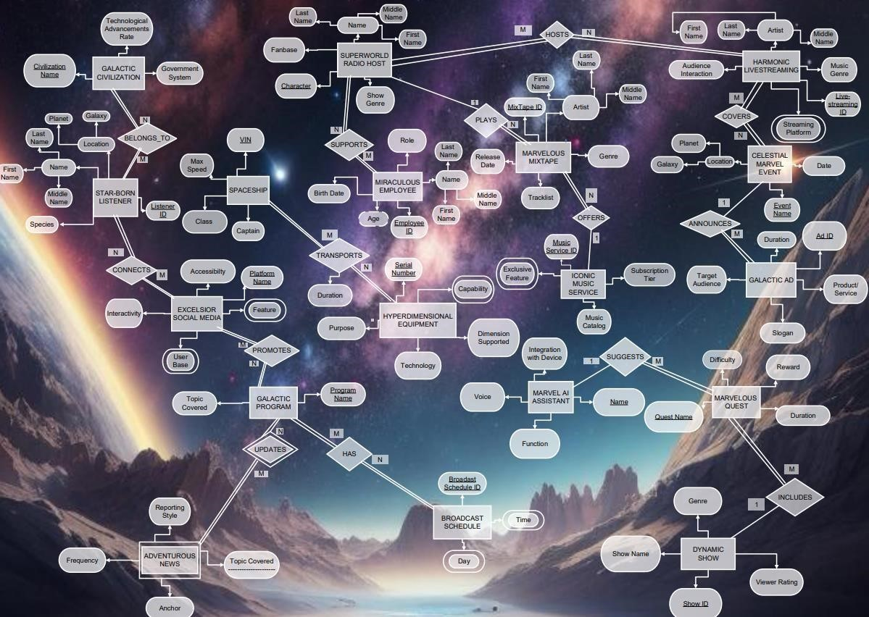

## 11. Database Creation and Queries for “Marvel Sounds of the Universe” database

We will now use SQL to build the database tables on the Oracle Database Server after designing the ER diagram and transforming it into a relational schema. Following the creation of the tables, we will load each table with relevant data and then run some queries against the database that represent the database's use in "The Marvel Sounds of the Universe " as well as the database's importance in supplying critical information in a convenient and efficient manner.

### 11.1. Creation of the Database Tables and their Descriptions

The tables were created in a specific order so that every foreign key in a relation is referencing to a preexisting referenced primary key. Also, to ensure that we have not made any mistakes, we may use the “Object Browser” on the Oracle database server to review the description of the tables once we have completed the creation of the table structures.

# HARMONIC_LIVESTREAMING

CREATE TABLE HARMONIC_LIVESTREAMING (

Livestreaming_ID CHAR (3) NOT NULL,

Music_Genre VARCHAR (50) NOT NULL,

Audience_interaction VARCHAR (15) NOT NULL,

First_name VARCHAR (50) NOT NULL,

Middle_Name VARCHAR (50),

Last_Name VARCHAR (50) NOT NULL,

PRIMARY KEY (Livestreaming_ID)

);

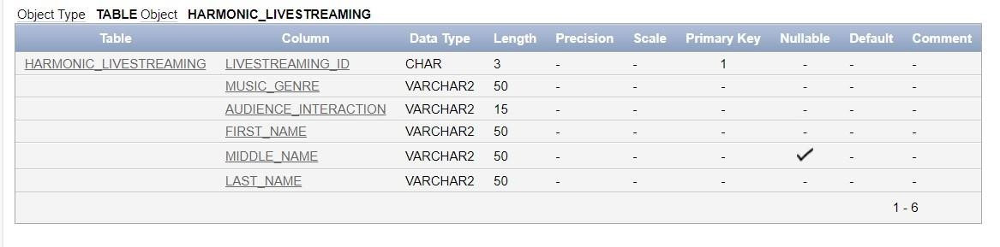

# CELESTIAL_MARVEL_EVENT

CREATE TABLE CELESTIAL_MARVEL_EVENT (

Universal_Ceremony VARCHAR (50) NOT NULL,

Occurrence_date DATE NOT NULL,

Galaxy VARCHAR (50) NOT NULL,

Planet VARCHAR (50) NOT NULL,

PRIMARY KEY (Universal_Ceremony)

);

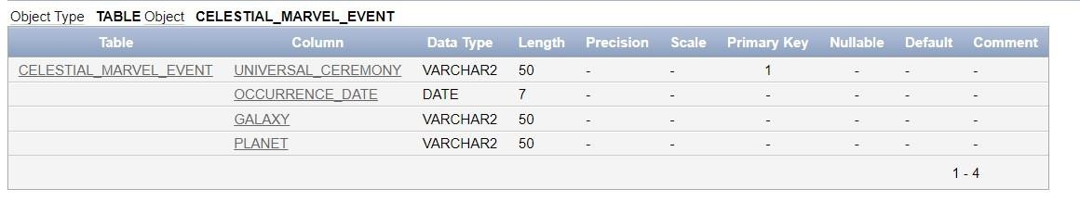

# HOSTS

CREATE TABLE HOSTS (

Char_H VARCHAR (50) NOT NULL,

Live_ID CHAR (3) NOT NULL,

PRIMARY KEY (Char_H, Live_ID),

FOREIGN KEY (Char_H) REFERENCES SUPERWORLD _RADIO_HOST(Character),

FOREIGN KEY (Live_ID) REFERENCES HARMONIC_LIVESTREAMING(Livestreaming_ID)

);

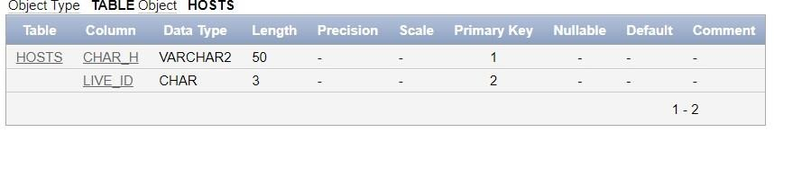

# COVERS

CREATE TABLE COVERS (

Livecover_ID CHAR (3) NOT NULL,

Event_tocover_Name VARCHAR (50) NOT NULL,

PRIMARY KEY (Livecover_ID, Event_tocover_Name)

FOREIGN KEY (Livecover_ID) REFERENCES HARMONIC_LIVESTREAMING(Livestreaming_ID),

FOREIGN KEY (Event_tocover_Name) REFERENCES CELESTIAL_MARVEL_EVENT(Universal_Ceremony)

);

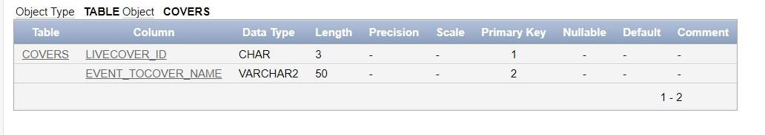

# GALACTIC_CIVILIZATION

CREATE TABLE GALACTIC_CIVILIZATION (

Civilization_Name VARCHAR (50) PRIMARY KEY,

Technological_Advancement_Rate VARCHAR (15) NOT NULL,

Government_System VARCHAR (50) NOT NULL

);

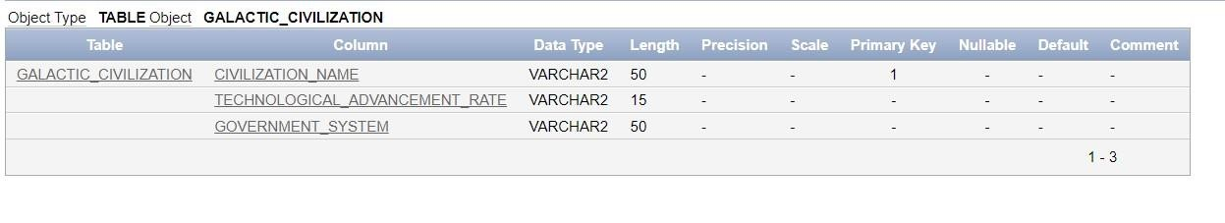

# STREAMING_PLATFORM

CREATE TABLE STREAMING_PLATFORM (

Livestreaming_ID CHAR (3) NOT NULL ,

Harmonic_Streaming_Platform VARCHAR (50) NOT NULL,

PRIMARY KEY (Livestreaming_ID, Harmonic_Streaming_Platform),

FOREIGN KEY (Livestreaming_ID) REFERENCES HARMONIC_LIVESTREAMING(Livestreaming_ID)

);

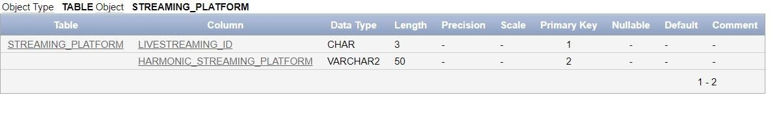

# BELONGS_TO

CREATE TABLE BELONGS_TO (

CivName VARCHAR (50) NOT NULL,

Lis_ID CHAR (4) NOT NULL ,

PRIMARY KEY (CivName, Lis_ID),

FOREIGN KEY (CivName) REFERENCES GALACTIC_CIVILIZATION(Civilization_Name),

FOREIGN KEY (Lis_ID) REFERENCES STARS_BORN_LISTENER(Listener_ID)

);

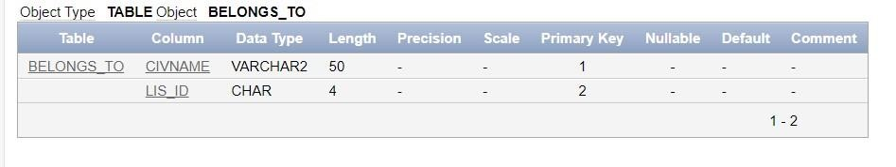

# CONNECTS

CREATE TABLE CONNECTS (

Lis_ID CHAR (4) NOT NULL ,

Plt_Name VARCHAR (50) NOT NULL,

PRIMARY KEY (Lis_ID, Plt_Name),

FOREIGN KEY (Lis_ID) REFERENCES STARS_BORN_LISTENER(Listener_ID),

FOREIGN KEY (Plt_Name) REFERENCES EXCELSIOR_SOCIAL_MEDIA(Platform_Name)

);

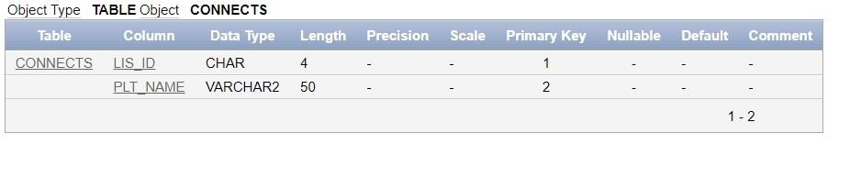

# STARS_BORN_LISTENER

CREATE TABLE STARS_BORN_LISTENER (

Listener_ID CHAR (4) PRIMARY KEY, Galaxy VARCHAR(50) NOT NULL,

Planet VARCHAR(50) NOT NULL,

First_Name VARCHAR(50) NOT NULL,

Middle_Name VARCHAR(50),

Last_Name VARCHAR(50) NOT NULL,

Species VARCHAR(50) NOT NULL,

CONSTRAINT chk_species CHECK (Species IN ('Human', 'Xelion', 'Terran', 'Zepharian', 'Celestian', 'Aquarian', 'Lumarian', 'Solarian', 'Draconian', 'Orionian'))

);

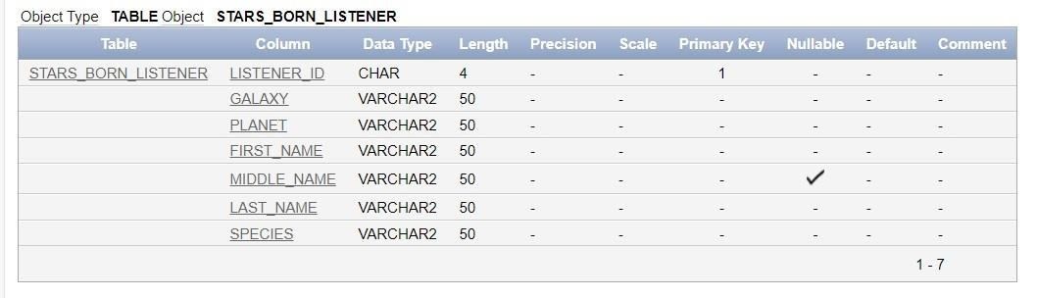

# MARVELEOUS_QUEST

CREATE TABLE MARVELEOUS_QUEST (

SQ_ID CHAR (4) NOT NULL,

Quest_Name VARCHAR (50) NOT NULL,

Difficulty VARCHAR (20) NOT NULL,

Reward VARCHAR (50) NOT NULL,

Duration VARCHAR (20),

AI_Name VARCHAR (50) NOT NULL,

FOREIGN KEY (SQ_ID) REFERENCES DYNAMIC_SHOW(Show_ID)

);

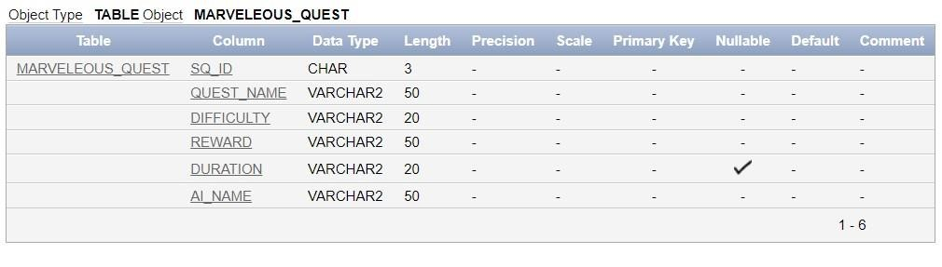

# EXCELSIOR_SOCIAL MEDIA

CREATE TABLE EXCELSIOR_SOCIAL_MEDIA (

Platform_Name VARCHAR (50) PRIMARY KEY,

Accessibility VARCHAR (20) NOT NULL,

Interactivity VARCHAR (20)

);

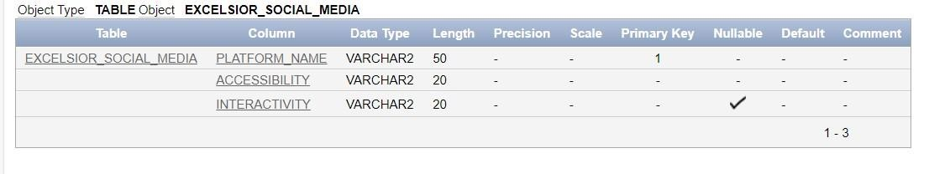

# PROMOTES

CREATE TABLE PROMOTES (

Plat_Name VARCHAR (50) NOT NULL,

P_Name VARCHAR (50) NOT NULL,

PRIMARY KEY (Plat_Name, P_Name),

FOREIGN KEY (Plat_Name) REFERENCES EXCELSIOR_SOCIAL_MEDIA(Platform_Name), FOREIGN KEY (P_Name) REFERENCES GALACTIC_PROGRAM(Program_Name)

);

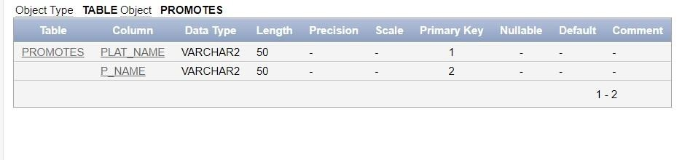

# GALACTIC_PROGRAM

CREATE TABLE GALACTIC_PROGRAM (

Program_Name VARCHAR (50) PRIMARY KEY,

Topic_Covered VARCHAR (50) NOT NULL

);

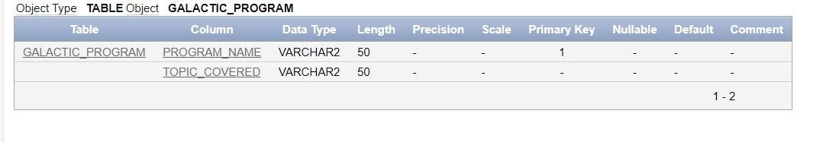

# UPDATES

CREATE TABLE UPDATES (

Adv_Prog_Name VARCHAR (50) NOT NULL,

TC VARCHAR (50) NOT NULL,

PRIMARY KEY (Adv_Prog_Name, TC),

FOREIGN KEY (Adv_Prog_Name) REFERENCES GALACTIC_PROGRAM(Program_Name),

);

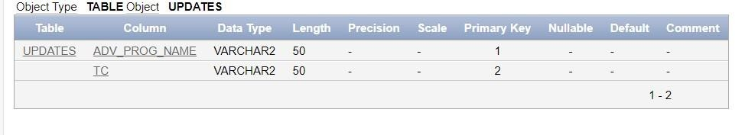

# SUPERWORLD_RADIO_HOST

CREATE TABLE SUPERWORLD_RADIO_HOST (

Character VARCHAR (50) PRIMARY KEY,

Fanbase VARCHAR (50) NOT NULL,

Show_Genre VARCHAR (50) NOT NULL,

First_Name VARCHAR (50) NOT NULL,

Middle_Name VARCHAR (50),

Last_Name VARCHAR (50) NOT NULL,

UNIQUE (Fanbase)

);

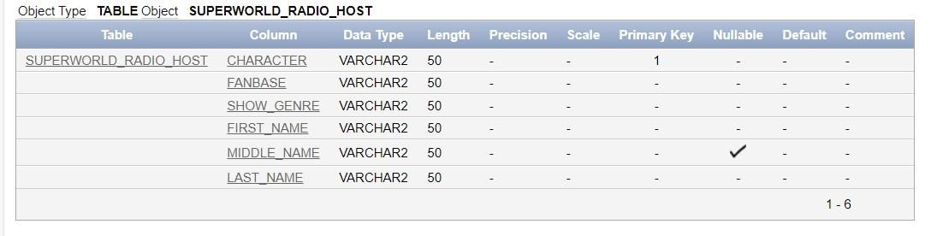

# HYPERDIMENSIONAL_EQUIPMENT

CREATE TABLE HYPERDIMENSIONAL_EQUIPMENT (

Serial_Number CHAR(6) PRIMARY KEY,

Purpose VARCHAR(255) NOT NULL,

Technology VARCHAR(255) NOT NULL,

Dimension_Supported VARCHAR(2) NOT NULL

);

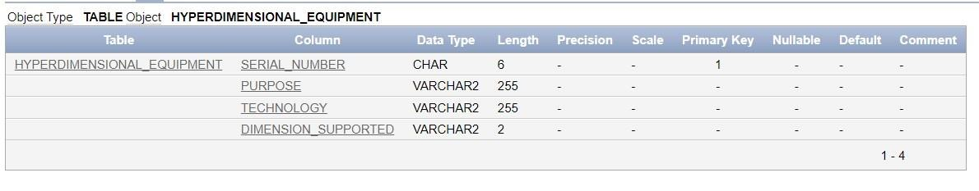

# SUPPORTS

CREATE TABLE SUPPORTS (

E_ID CHAR (4) NOT NULL ,

Char_ID VARCHAR(30) NOT NULL,

PRIMARY KEY (E_ID, Char_ID),

FOREIGN KEY (E_ID) REFERENCES MIRACULOUS_EMPLOYEE (Employee_ID),

FOREIGN KEY (Char_ID) REFERENCES SUPER_WORLD_RADIO_HOST (Character)

);

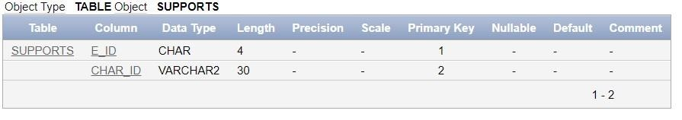

# BROADCAST SCHEDULE

CREATE TABLE BROADCAST_SCHEDULE (

Broadcast_Schedule_ID CHAR (3) PRIMARY KEY

);

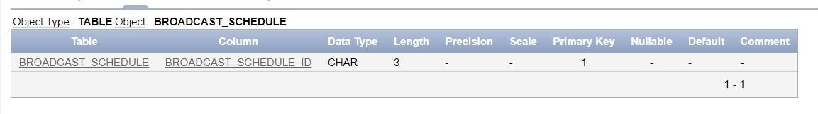

# MARVELEOUS MIXTAPE

CREATE TABLE MARVELOUS_MIXTAPE (

Mixtape_ID CHAR (3) PRIMARY KEY,

First_Name VARCHAR (50) NOT NULL,

Middle_Name VARCHAR(50),

Last_Name VARCHAR(50) NOT NULL,

Genre VARCHAR(50) NOT NULL,

Track_List VARCHAR(255) NOT NULL,

Release_Date DATE NOT NULL,

MID CHAR (3) NOT NULL,

CharM VARCHAR(30) NOT NULL,

FOREIGN KEY (MID) REFERENCES ICONIC_MUSIC_SERVICE (Music_Service_ID),

FOREIGN KEY (CharM) REFERENCES SUPERWORLD_RADIO_HOST (Character)

);

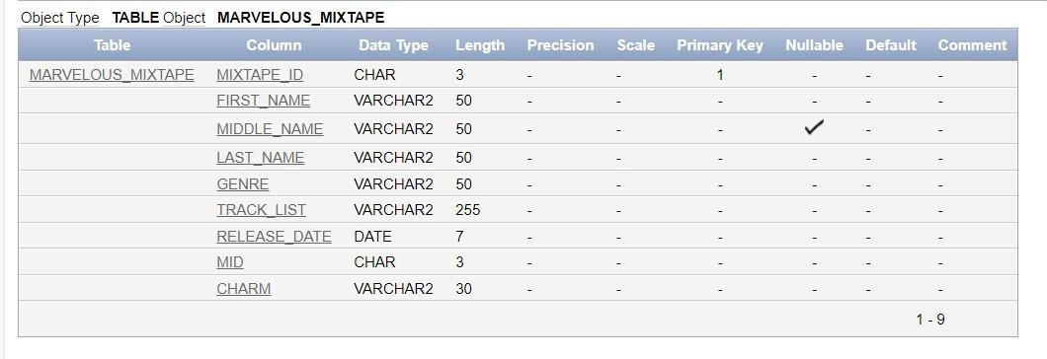

# SPACESHIP

CREATE TABLE SHAPESHIP (

VIN VARCHAR(9) PRIMARY KEY,

Max_Speed DECIMAL(3, 1) NOT NULL,

Class VARCHAR(20) NOT NULL,

Captain VARCHAR(50) NULL

);

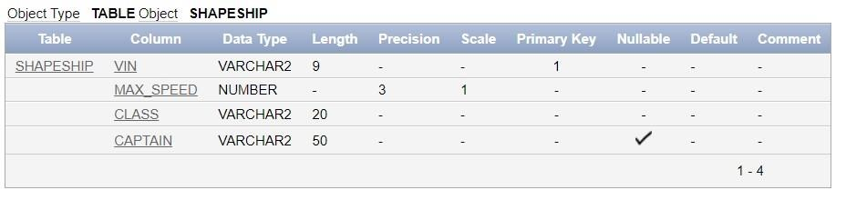

# TRANSPORTS

CREATE TABLE TRANSPORTS (

Ser_No CHAR(6),

VIN_S VARCHAR(9),

Duration VARCHAR(50) NOT NULL,

PRIMARY KEY (Ser_No, VIN_S),

FOREIGN KEY (VIN_S) REFERENCES SHAPESHIP (VIN),

FOREIGN KEY (Ser_No) REFERENCES HYPERDIMENSIONAL_EQUIPMENT (Serial_Number)

);

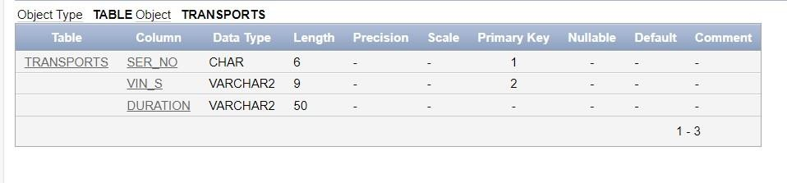

# MIRACULOUS EMPLOYEE

CREATE TABLE MIRACULOUS_EMPLOYEE (

Employee_ID CHAR (4) PRIMARY KEY,

FirstName VARCHAR(50) NOT NULL,

MiddleName VARCHAR(50),

LastName VARCHAR(50) NOT NULL,

Role VARCHAR(50) NOT NULL,

Birthday_Date DATE NOT NULL,

CONSTRAINT valid_role CHECK (Role IN ('Manager', 'Engineer', 'Analyst', 'Designer', 'Developer'))

);

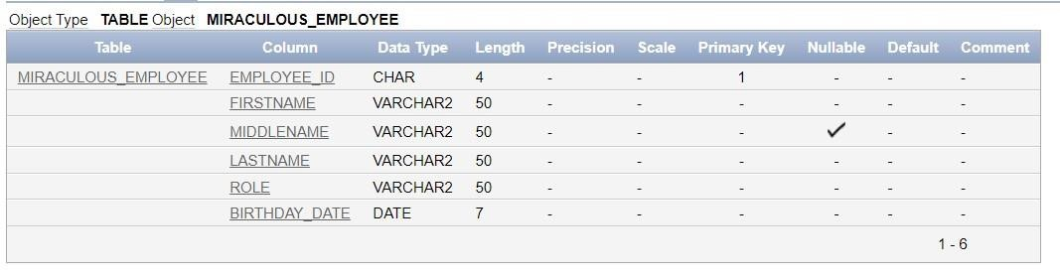

# MARVEL AI ASSISTANT

CREATE TABLE MARVEL_AI_ASSISTANT (

Name VARCHAR(50) PRIMARY KEY,

Integration_With_Device VARCHAR(255) NOT NULL,

Voice VARCHAR(3) CHECK (Voice IN ('Yes', 'No')) NOT NULL,

Function VARCHAR(255) NOT NULL

);

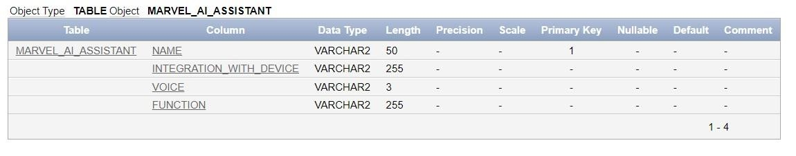

# GALACTIC AD

CREATE TABLE GALACTIC_AD ( EA VARCHAR(50) NOT NULL,

Ad_ID CHAR(6) PRIMARY KEY,

Product_Service VARCHAR(255) NOT NULL,

Target_Audience VARCHAR(255) NOT NULL,

Slogan VARCHAR(255) NOT NULL,

Duration VARCHAR(50) NOT NULL,

FOREIGN KEY (EA) REFERENCES CELESTIAL_MARVEL_EVENT(Universal_Ceremony)

);

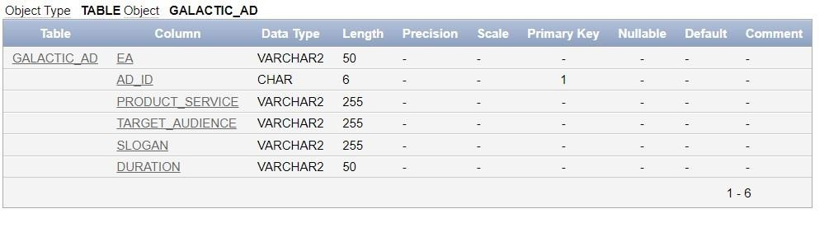

# ICONIC MUSIC SERVICE

CREATE TABLE ICONIC_MUSIC_SERVICES (

Music_Service_ID CHAR(3) PRIMARY KEY, Subscription_Tier VARCHAR(3) NOT NULL,

Music_Catalog VARCHAR(255) NOT NULL

);

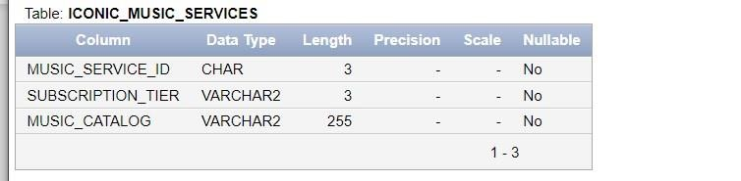

# DYNAMIC SHOW

CREATE TABLE DYNAMIC_SHOW (

Show_ID CHAR(3) PRIMARY KEY,

Viewer_Rating DECIMAL(3, 1) NOT NULL CHECK (Viewer_Rating >= 0 AND Viewer_Rating <= 5),

Genre VARCHAR(50) NOT NULL,

Show_Name VARCHAR(255) NOT NULL,

UNIQUE(Show_Name)

);

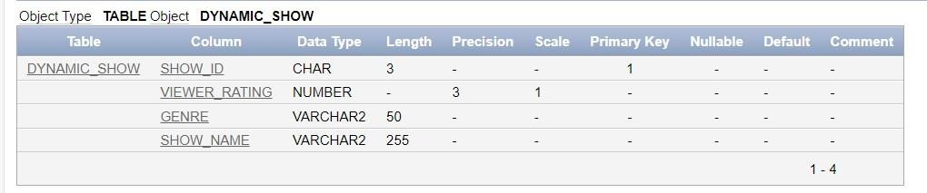

# ADVENTUROUS NEW

CREATE TABLE ADVENTUROUS_NEW (

PN VARCHAR(50),

Topic VARCHAR(50),

Reporting_Style VARCHAR(50),

Frequency VARCHAR(20),

Anchor VARCHAR(50),

PRIMARY KEY (PN, topic),

FOREIGN KEY (PN) REFERENCES GALACTIC_PROGRAM(Program_Name)

);

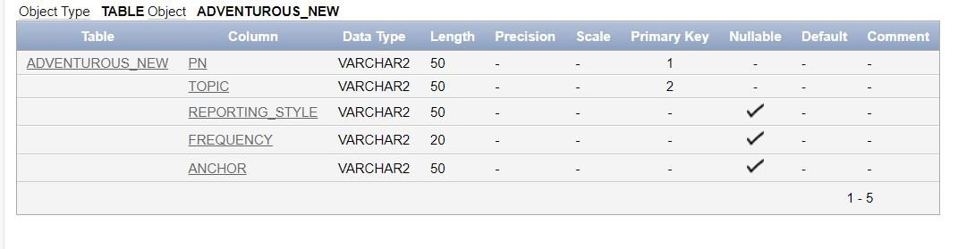

# EXCLUSIVE FEATURES

CREATE TABLE EXCLUSIVE_FEATURE (

Music_Service_ID CHAR(3) NOT NULL,

Exclusive_Feature VARCHAR(255) NOT NULL,

PRIMARY KEY (Music_Service_ID, Exclusive_Feature),

FOREIGN KEY (Music_Service_ID) REFERENCES ICONIC_MUSIC_SERVICES (Music_Service_ID)

);

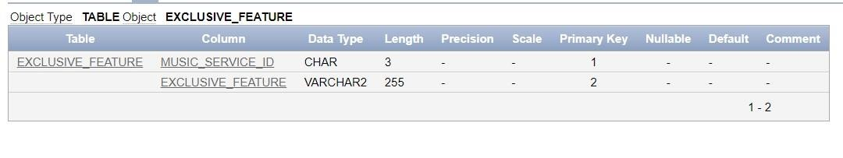

# EXCELSIOR_USERBASE

CREATE TABLE EXCELSIOR_USER_BASE (

Platform_Name VARCHAR(50) NOT NULL, E_User_Base INT NOT NULL,

PRIMARY KEY (Platform_Name, E_User_Base),

FOREIGN KEY (Platform_Name) REFERENCES EXCELSIOR_SOCIAL_MEDIA (Platform_Name), CONSTRAINT chk_E_User_Base CHECK (E_User_Base >= 0)

);

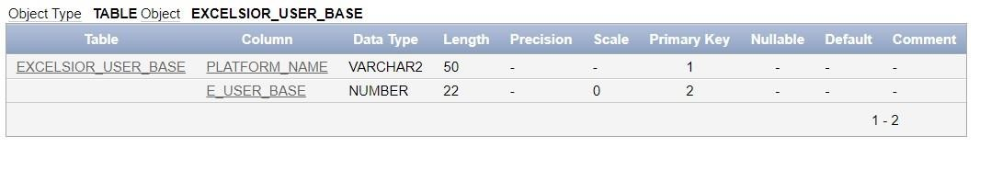

# HAS

CREATE TABLE HAS (

Prog_Name VARCHAR(50) NOT NULL,

Brodsched_ID CHAR(3) NOT NULL,

PRIMARY KEY (Prog_Name, Brodsched_ID),

FOREIGN KEY (Prog_Name) REFERENCES GALACTIC_PROGRAM (Program_Name),

FOREIGN KEY (Brodsched_ID) REFERENCES BROADCAST_SCHEDULE (Broadcast_Schedule_ID)

);

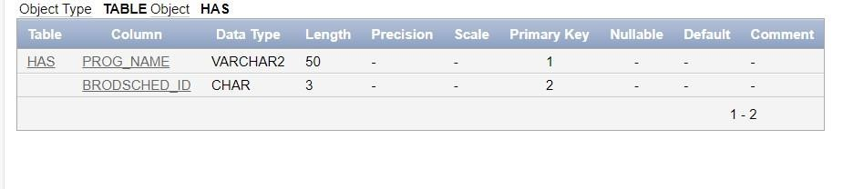

# BROADCAST SCHEDULE_DAY

CREATE TABLE BROADCAST_SCHEDULE_DAY (

Broadcast_Schedule_ID CHAR(3) NOT NULL,

B_day VARCHAR(15) NOT NULL,

PRIMARY KEY (Broadcast_Schedule_ID, B_day),

FOREIGN KEY (Broadcast_Schedule_ID) REFERENCES BROADCAST_SCHEDULE (Broadcast_Schedule_ID)

);

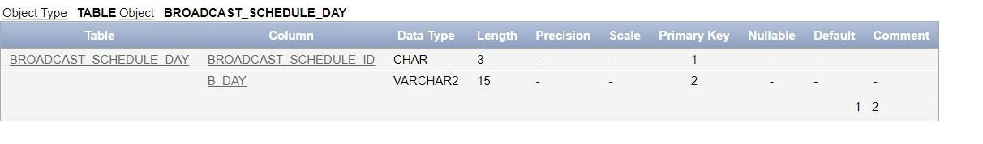

# BROADCAST SCHEDULE_TIME

CREATE TABLE BROADCAST_SCHEDULE_TIME (

Broadcast_Schedule_ID CHAR(3) NOT NULL, B_Time TIMESTAMP NOT NULL,

PRIMARY KEY (Broadcast_Schedule_ID, B_Time),

FOREIGN KEY (Broadcast_Schedule_ID) REFERENCES BROADCAST_SCHEDULE (Broadcast_Schedule_ID)

);

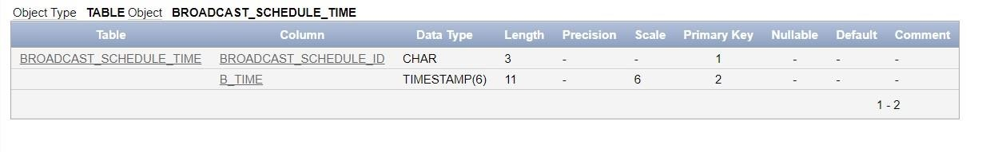

**EQUIPMENT**

**CAPABILITY**

CREATE TABLE EQUIPMENT_CAPABILITY (

Serial_Number CHAR(6) NOT NULL,

Eq_Capability VARCHAR(50) NOT NULL,

PRIMARY KEY (Serial_Number, Eq_Capability),

FOREIGN KEY (Serial_Number) REFERENCES HYPERDIMENSIONAL_EQUIPMENT (Serial_Number)

);

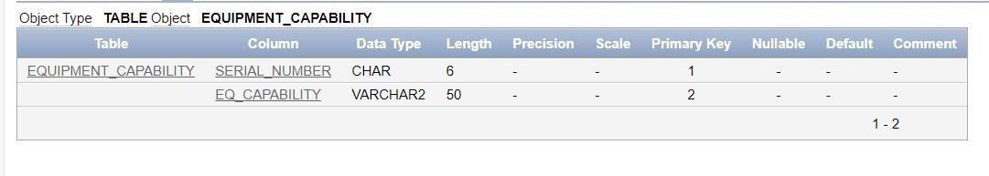

# EXCELSIOR_FEATURE

CREATE TABLE EXCELSIOR_FEATURE (

Platform_Name VARCHAR(50) NOT NULL,

E_Feature VARCHAR(225) NOT NULL,

PRIMARY KEY (Platform_Name, E_Feature),

FOREIGN KEY (Platform_Name) REFERENCES EXCELSIOR_SOCIAL_MEDIA (Platform_Name)

);

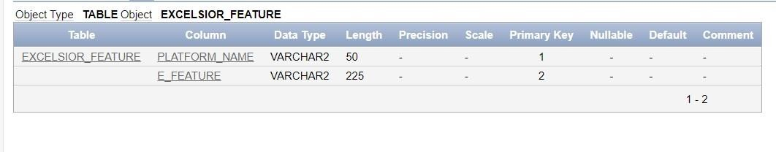

**11.2. Insertion of Data into the Database Tables**

# HARMONIC LIVESTREAMING

INSERT INTO HARMONIC_LIVESTREAMING VALUES ('001', 'Space Ambient', 'High', 'Johnson','Andrew',

'David');

INSERT INTO HARMONIC_LIVESTREAMING VALUES ('002', 'Sci-Fi Rock', 'Medium', 'Smith','Benjamin', 'Emily');

INSERT INTO HARMONIC_LIVESTREAMING VALUES ('003', ' Galactic Jazz, 'Low', 'Anderson','Carter', 'Michael');

INSERT INTO HARMONIC_LIVESTREAMING VALUES ('004', 'Alien Pop', 'High', 'Davis','Daniel', 'Sophia'),

INSERT INTO HARMONIC_LIVESTREAMING VALUES ('005', 'Cosmic EDM', 'Medium', 'Patel','Elijah', 'Aiden'),

INSERT INTO HARMONIC_LIVESTREAMING VALUES ('006', 'Astro Metal', 'Low', 'Wang', 'Finn', 'Olivia'),

INSERT INTO HARMONIC_LIVESTREAMING VALUES ('007', 'Intergalactic', 'High', 'Kim','Grace', 'Ethan'),

INSERT INTO HARMONIC_LIVESTREAMING VALUES ('008', 'Nebula Blues', 'Medium', 'Rodriguez','Rodriguez',

'Mia'),

INSERT INTO HARMONIC_LIVESTREAMING VALUES ('009', 'Star Pop', 'Low', 'Lee','Isabella', 'Liam'),

INSERT INTO HARMONIC_LIVESTREAMING VALUES ('010', 'Quantum Rock', 'High', 'Turner', 'Turner', 'Ava');

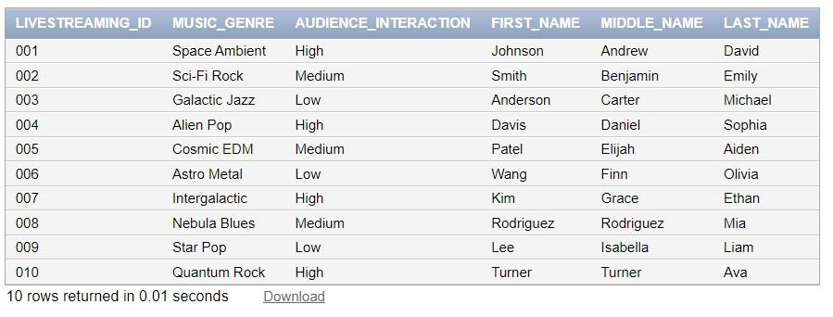

# CELESTIAL_MARVEL_EVENT

INSERT INTO CELESTIAL_MARVEL_EVENT VALUES ('Cosmic Convergence',TO_DATE('15/11/2023',

'DD/MM/YYYY'), 'Andromeda', 'Nova Prime');

INSERT INTO CELESTIAL_MARVEL_EVENT VALUES ('Galactic Nexus', TO_DATE ('02/03/2024',

'DD/MM/YYYY'), 'Triangulum', 'Celestoria');

INSERT INTO CELESTIAL_MARVEL_EVENT VALUES ('Starfall Spectacle', TO_DATE ('20/07/2024',

'D/MM/YYYY'), 'Milky Way', 'Earth');

INSERT INTO CELESTIAL_MARVEL_EVENT VALUES ('Nebula Unveiling', TO_DATE ('12/10/2024',

'DD/MM/YYYY'), 'Centaurus A', 'Zenithar');

INSERT INTO CELESTIAL_MARVEL_EVENT VALUES ('Celestial Harmony', TO_DATE ('05/02/2025',

'DD/MM/YYYY'), 'Magellanic Cloud', 'Seraphion');

INSERT INTO CELESTIAL_MARVEL_EVENT VALUES ('Quantum Revelation', TO_DATE ('09/09/2025',

'DD/MM/YYYY'), 'Pegasus', 'Astralis');

INSERT INTO CELESTIAL_MARVEL_EVENT VALUES ('Infinity Eclipse', TO_DATE('18/06/2025',

'DD/MM/YYYY'), 'Virgo Supercluster', 'Galactica');

INSERT INTO CELESTIAL_MARVEL_EVENT VALUES ('Stellar Odyssey', TO_DATE('22/01/2026', '

DD/MM/YYYY'), 'Hercules', 'Starhaven');

INSERT INTO CELESTIAL_MARVEL_EVENT VALUES ('Nebula Fusion', TO_DATE('07/08/2026',

'DD/MM/YYYY'), 'Hydra', 'Nebulon');

INSERT INTO CELESTIAL_MARVEL_EVENT VALUES ('Cosmic Ascendance', TO_DATE('14/052026',

'DD/MM/YYYY'), 'Phoenix Cluster', 'Celestialis');

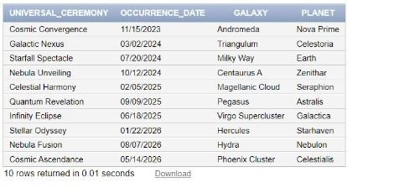

# HOSTS

INSERT INTO HOSTS VALUES ('Galaxy Explorer', '001'),

INSERT INTO HOSTS VALUES ('Nebula Navigator', '002'),

INSERT INTO HOSTS VALUES ('Cosmic DJ', '003'),

INSERT INTO HOSTS VALUES ('Astro Ambassador', '004'),

INSERT INTO HOSTS VALUES ('Galactic Guru', '005'),

INSERT INTO HOSTS VALUES ('Celestial Choreographer', '006'),

INSERT INTO HOSTS VALUES ('Orbiting Oracle', '007'),

INSERT INTO HOSTS VALUES ('Space Siren', '008'),

INSERT INTO HOSTS VALUES ('Cosmic Communicator', '009'), INSERT INTO HOSTS VALUES ('Solar Serenader', '010');

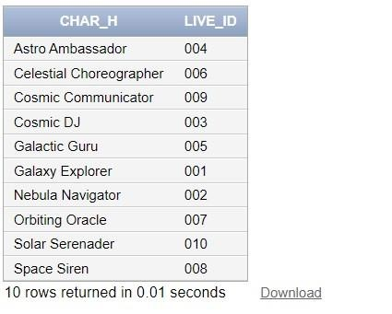

# COVERS

INSERT INTO COVERS VALUES ('001', 'Cosmic Convergence');

INSERT INTO COVERS VALUES ('002', 'Galactic Nexus');

INSERT INTO COVERS VALUES ('003', 'Starfall Spectacle');

INSERT INTO COVERS VALUES ('004', 'Nebula Unveiling');

INSERT INTO COVERS VALUES ('005', 'Celestial Harmony');

INSERT INTO COVERS VALUES ('006', 'Quantum Revelation');

INSERT INTO COVERS VALUES ('007', 'Infinity Eclipse');

INSERT INTO COVERS VALUES ('008', 'Stellar Odyssey');

INSERT INTO COVERS VALUES ('009', 'Nebula Fusion');

INSERT INTO COVERS VALUES ('010', 'Cosmic Ascendance');

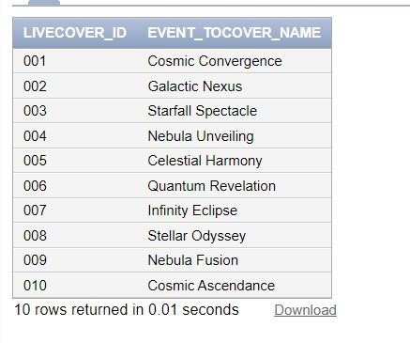

# GALACTIC_CIVILIZATION

INSERT INTO GALACTIC_CIVILIZATION VALUES ('Celestial Alliance', 'High', 'Federal Republic');

INSERT INTO GALACTIC_CIVILIZATION VALUES ('Quantum Dominion', 'Medium', 'Technocratic Oligarchy');

INSERT INTO GALACTIC_CIVILIZATION VALUES ('Starlight Consortium', 'Very High', 'Democratic Confederation');

INSERT INTO GALACTIC_CIVILIZATION VALUES ('Nebula Empire', 'Low', 'Authoritarian Monarchy');

INSERT INTO GALACTIC_CIVILIZATION VALUES ('Cosmic Federation', 'Very High', 'Parliamentary Democracy'); INSERT INTO GALACTIC_CIVILIZATION VALUES ('Galactic Union', 'Medium', 'Unitary Socialist State');

INSERT INTO GALACTIC_CIVILIZATION VALUES ('Interstellar Republic', 'High', 'Federal Parliamentary Republic');

INSERT INTO GALACTIC_CIVILIZATION VALUES ('Astral Hegemony', 'Low', 'Totalitarian Oligarchy');

NSERT INTO GALACTIC_CIVILIZATION VALUES ('Nova Commonwealth', 'Very High', 'Democratic Federalism');

INSERT INTO GALACTIC_CIVILIZATION VALUES ('Nebula Ascendancy', 'Medium', 'Corporate Plutocracy');

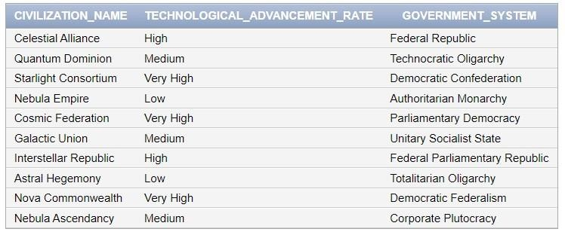

# STREAMING_PLATFORM

INSERT INTO STREAMING_PLATFORM VALUES ('001', 'Spotify');

INSERT INTO STREAMING_PLATFORM VALUES ('002', 'Apple Music');

INSERT INTO STREAMING_PLATFORM VALUES ('003', 'Slacker Radio');

INSERT INTO STREAMING_PLATFORM VALUES ('004', 'SoundCloud');

INSERT INTO STREAMING_PLATFORM VALUES ('005', 'Deezer');

INSERT INTO STREAMING_PLATFORM VALUES ('006', 'Tidal');

INSERT INTO STREAMING_PLATFORM VALUES ('007', 'Amazon Music');

INSERT INTO STREAMING_PLATFORM VALUES ('008', 'Last.fm');

INSERT INTO STREAMING_PLATFORM VALUES ('009', 'Angami');

INSERT INTO STREAMING_PLATFORM VALUES ('010', 'Google Play Music');

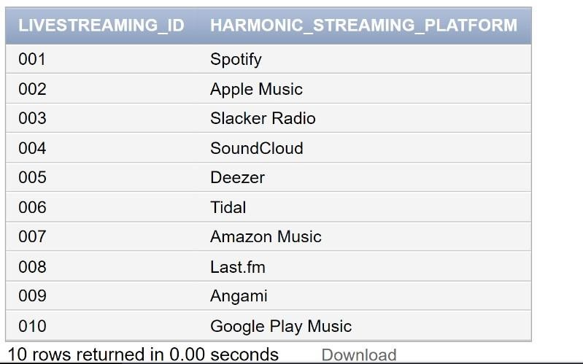

# BELONGS_TO

INSERT INTO BELONGSTO VALUES ('Celestial Alliance', '7532');

INSERT INTO BELONGSTO VALUES ('Quantum Dominion', '4198');

INSERT INTO BELONGSTO VALUES ('Starlight Consortium', '1265');

INSERT INTO BELONGSTO VALUES ('Nebula Empire', '8954');

INSERT INTO BELONGSTO VALUES ('Cosmic Federation', '6321');

INSERT INTO BELONGSTO VALUES ('Galactic Union', '3076');

INSERT INTO BELONGSTO VALUES ('Interstellar Republic', '5489');

INSERT INTO BELONGSTO VALUES ('Astral Hegemony', '1823');

INSERT INTO BELONGSTO VALUES ('Nova Commonwealth', '9743');

INSERT INTO BELONGSTO VALUES ('Nebula Ascendancy', '6904');

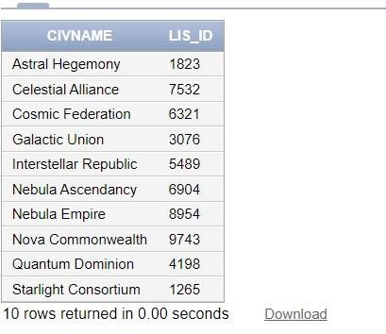

# CONNECTS

INSERT INTO CONNECTS VALUES ('7532', 'Galactic Tunes');

INSERT INTO CONNECTS VALUES ('4198', 'Astro Podcast Network');

INSERT INTO CONNECTS VALUES ('1265', 'Cosmic Chatter');

INSERT INTO CONNECTS VALUES ('8954', 'Star Jams Radio');

INSERT INTO CONNECTS VALUES ('6321', 'Nebula News Feed');

INSERT INTO CONNECTS VALUES ('3076', 'Interstellar Gram');

INSERT INTO CONNECTS VALUES ('5489', 'Space Book');

INSERT INTO CONNECTS VALUES ('1823', 'Celestial Snap');

INSERT INTO CONNECTS VALUES ('9743', 'Galaxy Pods');

INSERT INTO CONNECTS VALUES ('6904', 'Stellar Social');

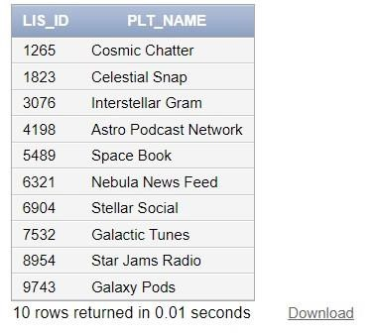

# STAR BORN LISTENER

INSERT INTO STARBORN_LISTENERS VALUES (7532, 'Andromeda', 'Nova Prime', 'Johnson', 'Amelia', 'Sophia',

'Human');

INSERT INTO STARBORN_LISTENERS VALUES (4198, 'Triangulum', 'Celestoria', 'Smith', 'Benjamin', 'Ethan',

'Xelion');

INSERT INTO STARBORN_LISTENERS VALUES (1265, 'Milky Way', 'Earth', 'Anderson', 'Carter', 'Liam', 'Terran');

INSERT INTO STARBORN_LISTENERS VALUES (8954, 'Centaurus A', 'Zenithar', 'Davis', 'Daniel', 'Ava',

'Zepharian'); INSERT INTO STARBORN_LISTENERS VALUES (6321, 'Magellanic Cloud', 'Seraphion', 'Patel', 'Elijah',

'Olivia',

'Celestian');

INSERT INTO STARBORN_LISTENERS VALUES (3076, 'Pegasus', 'Astralis', 'Wang', 'Finn', 'Noah', 'Aquarian');

INSERT INTO STARBORN_LISTENERS VALUES (5489, 'Virgo Supercluster', 'Galactica', 'Kim', 'Grace', 'Mia',

'Lumarian');

INSERT INTO STARBORN_LISTENERS VALUES (1823, 'Hercules', 'Starhaven', 'Rodriguez', 'Henry', 'Elijah',

'Solarian');

INSERT INTO STARBORN_LISTENERS VALUES (9743, 'Hydra', 'Nebulon', 'Lee', 'Isabella', 'Draconian', 'Draconian');

INSERT INTO STARBORN_LISTENERS VALUES (6904, 'Phoenix Cluster', 'Celestialis', 'Turner', 'James', 'Aiden', 'Orionian');

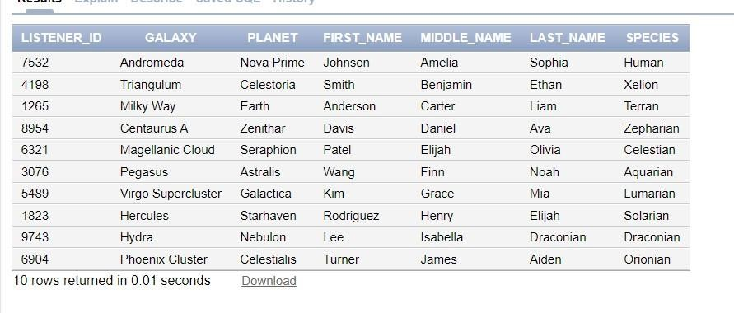

# MARVELEOUS QUEST

INSERT INTO MARVELEOUS_QUEST VALUES (101, 'Cosmic Conundrum', 'Medium', '150 Galactic Credits', '2.5 hours', 'Puzzle Master AI');

INSERT INTO MARVELEOUS_QUEST VALUES ( (102, 'Starship Racing Challenge', 'Easy', '120 Galactic Credits', '2 hours', 'Racer Bot');

MARVELEOUS_QUEST VALUES ( (103, 'Exoplanet Exploration', 'Hard ', '250 Galactic Credits', '3.5

hours', 'Explorer AI');

INSERT INTO MARVELEOUS_QUEST VALUES ( (104, 'Astrobiology Adventure', 'Medium', '180 Galactic Credits',

'2.5 hours', 'Bio Bot');

INSERT INTO MARVELEOUS_QUEST VALUES ( (105, 'Cosmic Art Gallery Tour', 'Easy', '100 Galactic Credits',

'NULL', 'Art Guide AI');

INSERT INTO MARVELEOUS_QUEST VALUES ( (106, 'Galactic Codebreaker Challenge', 'Hard', '300 Galactic

Credits', '4 hours', 'Code breaker AI');

INSERT INTO MARVELEOUS_QUEST VALUES ( (107, 'Nebula Navigation Quest', 'Medium', '200 Galactic Credits',

'3 hours', 'Navigator Bot');

INSERT INTO MARVELEOUS_QUEST VALUES ( (108, 'Star Wars Simulation', ' Easy', '500 Galactic Credits',

'NULL', 'Simulation Master AI');

INSERT INTO MARVELEOUS_QUEST VALUES ( (109, 'Quantum Physics Expedition', 'Hard', '280 Galactic Credits', '4 hours', 'Quantum Explorer AI');

INSERT INTO MARVELEOUS_QUEST VALUES ( (110, ' Black Hole Mysteries', 'Hard', ' 400 Galactic Credits', '4.5 hours', 'Astro Physici');

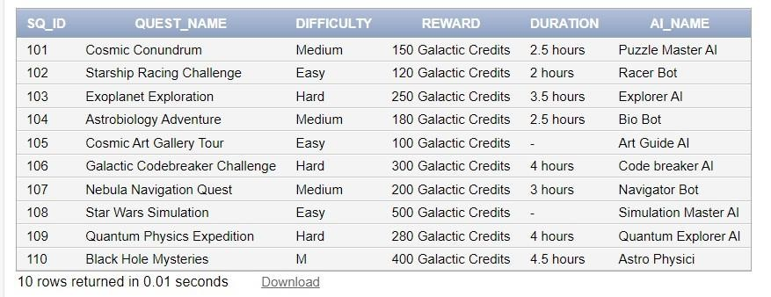

# EXELSIOR SOCIAL MEDIA

INSERT INTO EXELSIOR_SOCIAL_MEDIA VALUES ('Galactic Tunes', 'Inclusive', 'High');

INSERT INTO EXELSIOR_SOCIAL_MEDIA VALUES ('Astro Podcast Network', 'Accessible', 'Medium');

INSERT INTO EXELSIOR_SOCIAL_MEDIA VALUES ('Cosmic Chatter', 'Universal', 'Very High');

INSERT INTO EXELSIOR_SOCIAL_MEDIA VALUES ('Star Jams Radio', 'Inclusive', 'High');

INSERT INTO EXELSIOR_SOCIAL_MEDIA VAL UES ('Nebula News Feed', 'Accessible', 'Medium');

INSERT INTO EXELSIOR_SOCIAL_MEDIA VALUES ('Interstellar Gram', 'Universal', 'Very High');

INSERT INTO EXELSIOR_SOCIAL_MEDIA VALUES ('Space Book', 'Inclusive', 'High');

INSERT INTO EXELSIOR_SOCIAL_MEDIA VALUES ('Celestial Snap', 'Accessible', 'NULL');

INSERT INTO EXELSIOR_SOCIAL_MEDIA VALUES ('Galaxy Pods', 'Universal', 'Very High');

INSERT INTO EXELSIOR_SOCIAL_MEDIA VALUES ('Stellar Social', 'Inclusive', 'High');

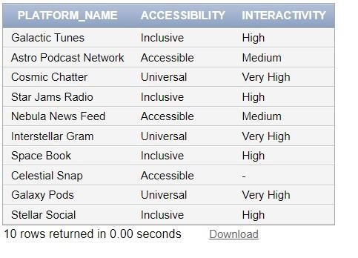

# PROMOTES

INSERT INTO PROMOTES VALUES ('Galactic Tunes', 'Stellar Exploration');

INSERT INTO PROMOTES VALUES ('Astro Podcast Network', 'Alien Jams');

INSERT INTOPROMOTES VALUES ('Cosmic Chatter', 'Space Talk');

INSERT INTO PROMOTES VALUES ('Star Jams Radio', 'Astro Sounds');

INSERT INTO PROMOTES VALUES ('Nebula News Feed', 'Cosmic Conversations');

INSERT INTO PROMOTES VALUES ('Interstellar Gram', 'Galactic Grooves');

INSERT INTO PROMOTES VALUES ('Space Book', 'Universal News');

INSERT INTO PROMOTES VALUES ('Celestial Snap', 'Quantum Quasar');

INSERT INTO PROMOTES VALUES ('Galaxy Pods', 'Solar Sermons');

INSERT INTO PROMOTES VALUES ('Stellar Social', 'Interstellar Interviews');

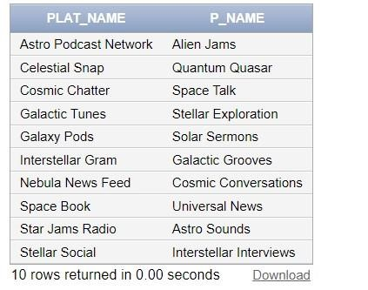

89

# GALACTIC PROGRAM

INSERT INTO GALACTIC_PROGRAM VALUES ('Stellar Exploration', 'Space Exploration');

INSERT INTO GALACTIC_PROGRAM VALUES ('Alien Jams', 'Extraterrestrial Music');

INSERT INTO GALACTIC_PROGRAM VALUES ('Space Talk', 'Celestial Conversations');

INSERT INTO GALACTIC_PROGRAM VALUES ('Astro Sounds', 'Space-Themed Music');

INSERT INTO GALACTIC_PROGRAM VALUES ('Cosmic Conversations', 'General Cosmic Discussions');

INSERT INTO GALACTIC_PROGRAM VALUES ('Galactic Grooves', 'Funky Beats from the Cosmos');

INSERT INTO GALACTIC_PROGRAM VALUES ('Universal News', 'Interstellar News Updates');

INSERT INTO GALACTIC_PROGRAM VALUES ('Quantum Quasar', 'Quantum Physics Exploration');

INSERT INTO GALACTIC_PROGRAM VALUES ('Solar Sermons', 'Sun and Solar System Topics');

INSERT INTO GALACTIC_PROGRAM VALUES ('Interstellar Interviews', 'Interviews with Space Experts');

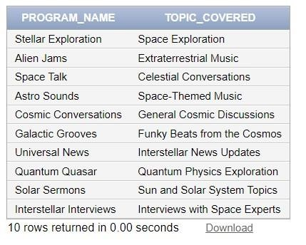

# UPDATES

INSERT INTO UPDATES VALUES ('Stellar Exploration', 'Space Exploration');

INSERT INTO UPDATES VALUES ('Alien Jams', 'Extraterrestrial Music');

INSERT INTO UPDATES VALUES ('Space Talk', 'Celestial Conversations');

INSERT INTO UPDATES VALUES ('Astro Sounds', 'Space-Themed Music');

INSERT INTO UPDATES VALUES ('Cosmic Conversations', 'General Cosmic Discussions');

INSERT INTO UPDATES VALUES ('Galactic Grooves', 'Funky Beats from the Cosmos');

INSERT INTO UPDATES VALUES ('Universal News', 'Interstellar News Updates');

INSERT INTO UPDATES VALUES ('Quantum Quasar', 'Quantum Physics Exploration');

INSERT INTO UPDATES VALUES ('Solar Sermons', 'Sun and Solar System Topics');

INSERT INTO UPDATES VALUES ('Interstellar Interviews', 'Interviews with Space Experts');

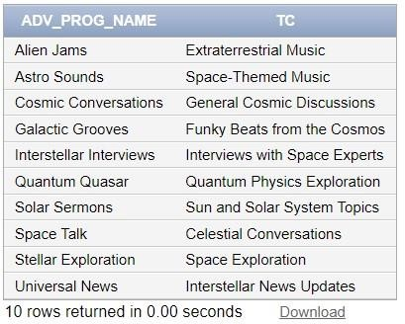

# SUPERWORLD RADIO HOST

INSERT INTO SUPERWORLD_RADIO_HOST VALUES ('Galaxy Explorer', 'Galaxy Explorer', 'Exploration Jams',

'Galax', 'Epsilon', 'Explorer');

INSERT INTO SUPERWORLD_RADIO_HOST VALUES ('Nebula Navigator', 'Nebula Navigator', 'Celestial Beats',

'Nebula', 'Nova', 'Navigator')

INSERT INTO SUPERWORLD_RADIO_HOST VALUES ('Cosmic DJ', 'Cosmic DJ', 'Cosmic Mixology', 'Cosmic',

'Delta', 'DJ');

INSERT INTO SUPERWORLD_RADIO_HOST VALUES ('Astro Ambassador', 'Solar Serenader', 'Solar Serenades',

'Solar', 'Sigma', 'Serenader');

INSERT INTO SUPERWORLD_RADIO_HOST VALUES ('Galactic Guru', 'Quantum Quasar', 'Quantum Waves',

'Quantum', 'Quasar', 'Quasar');

INSERT INTO SUPERWORLD_RADIO_HOST VALUES ('Celestial Choreographer', 'Celestial DJ', 'Starry Rhythms',

'Celestial', 'Marvelous', 'DJ');

INSERT INTO SUPERWORLD_RADIO_HOST VALUES ('Orbiting Oracle', 'Astro Ambassador', 'Space Diplomacy',

'Astro', 'Alpha', 'Ambassador');

INSERT INTO SUPERWORLD_RADIO_HOST VALUES ('Space Siren', 'Starlight Serenade', '29', 'Non-binary', 'Pluto',

'108');

INSERT INTO SUPERWORLD_RADIO_HOST VALUES ('Cosmic Communicator', 'Orion Observer', '41', 'Male',

'Neptune', '109');

INSERT INTO SUPERWORLD_RADIO_HOST VALUES ('Solar Serenader', 'Galactic Guru', '36', 'Female', 'Mars',

'110');

91

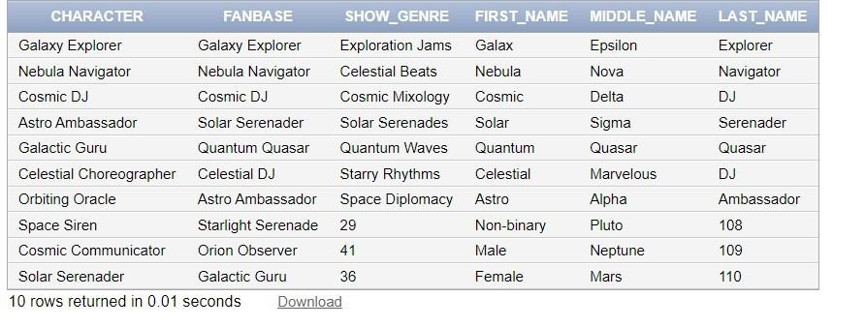

# SUPPORTS

INSERT INTO SUPPORTS VALUES (7823, 'Galaxy Explorer');

INSERT INTO SUPPORTS VALUES (5981, 'Nebula Navigator');

INSERT INTO SUPPORTS VALUES (2345, 'Cosmic DJ');

INSERT INTO SUPPORTS VALUES (8762, 'Astro Ambassador');

INSERT INTO SUPPORTS VALUES (1098, 'Galactic Guru');

INSERT INTO SUPPORTS VALUES (4567, 'Celestial Choreographer');

INSERT INTO SUPPORTS VALUES (3210, 'Orbiting Oracle');

INSERT INTO SUPPORTS VALUES (7890, 'Space Siren');

INSERT INTO SUPPORTS VALUES (5432, 'Cosmic Communicator');

INSERT INTO SUPPORTS VALUES (9876, 'Solar Serenader');

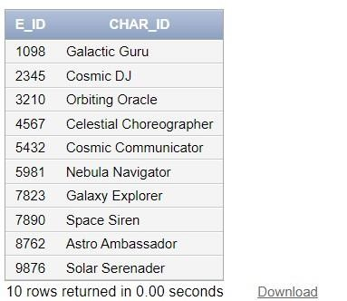

# BROADCAST SCHEDULE

INSERT INTO BROADCAST_SCHEDULE VALUES (101);

INSERT INTO BROADCAST_SCHEDULE VALUES (102);

INSERT INTO BROADCAST_SCHEDULE VALUES (103);

INSERT INTO BROADCAST_SCHEDULE VALUES (104);

INSERT INTO BROADCAST_SCHEDULE VALUES (105);

INSERT INTO BROADCAST_SCHEDULE VALUES (106);

INSERT INTO BROADCAST_SCHEDULE VALUES (107);

INSERT INTO BROADCAST_SCHEDULE VALUES (108);

INSERT INTO BROADCAST_SCHEDULE VALUES (109);

INSERT INTO BROADCAST_SCHEDULE VALUES (110);

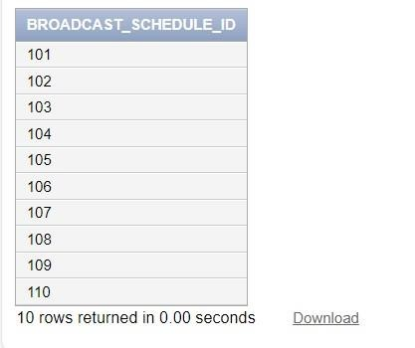

# MARVELEOUS_MIXTAPE

INSERT INTO MARVELEOUS_MIXTAPE VALUES (301, 'Cosmic', 'Harmony', 'Explorer', 'Space Beats', 'Celestial

Groove', TO_DATE ('15/05/2023','DD/MM/YYYY'), 101, 'Galaxy Explorer');

INSERT INTO MARVELEOUS_MIXTAPE VALUES (302, 'Nebula', 'Stellar', 'Serenader', 'Astro Jazz', 'Nebula Nights',

TO_DATE('20/04/2023','DD/MM/YYYY'), 102, 'Nebula Navigator');

INSERT INTO MARVELEOUS_MIXTAPE VALUES (303, 'Galactic', 'Rhythms', 'Voyager', 'Cosmic EDM', 'Interstellar

Vibes', TO_DATE'10/03/2023','DD/MM/YYYY'), 103, 'Cosmic DJ');

INSERT INTO MARVELEOUS_MIXTAPE VALUES (304, 'Solar', 'Harmony', 'Melodies', 'Solar Pop', 'Solar Serenade',

TO_DATE ('05/06/2023','DD/MM/YYYY'), 104, 'Astro Ambassador');

INSERT INTO MARVELEOUS_MIXTAPE VALUES (305, 'Quantum', 'Sonic', 'Quasar', 'Quantum Beats', 'Quantum

Leap', TO_DATE('25/02/2023','DD/MM/YYYY'), 105, 'Galactic Guru');

INSERT INTO MARVELEOUS_MIXTAPE VALUES (306, 'Celestial', 'Radiance', 'DJ', 'Celestial Mix', 'Celestial

Harmony', TO_DATE('12/07/2023','DD/MM/YYYY'), 106, 'Celestial Choreographer');

INSERT INTO MARVELEOUS_MIXTAPE VALUES (307, 'Astro', 'Ambiance', 'Ambassador', 'Galactic Lounge',

'Cosmic Chill', TO_DATE('18/08/2023','DD/MM/YYYY'), 107, 'Orbiting Oracle')

INSERT INTO MARVELEOUS_MIXTAPE VALUES (308, 'Starlight', 'Serenade', 'DJ', 'Cosmic Ballads', 'Starry

Serenity', TO_DATE ('29/09/2023', 'DD/MM/YYYY'), 108, 'Space Siren');

INSERT INTO MARVELEOUS_MIXTAPE VALUES (309, 'Orion', 'Cosmic', 'Observer', 'Stellar Rock', 'Orion''s

Odyssey', TO_DATE('05/11/2023', 'DD/MM/YYYY'), 109, 'Cosmic Communicator');

INSERT INTO MARVELEOUS_MIXTAPE VALUES (310, 'Galactic', 'Grooves', 'Guru', 'Space Funk', 'Galactic Groove',

TO_DATE('15/10/2023','DD/MM/YYYY'), 110, 'Solar Serenader');

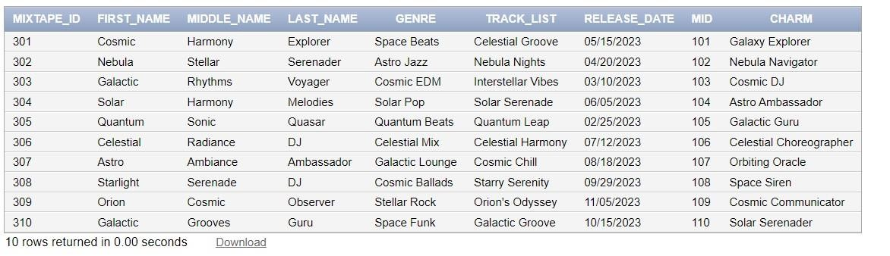

# SHAPESHIP

INSERT INTO SPACESHIP VALUES (123456789, 9.5, 'Cruiser', 'Stellar');

INSERT INTO SPACESHIP VALUES (987654321, 8.2, 'Fighter', 'Nebula');

INSERT INTO SPACESHIP VALUES (456789012, 7.1, 'Explorer', 'Galaxy');

INSERT INTO SPACESHIP VALUES (789012345, 9.0, 'Frigate', 'Orion');

INSERT INTO SPACESHIP VALUES (234567890, 8.8, 'Transporter', 'Celestial');

INSERT INTO SPACESHIP VALUES (567890123, 6.5, 'Scout', 'Nova');

INSERT INTO SPACESHIP VALUES (890123456, 9.7, 'Battleship', 'Cosmic');

INSERT INTO SPACESHIP VALUES (345678901, 7.9, 'Corvette', 'Astro');

INSERT INTO SPACESHIP VALUES (678901234, 8.5, 'Carrier', 'Stardust');

INSERT INTO SPACESHIP VALUES (012345678, 9.3, 'Dreadnought', 'Infinity');

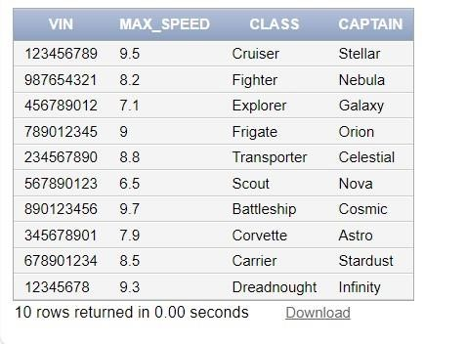

# TRANSPORTS

INSERT INTO TRANSPORTS VALUES (123456, 123456789, '2 hours');

INSERT INTO TRANSPORTS VALUES (789012, 987654321, '3 hours');

INSERT INTO TRANSPORTS VALUES (345678, 456789012, '1.5 hours');

INSERT INTO TRANSPORTS VALUES (901234, 789012345, '4 hours');

INSERT INTO TRANSPORTS VALUES (567890, 234567890, '2.5 hours');

INSERT INTO TRANSPORTS VALUES (234567, 567890123, '1 hour');

INSERT INTO TRANSPORTS VALUES (890123, 890123456, '3.5 hours');

INSERT INTO TRANSPORTS VALUES (456789, 345678901, '2 hours');

INSERT INTO TRANSPORTS VALUES (012345, 678901234, '5 hours');

INSERT INTO TRANSPORTS VALUES (678901, 012345678, '4.5 hours');

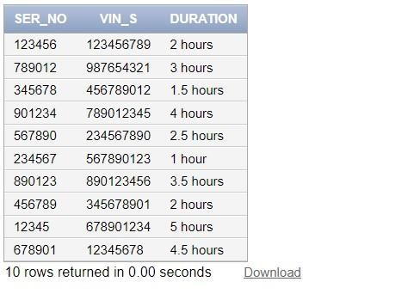

# MIRACULOUS_EMPLOYEE

INSERT INTO MIRACULOUS_EMPLOYEE VALUES (7823, 'John', 'Alexander', 'Doe', 'Manager', TO_DATE ('15/05/1990', 'DD/MM/YYYY')),

INSERT INTO MIRACULOUS_EMPLOYEE VALUES (5981, 'Jane', 'Benjamin', 'Smith', 'Engineer', TO_DATE

('20/09/1985', 'DD/MM/YYYY')),

INSERT INTO MIRACULOUS_EMPLOYEE VALUES (2345, 'Robert', 'Charles', 'Johnson', 'Analyst', TO_DATE

('12/03/1988', 'DD/MM/YYYY')),

INSERT INTO MIRACULOUS_EMPLOYEE VALUES (8762, 'Emily', 'Daniel', 'Davis', 'Designer', TO_DATE

('28/11/1992', 'DD/MM/YYYY')),

INSERT INTO MIRACULOUS_EMPLOYEE VALUES (1098, 'Michael', 'Elijah', 'Anderson', 'Developer', TO_DATE

('05/07/1984', 'DD/MM/YYYY')),

INSERT INTO MIRACULOUS_EMPLOYEE VALUES (4567, 'Olivia', 'Finn', 'Wilson', 'Manager', TO_DATE

('18/02/1995', 'DD/MM/YYYY')),

INSERT INTO MIRACULOUS_EMPLOYEE VALUES (3210, 'Ethan', 'Gabriel', 'Brown', 'Engineer', TO_DATE

('30/06/1987', 'DD/MM/YYYY')),

INSERT INTO MIRACULOUS_EMPLOYEE VALUES (7890, 'Sophia', 'Henry', 'Miller', 'Analyst', TO_DATE

('14/09/1993', 'DD/MM/YYYY')),

INSERT INTO MIRACULOUS_EMPLOYEE VALUES (5432, 'Liam', 'Isaac', 'Taylor', 'Designer', TO_DATE

('03/12/1989', 'DD/MM/YYYY')),

INSERT INTO MIRACULOUS_EMPLOYEE VALUES (9876, 'Ava ', 'James', 'Martinez', 'Developer', TO_DATE ('22/04/1998', 'DD/MM/YYYY'));

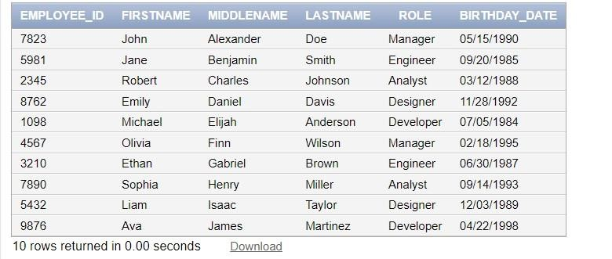

# MARVEL AI ASSISTANT

INSERT INTO MARVEL_AI_ASSISTANT VALUES ('Jarvis 2.0', 'Smartphones, Smart Homes', 'Yes', 'Personal

Assistant');

INSERT INTO MARVEL_AI_ASSISTANT VALUES ('Stark AI', 'Wearables, IoT Devices', 'Yes', 'Home Automation,

Alerts');

INSERT INTO MARVEL_AI_ASSISTANT VALUES ('Thor''s Companion', 'Smart Glasses, Vehicles', 'Yes', 'Navigation, Assistance');

INSERT INTO MARVEL_AI_ASSISTANT VALUES ('Black Widow Helper', 'Laptops, Smartphones', 'Yes', 'Security,

Information');

INSERT INTO MARVEL_AI_ASSISTANT VALUES ('Hulk Voice', 'Smart Speakers, TVs', 'Yes', 'Entertainment,

Control');

INSERT INTO MARVEL_AI_ASSISTANT VALUES ('Spider AI', 'Smartwatches, Cameras', 'Yes', 'Surveillance, Reminders');

INSERT INTO MARVEL_AI_ASSISTANT VALUES ('Captain Command', 'Tablets, Smart Appliances', 'Yes', 'Task Management');

INSERT INTO MARVEL_AI_ASSISTANT VALUES ('Doctor Strange Voice', 'VR Headsets, AR Devices', 'Yes', 'Virtual

Assistance');

INSERT INTO MARVEL_AI_ASSISTANT VALUES ('Black Panther AI', 'Gaming Consoles, Cars', 'Yes', 'Gaming Tips,

Driving');

INSERT INTO MARVEL_AI_ASSISTANT VALUES ('Iron Man Innovator', 'Smart Wearables, Drones', 'Yes',

'Innovation, Exploration');

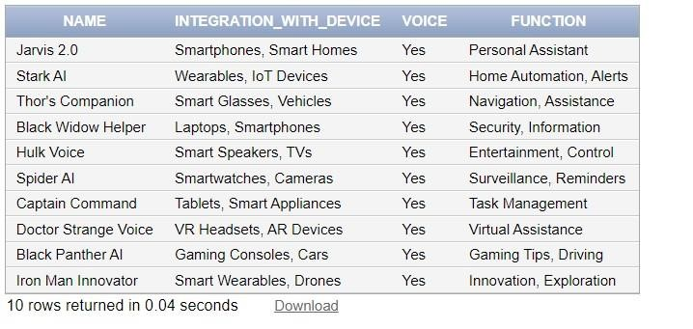

# GALACTIC_AD

INSERT INTO GALACTIC_AD VALUES ('Cosmic Convergence', 123001, 'Hyperdrive Engines', 'Hyperdrive Engines', 'Zoom Across the Cosmos!', '30 seconds');

INSERT INTO GALACTIC_AD VALUES ('Galactic Nexus', 456002, 'Alien Cuisine', 'Alien Cuisine', 'Taste the Flavors of

Vega!', '15 seconds');

INSERT INTO GALACTIC_AD VALUES ('Starfall Spectacle', 789003, 'Celestial Fashion', 'Celestial Fashion', 'Dress like a Star!', '45 seconds');

INSERT INTO GALACTIC_AD VALUES ('Nebula Unveiling', 234004, 'Quantum Computers', 'Quantum Computers',

'Empowering Your Galaxy!', '60 seconds');

INSERT INTO GALACTIC_AD VALUES ('Celestial Harmony', 567005, 'Nebula Cruise Lines', 'Nebula Cruise Lines', 'Sail Through Nebulae!', '90 seconds');

INSERT INTO GALACTIC_AD VALUES ('Quantum Revelation', 890006, 'Astro Photography', 'Astro Photography', 'Capture the Beauty Beyond!', '20 seconds');

INSERT INTO GALACTIC_AD VALUES ('Infinity Eclipse', 123007, 'Galactic Fitness Gear', 'Galactic Fitness Gear', 'Train Like a Cosmic Warrior', '40 seconds');

INSERT INTO GALACTIC_AD VALUES ('Stellar Odyssey', 456008, 'Starlight Resorts', 'Starlight Resorts', 'Experience Stellar Luxury!', '75 seconds');

INSERT INTO GALACTIC_AD VALUES ('Nebula Fusion', 789009, 'Alien Pet Supplies', 'Alien Pet Supplies', 'Spoil Your Space Companions!', '30 seconds');

INSERT INTO GALACTIC_AD VALUES ('Cosmic Ascendance', 234010, 'Quantum Music Streaming', 'Quantum Music

Streaming', 'Harmonies Across Galaxies!', '45 seconds');

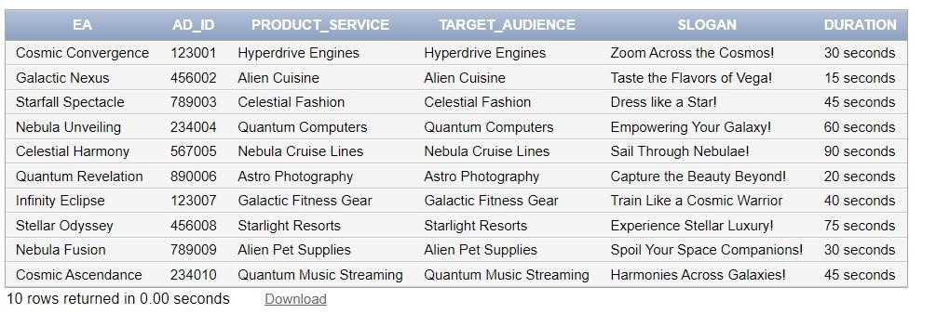

# ICONIC MUSIC SERVICES

INSERT INTO ICONIC_MUSIC_SERVICES VALUES (101, '001', 'Celestial Sounds Collection');

INSERT INTO ICONIC_MUSIC_SERVICES VALUES (102, '002', 'Galactic Grooves Playlist')

INSERT INTO ICONIC_MUSIC_SERVICES VALUES (103, '003', 'Nebula Beats Mixtape');

INSERT INTO ICONIC_MUSIC_SERVICES VALUES (104, '004', 'Solar Serenades Selection');

INSERT INTO ICONIC_MUSIC_SERVICES VALUES (105, '005', 'Quantum Quasar Jams');

INSERT INTO ICONIC_MUSIC_SERVICES VALUES (106, '006', 'Cosmic Harmony Library');

INSERT INTO ICONIC_MUSIC_SERVICES VALUES (107, '007', 'Stellar Serenade Playlist');

INSERT INTO ICONIC_MUSIC_SERVICES VALUES (108, '008', 'Astro Ambient Melodies');

INSERT INTO ICONIC_MUSIC_SERVICES VALUES (109, '009', 'Lunar Lullabies Collection');

INSERT INTO ICONIC_MUSIC_SERVICES VALUES (110, '010', 'Universal Uplift Mix');

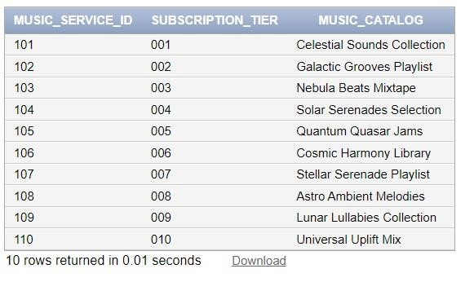

# DYNAMIC_SHOW

INSERT INTO DYNAMIC_SHOW VALUES (101, 4.5, 'Space Exploration', 'Galactic Odyssey');

INSERT INTO DYNAMIC_SHOW VALUES (102, 4.2, 'Cosmic Talk', 'Celestial Conversations');

INSERT INTO DYNAMIC_SHOW VALUES (103, 4.8, 'Intergalactic Beats', 'Quantum Groove Lounge');

INSERT INTO DYNAMIC_SHOW VALUES (104, 4.0, 'Sci-Fi Comedy', 'Astro Laughs');

INSERT INTO DYNAMIC_SHOW VALUES (105, 4.6, 'Alien Adventures', 'Stellar Encounters');

INSERT INTO DYNAMIC_SHOW VALUES (106, 4.3, 'Astro Educational', 'Cosmic Insights');

INSERT INTO DYNAMIC_SHOW VALUES (107, 4.9, 'Galactic Mysteries', 'Orion\'s Enigma');

INSERT INTO DYNAMIC_SHOW VALUES (108, 4.1, 'Cosmic Fitness', 'Galaxy Fit Workout');

INSERT INTO DYNAMIC_SHOW VALUES (109, 4.7, 'Space News Update', 'Universal Briefing');

INSERT INTO DYNAMIC_SHOW VALUES (110, 4.4, 'Celestial Cooking', 'Galactic Gastronomy');

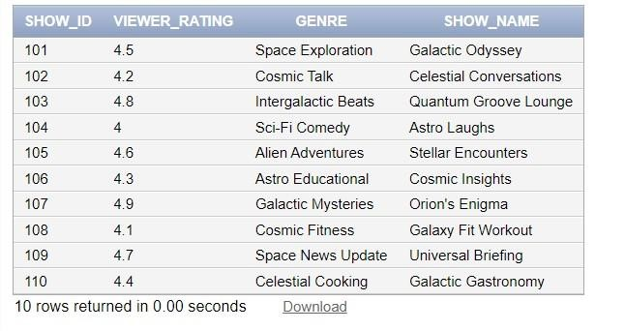

# ADVENTEROUS NEW

INSERT INTO ADVENTEROUS_NEW VALUES ('Stellar Exploration', 'Space Exploration', 'Space Explorations',

'Daily',

'Stella Starlight');

INSERT INTO ADVENTEROUS_NEW VALUES ('Alien Jams', 'Extraterrestrial Music', 'Alien Discoveries', 'Weekly',

'Nova Navigator');

INSERT INTO ADVENTEROUS_NEW VALUES ('Space Talk', 'Celestial Conversations', 'Cosmic Wonders', 'Biweekly',

'Celestial Voyager');

INSERT INTO ADVENTEROUS_NEW VALUES ('Astro Sounds', 'Space-Themed Music', 'Intergalactic Mysteries',

'Daily', 'Orion Observer');

INSERT INTO ADVENTEROUS_NEW VALUES ('Cosmic Conversations', 'General Cosmic Discussions', 'Stellar

Events', 'Monthly', 'Solar Serenader');

INSERT INTO ADVENTEROUS_NEW VALUES ('Galactic Grooves', 'Funky Beats from the Cosmos', 'Galactic Expeditions', 'Weekly', 'Nebula Navigator');

INSERT INTO ADVENTEROUS_NEW VALUES ('Universal News', 'Interstellar News Updates', 'Astro Highlights', 'Daily', 'Astro Ambassador');

INSERT INTO ADVENTEROUS_NEW VALUES ('Quantum Quasar', 'Quantum Physics Exploration', 'Celestial

Phenomena', 'Bi-weekly', 'Starlight Serenade');

INSERT INTO ADVENTEROUS_NEW VALUES ('Solar Sermons', 'Sun and Solar System Topics', 'Universal Discoveries', 'Weekly', 'Quantum Quasar');

INSERT INTO ADVENTEROUS_NEW VALUES ('Interstellar Interviews', 'Interviews with Space Experts', 'Cosmic Chronicles', 'Monthly', 'Celestial DJ');

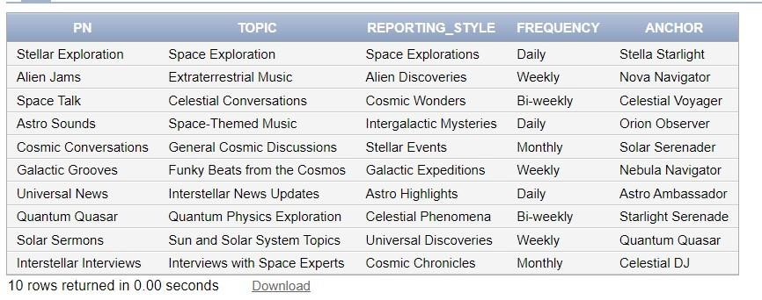

# EXCLUSIVE_FEATURES

INSERT INTO EXCLUSIVE_FEATURES VALUES (101, 'Artist Collaborations, High-Fidelity Audio');

INSERT INTO EXCLUSIVE_FEATURES VALUES (102, 'Personalized Playlists, Offline Listening');

INSERT INTO EXCLUSIVE_FEATURES VALUES (103, 'Live Concert Streaming, Exclusive Interviews');

INSERT INTO EXCLUSIVE_FEATURES VALUES (104, 'AI-generated Playlists, Lyrics Integration');

INSERT INTO EXCLUSIVE_FEATURES VALUES (105, 'Customizable Radio Stations, Early Releases');

INSERT INTO EXCLUSIVE_FEATURES VALUES (106, 'Virtual Reality Concerts, Enhanced Lyrics');

INSERT INTO EXCLUSIVE_FEATURES VALUES (107, 'Curated Theme Playlists, Behind-the-Scenes');

INSERT INTO EXCLUSIVE_FEATURES VALUES (108, 'Social Music Sharing, Immersive Soundscapes'); INSERT INTO EXCLUSIVE_FEATURES VALUES (109, 'Playlist Recommendations, 360° Audio');

INSERT INTO EXCLUSIVE_FEATURES VALUES (110, 'AI-driven Music Discovery, Limited Editions');

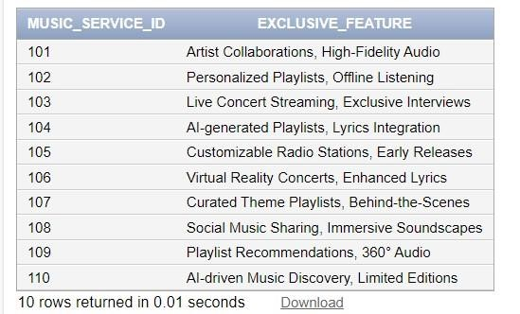

# EXCELSIOR_USER_BASES

INSERT INTO EXCELSIOR_USER_BASES VALUES ('Galactic Tunes', 500000);

INSERT INTO EXCELSIOR_USER_BASES VALUES ('Astro Podcast Network', 300000);

INSERT INTO EXCELSIOR_USER_BASES VALUES ('Cosmic Chatter', 700000);

INSERT INTO EXCELSIOR_USER_BASES VALUES ('Star Jams Radio', 1200000);

INSERT INTO EXCELSIOR_USER_BASES VALUES ('Nebula News Feed', 800000);

INSERT INTO EXCELSIOR_USER_BASES VALUES ('Interstellar Gram', 1500000);

INSERT INTO EXCELSIOR_USER_BASES VALUES ('Space Book', 2000000);

INSERT INTO EXCELSIOR_USER_BASES VALUES ('Celestial Snap', 1000000);

INSERT INTO EXCELSIOR_USER_BASES VALUES ('Galaxy Pods', 400000);

INSERT INTO EXCELSIOR_USER_BASES VALUES ('Stellar Social', 1800000);

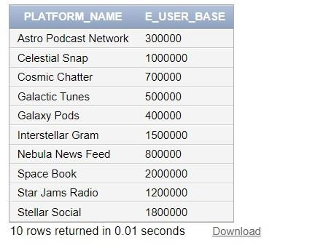

# HAS

INSERT INTO HAS VALUES ('Stellar Exploration', 101);

INSERT INTO HAS VALUES ('Alien Jams', 102);

INSERT INTO HAS VALUES ('Space Talk', 103);

INSERT INTO HAS VALUES ('Astro Sounds', 104);

INSERT INTO HAS VALUES ('Cosmic Conversations', 105);

INSERT INTO HAS VALUES ('Galactic Grooves', 106);

INSERT INTO HAS VALUES ('Universal News', 107);

INSERT INTO HAS VALUES ('Quantum Quasar', 108);

INSERT INTO HAS VALUES ('Solar Sermons', 109);

INSERT INTO HAS VALUES ('Interstellar Interviews', 110);

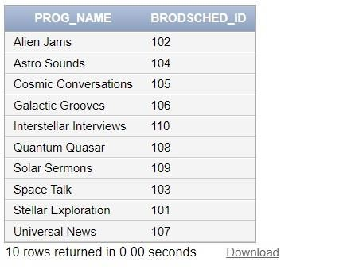

# BROADCAST SCHEDULE_DAY

INSERT INTO BROADCAST_SCHEDULE_DAY VALUES (101, 'Monday'); INSERT INTO BROADCAST_SCHEDULE_DAY VALUES (102, 'Tuesday');

INSERT INTO BR OADCAST_SCHEDULE_DAY VALUES (103, 'Wednesday');

INSERT INTO BROADCAST_SCHEDULE_DAY VALUES (104, 'Thursday');

INSERT INTO BROADCAST_SCHEDULE_DAY VALUES (105, 'Friday');

INSERT INTO BROADCAST_SCHEDULE_DAY VALUES (106, 'Saturday');

INSERT INTO BROADCAST_SCHEDULE_DAY VALUES (107, 'Sunday');

INSERT INTO BROADCAST_SCHEDULE_DAY VALUES (108, 'Monday'); INSERT INTO BROADCAST_SCHEDULE_DAY VALUES (109, 'Tuesday');

INSERT INTO BROADCAST_SCHEDULE_DAY VALUES (110, 'Wednesday');

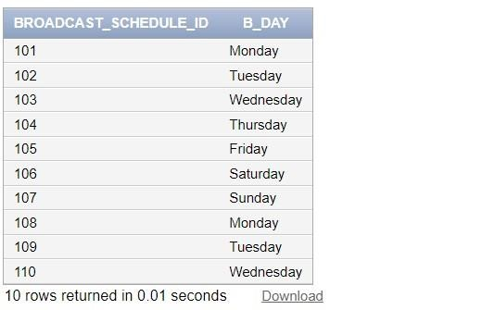

# BROADCAST_SCHEDULE_TIME

INSERT INTO BROADCAST_SCHEDULE_TIME VALUES (101, TO_TIME('08:00 AM', 'HH:MI AM'));

INSERT INTO BROADCAST_SCHEDULE_TIME VALUES (102, TO_TIME('02:30 PM', 'HH:MI PM'));

INSERT INTO BROADCAST_SCHEDULE_TIME VALUES (103, TO_TIME ('11:00 AM', 'HH:MI AM'));

INSERT INTO BROADCAST_SCHEDULE_TIME VALUES (104, TO_TIME('06:45 PM', 'HH:MI PM'));

INSERT INTO BROADCAST_SCHEDULE_TIME VALUES (105, TO_TIME ('04:15 PM', 'HH:MI PM'));

INSERT INTO BROADCAST_SCHEDULE_TIME VALUES (106, TO_TIME ('10:30 AM', 'HH:MI AM'));

INSERT INTO BROADCAST_SCHEDULE_TIME VALUES (107, TO_TIME ('09:00 AM', 'HH:MI AM'));

INSERT INTO BROADCAST_SCHEDULE_TIME VALUES (108, TO_TIME ('07:30 PM', 'HH:MI PM'));

INSERT INTO BROADCAST_SCHEDULE_TIME VALUES (109, TO_TIME ('05:45 AM', 'HH:MI AM'));

INSERT INTO BROADCAST_SCHEDULE_TIME VALUES (110, TO_TIME ('03:00 PM', 'HH:MI PM'));

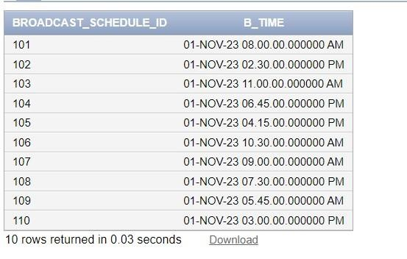

# EQUIPMENT_CAPABILITY

INSERT INTO EQUIPMENT_CAPABILITY VALUES (123456, 'Hyperdimensional Scanner');

INSERT INTO EQUIPMENT_CAPABILITY VALUES (789012, 'Quantum Data Processor');

INSERT INTO EQUIPMENT_CAPABILITY VALUES (345678, 'Celestial Audio Mixer');

INSERT INTO EQUIPMENT_CAPABILITY VALUES (901234, 'Nebula Visualizer');

INSERT INTO EQUIPMENT_CAPABILITY VALUES (567890, 'Astro Frequency Analyzer');

INSERT INTO EQUIPMENT_CAPABILITY VALUES (234567, 'Galactic Communication Array');

INSERT INTO EQUIPMENT_CAPABILITY VALUES (890123, 'Solar Energy Converter');

INSERT INTO EQUIPMENT_CAPABILITY VALUES (456789, 'Quantum Entanglement Transmitter');

INSERT INTO EQUIPMENT_CAPABILITY VALUES (012345, 'Celestial Imaging Device');

INSERT INTO EQUIPMENT_CAPABILITY VALUES (678901, 'Stellar Navigation System');

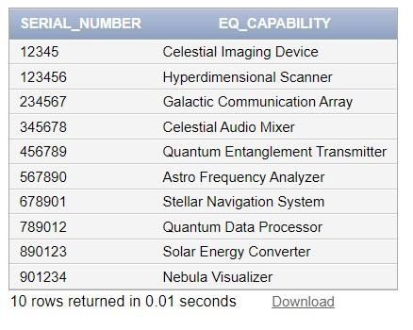

# EXCELSIOR_FEATURE

INSERT INTO EXCELSIOR_FEATURE VALUES ('Galactic Tunes', 'Customized Space Playlists');

INSERT INTO EXCELSIOR_FEATUREVALUES ('Astro Podcast Network', 'In-Depth Astrological Discussions');

INSERT INTO EXCELSIOR_FEATURE VALUES ('Cosmic Chatter', 'Live Cosmic Conversations');

INSERT INTO EXCELSIOR_FEATURE VALUES ('Star Jams Radio', 'Celestial Music Discoveries');

INSERT INTO EXCELSIOR_FEATURE VALUES ('Nebula News Feed', 'Real-Time Galactic Updates');

INSERT INTO EXCELSIOR_FEATURE VALUES ('Interstellar Gram', 'Stunning Space Photography');

INSERT INTO EXCELSIOR_FEATURE VALUES ('Space Book', 'Interconnected Galactic Community');

INSERT INTO EXCELSIOR_FEATURE VALUES ('Celestial Snap', 'Instant Cosmic Moments Sharing');

INSERT INTO EXCELSIOR_FEATURE VALUES ('Galaxy Pods', 'Interstellar Podcast Streaming');

INSERT INTO EXCELSIOR_FEATURE VALUES ('Stellar Social', 'Dynamic Cosmic Social Hub');

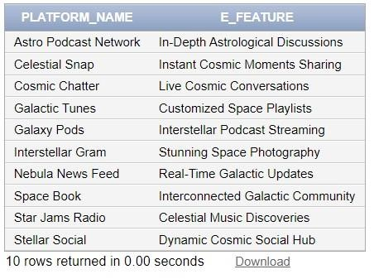

# HYPERDIMENTIONAL EQUIPMENT

INSERT INTO HYPERDIMENTIONAL_EQUIPMENT VALUES (123456, 'Quantum Communication', 'Entanglement

Transceiver', '4D');

INSERT INTO HYPERDIMENTIONAL_EQUIPMENT VALUES (789012, 'Interdimensional Gateway', 'Spatial Warping Module', '5D');

INSERT INTO HYPERDIMENTIONAL_EQUIPMENT VALUES (345678, 'Temporal Manipulation', 'Chrono-Sync

Processor', '6D');

INSERT INTO HYPERDIMENTIONAL_EQUIPMENT VALUES (901234, 'Multiverse Exploration', 'Hyperphase

Resonator', '7D');

INSERT INTO HYPERDIMENTIONAL_EQUIPMENT VALUES (567890, 'Dimensional Energy Harvesting',

'Quantum Flux Extractor', '3D');

INSERT INTO HYPERDIMENTIONAL_EQUIPMENT VALUES (234567, 'Parallel Reality Viewer', 'Holographic

Interface', '5D');

INSERT INTO HYPERDIMENTIONAL_EQUIPMENT VALUES (890123, 'Cosmic Energy Amplification', 'Quantum

Infusion Core', '6D');

INSERT INTO HYPERDIMENTIONAL_EQUIPMENT VALUES (456789, 'Hyperdimensional Defense', 'Reality

Shield Generator', '5D');

INSERT INTO HYPERDIMENTIONAL_EQUIPMENT VALUES (012345, 'Infinite Knowledge Matrix', 'Neural Quantum Processor', '7D');

INSERT INTO HYPERDIMENTIONAL_EQUIPMENT VALUES (678901, 'Intergalactic Teleportation', 'Wormhole

Generator', '6D');

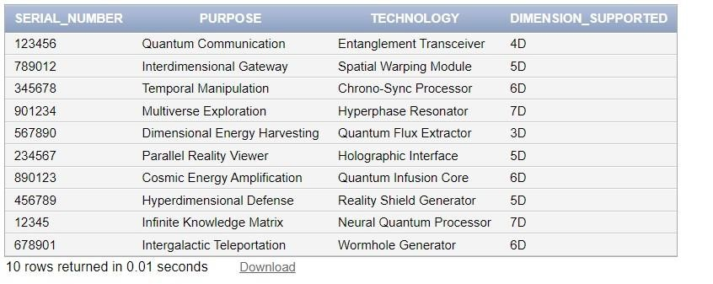

## 11.3. Complex Queries

**11.3.1. Query for Harmonic Livestreaming Platform with the Most Listeners:**

This query aims to identify the Harmonic Streaming Platform that has garnered the highest number of listeners during livestreams characterized by 'High' audience interaction. By selecting the Livestreaming_ID associated with the maximum audience interaction level in the nested query, it pinpoints the platform delivering the most engaging content to the Star-Born Listeners. This information is valuable for assessing the popularity and effectiveness of different Harmonic Streaming Platforms, enabling strategic decisions to optimize content and engagement.

SELECT Harmonic_Streaming_Platform

FROM STREAMING_PLATFORM

WHERE Livestreaming_ID = (

SELECT MAX(Livestreaming_ID)

FROM HARMONIC_LIVESTREAMING

WHERE Audience_interaction = 'High'

);

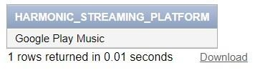

**11.3.2. Query for Listeners from Celestial Alliance with Exclusive Features:**

Focused on the Celestial Alliance civilization, this query identifies Star-Born Listeners who enjoy exclusive features. By linking listener data with supporting characters associated with the Galactic Tunes platform, it provides insights into the preferences of listeners from specific civilizations. Understanding the demographics of listeners who engage with exclusive features aids in tailoring content and promotions for specific groups, fostering a sense of inclusivity within the Celestial Alliance community.

SELECT Listener_ID, First_Name, Last_Name

FROM STARS_BORN_LISTENER, GALACTIC_CIVILIZATION

WHERE CIVILIZATION_NAME = 'Celestial Alliance'

AND Listener_ID IN (

SELECT Listener_ID

FROM SUPERWORLD_RADIO_HOST, SUPPORTS

WHERE Char_ID IN (

SELECT Char_ID

FROM SUPPORTS, EXCELSIOR_USER_BASE

WHERE E_ID IN (

SELECT E_ID

FROM EXCELSIOR_USER_BASE, SUPPORTS

WHERE Platform_Name = 'Galactic Tunes'

)

)

);

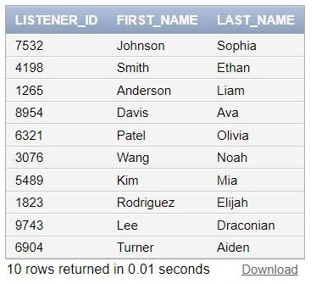

**11.3.3. Query for Civilization with the Most High-Tech Rate:**

This straightforward query seeks to determine the Galactic Civilization with the highest technological advancement rate. By comparing technological rates across civilizations, it allows for the identification of the most advanced society. This information is crucial for assessing the overall technological landscape and may influence strategic decisions related to technology-focused initiatives or collaborations.

SELECT Civilization_Name

FROM GALACTIC_CIVILIZATION

WHERE Technological_Advancement_Rate = (

SELECT MAX(Technological_Advancement_Rate)

FROM GALACTIC_CIVILIZATION

);

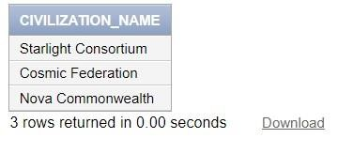

**11.3.4. Query for Excelsior Features Available on Platforms with Over 1 Million User Bases:**

This query identifies excelsior features available on platforms with a substantial user base, exceeding one million. By connecting user base data with platform features, it provides a curated list of premium offerings available on widely adopted platforms. This information is valuable for users seeking enhanced experiences and for platform operators looking to highlight premium features that cater to a large audience.

SELECT EF.Platform_Name, EF.E_Feature

FROM EXCELSIOR_FEATURE EF

INNER JOIN EXCELSIOR_SOCIAL_MEDIA SM ON EF.Platform_Name = SM.Platform_Name WHERE

EF.Platform_Name IN (

SELECT EUB.Platform_Name

FROM EXCELSIOR_USER_BASE EUB

WHERE EUB.E_USER_BASE > 1000000

);

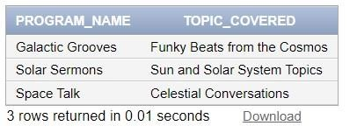

**11.3.5. Query for Programs Promoted on Platforms with Very High Interactivity:**

Focusing on the interactivity level of Excelsior Social Media platforms, this query identifies programs promoted on platforms known for very high interactivity. The link between program promotion and social media engagement levels provides insights into the symbiotic relationship between content and audience interaction. This information is useful for tailoring promotional strategies to platforms that encourage active audience participation.

SELECT Program_Name, Topic_Covered

FROM GALACTIC_PROGRAM

WHERE Program_Name IN (

SELECT P_Name

FROM PROMOTES

WHERE Plat_Name IN (

SELECT Platform_Name

FROM EXCELSIOR_SOCIAL_MEDIA

WHERE Interactivity = 'Very High'

)

);

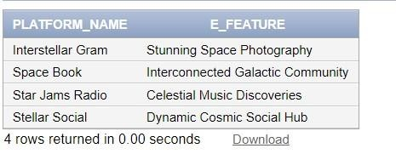

**11.3.6. Query for Retrieving Programs with Viewer Rating Above the Average:**

This query retrieves programs with a viewer rating above the average. It involves nested queries to calculate the average viewer rating for programs and the overall average viewer rating for shows.

SELECT Program_Name

FROM GALACTIC_PROGRAM

WHERE Program_Name IN (

SELECT Prog_Name

FROM HAS

GROUP BY Prog_Name

HAVING AVG(Brodsched_ID) > (

SELECT AVG(Viewer_Rating)

FROM DYNAMIC_SHOW

) ):

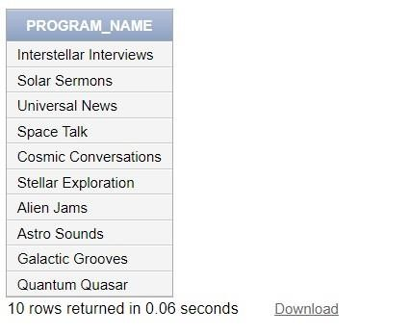

**11.3.7. Query for Retrieving Social Media Platforms with More Than 1 Million Excelsior User Base:**

This query retrieves social media platforms with more than 1 million Excelsior user base. It involves nested queries to sum user bases for each platform and filter based on the total user count.

SELECT Platform_Name

FROM EXCELSIOR_SOCIAL_MEDIA

WHERE Platform_Name IN (

SELECT Platform_Name

FROM EXCELSIOR_USER_BASE

GROUP BY Platform_Name

HAVING SUM(E_User_Base) > 1000000

);

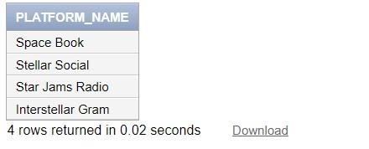

**11.3.8. Query for Finding Hosts with the Same Reporting Style as 'Adventurous New' Program:**

This query finds hosts with the same reporting style as the 'Adventurous New' program. It uses nested queries to match hosts based on reporting style with the anchor of the specified program.

SELECT CharM

FROM MARVELOUS_MIXTAPE

WHERE CharM IN (

SELECT Anchor

FROM ADVENTUROUS_NEW

WHERE Reporting_Style = ( SELECT Reporting_Style FROM ADVENTUROUS_NEW

WHERE PN = 'Universal News'

)

);

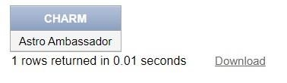

**11.3.9. Evaluate the effectiveness of exclusive features in boosting music service subscriptions:**

This query assesses the impact of exclusive features on music service subscriptions by calculating the percentage increase in subscription count for services that offer such features. By joining ICONIC_MUSIC_SERVICES and

EXCLUSIVE_FEATURE tables, it provides a comprehensive view of how unique features contribute to the success of music services in attracting and retaining subscribers.

SELECT ims.Music_Service_ID, Subscription_Tier,

(COUNT(*) / (SELECT COUNT(*) FROM ICONIC_MUSIC_SERVICES)) * 100 AS Subscription_Percentage FROM ICONIC_MUSIC_SERVICES ims

JOIN EXCLUSIVE_FEATURE ef ON ims.Music_Service_ID = ef.Music_Service_ID GROUP

BY ims.Music_Service_ID, Subscription_Tier;

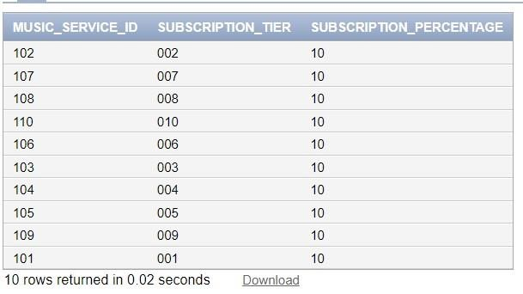

**11.3.10. Query for Civ_Listener_Count_View:**

The Civ_Listener_Count_View provides the count of Star-Born Listeners for each Galactic Civilization. It selects the Civilization_Name and the count of Lis_ID from the GALACTIC_CIVILIZATION and BELONGS_TO tables, joining them on Civilization_Name and grouping the results by Civilization_Name. This helps in understanding the listener distribution across different civilizations.

CREATE VIEW Civ_Listener_Count_View AS

SELECT g.Civilization_Name, COUNT(sb.Listener_ID) AS Listener_Count

FROM GALACTIC_CIVILIZATION g

LEFT JOIN BELONGS_TO b ON g.Civilization_Name = b.CivName

LEFT JOIN STARS_BORN_LISTENER sb ON b.Lis_ID = sb.Listener_ID

GROUP BY g.Civilization_Name;

SELECT * FROM Civ_Listener_Count_View;

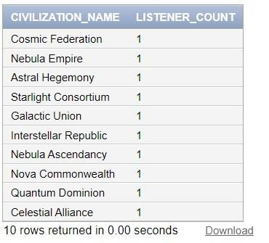

## 12. Normalization until the BCNF Normal Form

After the creation of our relations, it becomes crucial to adequately assess each relation by the standards of

normalization. We will evaluate if each relation complies with each normal form, starting with the first normal form, until it satisfies the BCNF conditions. At every step, the necessary changes will be properly implemented.

The characteristics of each normal form are as follows:

**First Normal Form (1NF):**

In the first normal form, the presence of composite and multivalued attributes is not allowed. As such, the value of each attribute in a tuple must be an atomic value corresponding to the domain of the attribute, and not a set of values.

**Second Normal Formal (2NF):**

As for the second normal form, it primarily depends on the primary key and the functional dependencies of a relation. A functional dependency is defined as a constraint between two sets of attributes X and Y. The expression X → Y illustrates that the values of the attributes of X functionally determine those of Y. As such, Y is said to be functionally dependent on X. An FD is said to be a fully functional dependency if the removal of any attribute from X means that the functional dependency does not hold anymore.

An attribute is said to be a prime attribute if it is a member of the primary key of a given relation. Conversely, a nonprime attribute is not part of said primary key. A relation is considered in the Second Normal Form if it follows the First Normal

Form (1NF), and every non-prime attribute in the relation is fully functionally dependent on the primary key.

**Third Normal Formal (3NF):**

When it comes to the Third Normal Form, we must first define a transitive functional dependency. An FD is said to be transitive for the expression X → Z, if it can be derived from the two following expressions: X → Y and Y → Z. A relation is in the Third Normal Form if it first complies with the 2NF, and no non-prime attribute in the relation is transitively dependent on the primary key. It is crucial to note that an issue only arises if X is a primary key, and Y is not a candidate key.

**Boyce-Codd Normal Form (BCNF):**

A relation is said to be in BCNF if for every functional dependency X → Y, X is a super key of the given relation.

**12.1. Normalization of each relation**

## HARMONIC LIVESTREAMING

**Live**

**streaming**

**ID**

**Music**

**Genre**

**Audience**

**interaction**

**Last**

**Name**

**Middle**

**Name**

**First**

**name**

1NF: All the attributes of the **HARMONIC LIVESTREAMING** relation are single and atomic. It does not contain any multivalued or composite attributes or any nested relations. Hence, the **HARMONIC LIVESTREAMING** relation satisfies the conditions of 1NF.



2NF: All non-prime attributes of the **HARMONIC LIVESTREAMING** relation are functionally dependent on the primary key (Live_Streaming_ID). Hence, the **HARMONIC LIVESTREAMING** relation satisfies the conditions of 2NF.

3NF: The **HARMONIC LIVESTREAMING** relation is already in 2NF, and all the non-prime attributes of the relation are NOT transitively determined by the primary keys (Live_Streaming_ID). Therefore, the **HARMONIC LIVESTREAMING** relation satisfies all the conditions of 3NF.



BCNF: The **HARMONIC LIVESTREAMING** relation schema is in Boyce-Codd Normal Form (BCNF) since whenever a functional dependency X → A holds in this relation schema, X is a superkey.

## CELESTIAL MAREVEL EVENT

**Event**

**name**

**Galaxy**

**Planet**

**Date**

1NF: All the attributes of the **CELESTIAL MARVEL EVENT** relation are single and atomic. It does not contain any multivalued or composite attributes or any nested relations. Hence, the **CELESTIAL MARVEL EVENT** relation satisfies the conditions of 1NF.

2NF: All non-prime attributes of the **CELESTIAL MARVEL EVENT** relation are functionally dependent on the primary key (Event_name). Hence, the **CELESTIAL MARVEL EVENT** relation satisfies the conditions of 2NF 3NF: The **CELESTIAL MARVEL EVENT** relation is already in 2NF, and all the non-prime attributes of the relation are NOT transitively determined by the primary keys (Event_name). Therefore, the **CELESTIAL MARVEL EVENT** relation satisfies all the conditions of 3NF.

BCNF: The **CELESTIAL MARVEL EVENT** relation schema is in Boyce-Codd Normal Form (BCNF) since whenever a functional dependency X → A holds in this relation schema, X is a superkey.

## GALACTIC CIVILIZATION

**Civilization**

**Name**

**Technological**

**Advancement**

**Rate**

**Government**

**System**

1NF: All the attributes of the **GALACTIC CIVILIZATION** relation are single and atomic. It does not contain any multivalued or composite attributes or any nested relations. Hence, the **GALACTIC CIVILIZATION** relation satisfies the conditions of 1NF.

2NF: All non-prime attributes of the **GALACTIC CIVILIZATION** relation are functionally dependent on the primary key (Civilization_Name). Hence, the **GALACTIC CIVILIZATION** relation satisfies the conditions of 2NF.

3NF: The **GALACTIC CIVILIZATION** relation is already in 2NF, and all the non-prime attributes of the relation are NOT transitively determined by the primary keys (Civilization_Name). Therefore, the **GALACTIC CIVILIZATION** relation satisfies all the conditions of 3NF.

BCNF: The **GALACTIC CIVILIZATION** relation schema is in Boyce-Codd Normal Form (BCNF) since whenever a functional dependency X → A holds in this relation schema, X is a superkey.

## ADVENTEROUS NEW

**Program_Name**

**Topic**

**Covered**

**Reporting**

**Style**

**Frequency**

**Anchor**

1NF: All the attributes of the **ADVENTEROUS NEW** relation are single and atomic. It does not contain any multivalued or composite attributes or any nested relations. Hence, the **ADVENTEROUS NEW** relation satisfies the conditions of 1NF.

2NF: All non-prime attributes of the **ADVENTEROUS NEW** relation are functionally dependent on the primary key (program_Name, Topic Coverd). Hence, the **ADVENTEROUS NEW** relation satisfies the conditions of 2NF.

3NF: The **ADVENTEROUS NEW** relation is already in 2NF, and all the non-prime attributes of the relation are NOT transitively determined by the primary keys (Program _Name, Topic_Coverd). Therefore, the **ADVENTEROUS**

**NEW** relation satisfies all the conditions of 3NF.

BCNF: The **ADVENTEROUS NEW** relation schema is in Boyce-Codd Normal Form (BCNF) since whenever a functional dependency X → A holds in this relation schema, X is a superkey.

# BROADCAST SCHEDULE _DAY

**Broadcast**

**Schedule**

**ID**

B_day

1NF: All the attributes of the **BROADCAST SCHEDULE _DAY** relation are single and atomic. It does not contain any multivalued or composite attributes or any nested relations. Hence, the **BROADCAST SCHEDULE _DAY** relation satisfies the conditions of 1NF.

2NF: All non-prime attributes of the **BROADCAST SCHEDULE _DAY** relation are functionally dependent on the primary key (Broadcast_Schedule_ID). Hence, the **BROADCAST SCHEDULE _DAY** relation satisfies the conditions of 2NF.

3NF: The **BROADCAST SCHEDULE _DAY** relation is already in 2NF, and all the non-prime attributes of the relation are NOT transitively determined by the primary key (Broadcast_Schedule_ID). Therefore, the **BROADCAST**

**SCHEDULE _DAY** relation satisfies all the conditions of 3NF.

BCNF: The **BROADCAST SCHEDULE _DAY** relation schema is in Boyce-Codd Normal Form (BCNF) since whenever a functional dependency X → A holds in this relation schema, then X is a superkey.

## BROADCAST SCHEDULE_TIME

**Broadcast Schedule**

**ID**

B_Time

1NF: All the attributes of the **BROADCAST SCHEDULE_TIME** relation are single and atomic. It does not contain any multivalued or composite attributes or any nested relations. Hence, the **BROADCAST SCHEDULE_TIME** relation satisfies the conditions of 1NF.

2NF: All non-prime attributes of the **BROADCAST SCHEDULE_TIME** relation are functionally dependent on the primary key (Broadcast_Schedule_ID). Hence, the **BROADCAST SCHEDULE_TIME** relation satisfies the conditions of 2NF.

3NF: The **BROADCAST SCHEDULE_TIME** relation is already in 2NF, and all the non-prime attributes of the relation are NOT transitively determined by the primary key (Broadcast_Schedule_ID). Therefore, the **BROADCAST**

**SCHEDULE_TIME** relation satisfies all the conditions of 3NF.

BCNF: The **BROADCAST SCHEDULE_TIME** relation schema is in Boyce-Codd Normal Form (BCNF) since whenever a functional dependency X → A holds in this relation schema, then X is a superkey.

## SHAPESHIP

**VIN**

**Max Speed**

**Class**

**Captain**

1NF: All the attributes of the **SHAPESHIP** relation are single and atomic. It does not contain any multivalued or composite attributes or any nested relations. Hence, the **SHAPESHIP** relation satisfies the conditions of 1NF.

2NF: All non-prime attributes of the SHAPESHIP relation are functionally dependent on the primary key (VIN). Hence, the **SHAPESHIP** relation satisfies the conditions of 2NF.

3NF: The **SHAPESHIP** relation is already in 2NF, and all the non-prime attributes of the relation are NOT transitively determined by the primary key (VIN). Therefore, the **SHAPESHIP** relation satisfies all the conditions of 3NF.

BCNF: The **SHAPESHIP** relation schema is in Boyce-Codd Normal Form (BCNF) since whenever a functional dependency X → A holds in this relation schema, then X is a super key.

## TRANSPORTS

**Ser_NO**

**VIN_S**

**Duration**

1NF: All the attributes of the TRANSPORTSrelation are single and atomic. It does not contain any multivalued or composite attributes or any nested relations. Hence, theTRANSPORTS relation satisfies the conditions of 1NF.

2NF: All non-prime attributes of the TRANSPORTS relation are functionally dependent on the primary key

(VIN_S,Ser_NO). Hence, the TRANSPORTS relation satisfies the conditions of 2NF.

3NF: The TRANSPORTS relation is already in 2NF, and all the non-prime attributes of the relation are NOT transitively determined by the primary key (VIN_S,Ser_NO). Therefore, the TRANSPORTS relation satisfies all the conditions of 3NF.

BCNF: The TRANSPORTS relation schema is in Boyce-Codd Normal Form (BCNF) since whenever a functional dependency X → A holds in this relation schema, then X is a super key.

## SUPERWORLD RADIO HOST

**Character**

**Fanbase**

**Show Genre**

**First Name**

**Middle Name**

**Last Name**

1NF: All the attributes of the **SUPERWORLD RADIO HOST** relation are single and atomic. It does not contain any multivalued or composite attributes or any nested relations. Hence, the **SUPERWORLD RADIO HOST** relation satisfies the conditions of 1NF.

2NF: All non-prime attributes of the **SUPERWORLD RADIO HOST** relation are functionally dependent on the primary key (Character).Hence, the **SUPERWORLD RADIO HOST** relation satisfies the conditions of 2NF.

3NF: The **SUPERWORLD RADIO HOST** relation is already in 2NF, and all the non-prime attributes of the relation are NOT transitively determined by the primary key (Character).Therefore, the **SUPERWORLD RADIO HOST** relation satisfies all the conditions of 3NF.

BCNF: The **SUPERWORLD RADIO HOST** relation schema is in Boyce-Codd Normal Form (BCNF) since whenever a functional dependency X → A holds in this relation schema, then X is a super key.

## MIRACULOUS EMPLOYEE

**Employee ID**

**First**

**Name**

**Middle**

**Name**

**Last**

**Name**

**Role**

**Birthdate**

1NF: All the attributes of the **MIRACULOUS EMPLOYEE** relation are single and atomic. It does not contain any multivalued or composite attributes or any nested relations. Hence, the **MIRACULOUS EMPLOYEE** relation satisfies the conditions of 1NF.

2NF: All non-prime attributes of the **MIRACULOUS EMPLOYEE** relation are functionally dependent on the primary key (Employee ID). Hence, the **MIRACULOUS EMPLOYEE** relation satisfies the conditions of 2NF. 3NF: The **MIRACULOUS EMPLOYEE** relation is already in 2NF, and all the non-prime attributes of the relation are NOT transitively determined by the primary key (Employee ID). Therefore, the **MIRACULOUS EMPLOYEE** relation satisfies all the conditions of 3NF.

BCNF: The **MIRACULOUS EMPLOYEE** relation schema is in Boyce-Codd Normal Form (BCNF) since whenever a functional dependency X → A holds in this relation schema, then X is a super key.

## HYPERDIMENSIONAL EQUIPMENT

**Serial Number**

**Purpose**

**Technology**

**Dimension Supported**

1NF: All the attributes of the **HYPERDIMENSIONAL EQUIPMENT** relation are single and atomic. It does not contain any multivalued or composite attributes or any nested relations. Hence, the **HYPERDIMENSIONAL**

**EQUIPMENT** relation satisfies the conditions of 1NF.

2NF: All non-prime attributes of the **HYPERDIMENSIONAL EQUIPMENT** relation are functionally dependent on the primary key (Serial Number). Hence, the **HYPERDIMENSIONAL EQUIPMENT** relation satisfies the conditions of 2NF.

3NF: The **HYPERDIMENSIONAL EQUIPMENT** relation is already in 2NF, and all the non-prime attributes of the relation are NOT transitively determined by the primary key (Serial Number). Therefore, the

**HYPERDIMENSIONAL EQUIPMENT** relation satisfies all the conditions of 3NF.

BCNF: The **HYPERDIMENSIONAL EQUIPMENT** relation schema is in Boyce-Codd Normal Form (BCNF) since whenever a functional dependency X → A holds in this relation schema, then X is a super key.

## MARVELEOUS QUEST

SQ ID

Quest_Name

Difficulty

Reward

Duration

AI_Name

1NF: All the attributes of the **MARVELEOUS QUEST** relation are single and atomic. It does not contain any multivalued or composite attributes or any nested relations. Hence, the **MARVELEOUS QUEST** relation satisfies the conditions of 1NF.

2NF: All non-prime attributes of the **MARVELEOUS QUEST** relation are functionally dependent on the primary key

(Quest Name). Hence, the **MARVELEOUS QUEST** relation satisfies the conditions of 2NF.

3NF: The **MARVELEOUS QUEST** relation is already in 2NF, and all the non-prime attributes of the relation are NOT transitively determined by the primary key (Quest Name). Therefore, the **MARVELEOUS QUEST** relation satisfies all the conditions of 3NF.

BCNF: The **MARVELEOUS QUEST** relation schema is in Boyce-Codd Normal Form (BCNF) since whenever a functional dependency X → A holds in this relation schema, then X is a superkey.

## STAR BORN LISTENER

Listener_ID

Galaxy

Planet

Last Name

Middle Name

First Name

Species

1NF: All the attributes of the **STAR BORN LISTENER** relation are single and atomic. It does not contain any multivalued or composite attributes or any nested relations. Hence, the **STAR BORN LISTENER** relation satisfies the conditions of 1NF.

2NF: All non-prime attributes of the **STAR BORN LISTENER** relation are functionally dependent on the primary key (Listener_ID). Hence, the **STAR BORN LISTENER** relation satisfies the conditions of 2NF.

3NF: The **STAR BORN LISTENER** relation is already in 2NF, and all the non-prime attributes of the relation are NOT transitively determined by the primary key (Listener_ID). Therefore, the **STAR BORN LISTENER** relation satisfies all the conditions of 3NF.

BCNF: The **STAR BORN LISTENER** relation schema is in Boyce-Codd Normal Form (BCNF) since whenever a functional dependency X → A holds in this relation schema, then X is a superkey.

## EXELSIOR SOCIAL MEDIA

Platfrom_Name

Accessibility

Interactivity

1NF: All the attributes of the **EXELSIOR SOCIAL MEDIA** relation are single and atomic. It does not contain any multivalued or composite attributes or any nested relations. Hence, the **EXELSIOR SOCIAL MEDIA** relation satisfies the conditions of 1NF.

2NF: All non-prime attributes of the **EXELSIOR SOCIAL MEDIA** relation are functionally dependent on the primary key (Platform_Name). Hence, the **EXELSIOR SOCIAL MEDIA** relation satisfies the conditions of 2NF.

3NF: The **EXELSIOR SOCIAL MEDIA** relation is already in 2NF, and all the non-prime attributes of the relation are NOT transitively determined by the primary key (Platfrom_Name). Therefore, the **EXELSIOR SOCIAL MEDIA** relation satisfies all the conditions of 3NF.

BCNF: The **EXELSIOR SOCIAL MEDIA** relation schema is in Boyce-Codd Normal Form (BCNF) since whenever a functional dependency X → A holds in this relation schema, then X is a superkey.

## GALACTIC PROGRAM

Program Name

Topic Covered

1NF: All the attributes of the **GALACTIC PROGRAM** relation are single and atomic. It does not contain any multivalued or composite attributes or any nested relations. Hence, the **GALACTIC PROGRAM** relation satisfies the conditions of 1NF.

2NF: All non-prime attributes of the **GALACTIC PROGRAM** relation are functionally dependent on the primary key (Program Name). Hence, the **GALACTIC PROGRAM** relation satisfies the conditions of 2NF.

3NF: The **GALACTIC PROGRAM** relation is already in 2NF, and all the non-prime attributes of the relation are

NOT transitively determined by the primary key (Program Name). Therefore, the **GALACTIC PROGRAM** relation satisfies all the conditions of 3NF.

BCNF: The **GALACTIC PROGRAM** relation schema is in Boyce-Codd Normal Form (BCNF) since whenever a functional dependency X → A holds in this relation schema, then X is a superkey.

**MARVELEOUS_MIXTAPE:**

**Mixtape**

**ID**

**First**

**Name**

**Middle**

**Name**

**Last**

**Name**

**Genre**

**Track**

**list**

**Release**

**Date**

**MID**

**CharM**

1NF: All the attributes of the MARVELOUS MIXTAPES relation are single and atomic. It does not contain any multivalued or composite attributes or any nested relations. Hence, the MARVELOUS MIXTAPES ASSISTANT relation satisfies the conditions of 1NF.

2NF: All non-prime attributes of the MARVELOUS MIXTAPES relation are functionally dependent on the primary key (**Mixtape_ID**). Hence, the MARVELOUS MIXTAPES relation satisfies the conditions of 2NF.

3NF: The MARVELOUS MIXTAPES relation is already in 2NF, and all the non-prime attributes of the relation are NOT transitively determined by the primary key (**Mixtape_ID**). Therefore, the MARVEL AI ASSISTANT relation satisfies all the conditions of 3NF.

BCNF: The MARVELOUS MIXTAPES relation schema is in Boyce-Codd Normal Form (BCNF) since whenever a functional dependency X → A holds in this relation schema, then X is a superkey.

## ICONIC MUSIC SERVICE

**Music**

**Service**

**ID**

**Subscription**

**Teir**

**Music**

**Catalog**

1NF: All the attributes of the **ICONIC MUSIC SERVICE** relation are single and atomic. It does not contain any multivalued or composite attributes or any nested relations. Hence, the **ICONIC MUSIC SERVICE** relation satisfies the conditions of 1NF.

2NF: All non-prime attributes of the **ICONIC MUSIC SERVICE** relation are functionally dependent on the primary key (**Music_Service_ID**). Hence, the **ICONIC MUSIC SERVICE** relation satisfies the conditions of 2NF.

3NF: The **ICONIC MUSIC SERVICE** relation is already in 2NF, and all the non-prime attributes of the relation are NOT transitively determined by the primary key (**Music_Service_ID**). Therefore, the **ICONIC MUSIC SERVICE** relation satisfies all the conditions of 3NF.

BCNF: The **ICONIC MUSIC SERVICE** relation schema is in Boyce-Codd Normal Form (BCNF) since whenever a functional dependency X → A holds in this relation schema, then X is a superkey.

## MARVEL AI ASSISTANT

**Name**

**Integration**

**With**

**Device**

**Voice**

**Function**

1NF: All the attributes of the **MARVEL AI ASSISTANT** relation are single and atomic. It does not contain any multivalued or composite attributes or any nested relations. Hence, the **MARVEL AI ASSISTANT** relation satisfies the conditions of 1NF.

2NF: All non-prime attributes of the **MARVEL AI ASSISTANT** relation are functionally dependent on the primary key (**Name**). Hence, the **MARVEL AI ASSISTANT** relation satisfies the conditions of 2NF.

3NF: The **MARVEL AI ASSISTANT** relation is already in 2NF, and all the non-prime attributes of the relation are

NOT transitively determined by the primary key (**Name**). Therefore, the **MARVEL AI ASSISTANT** relation satisfies all the conditions of 3NF.

BCNF: The **MARVEL AI ASSISTANT** relation schema is in Boyce-Codd Normal Form (BCNF) since whenever a functional dependency X → A holds in this relation schema, then X is a superkey.

## GALACTIC AD

**EA**

**Name**

**Ad**

**ID**

**Product/Service**

**Target**

**Audience**

**Slogan**

**Duration**

1NF: All the attributes of the GALACTIC AD relation are single and atomic. It does not contain any multivalued or composite attributes or any nested relations. Hence, the GALACTIC AD relation satisfies the conditions of 1NF.

2NF: All non-prime attributes of the GALACTIC AD relation are functionally dependent on the primary key (**Ad ID**).

Hence, the GALACTIC AD relation satisfies the conditions of 2NF.

3NF: The GALACTIC AD relation is already in 2NF, and all the non-prime attributes of the relation are NOT transitively determined by the primary key (**Ad ID**). Therefore, the GALACTIC AD relation satisfies all the conditions of 3NF.

BCNF: The GALACTIC AD relation schema is in Boyce-Codd Normal Form (BCNF) since whenever a functional dependency X → A holds in this relation schema, then X is a superkey.

## DYNAMIC SHOW

**Show**

**ID**

**Viewer**

**Rating**

**Genre**

**Show**

**Name**

1NF: All the attributes of the **DYNAMIC SHOW** relation are single and atomic. It does not contain any multivalued or composite attributes or any nested relations. Hence, the **DYNAMIC SHOW** relation satisfies the conditions of 1NF.

2NF: All non-prime attributes of the **DYNAMIC SHOW** relation are functionally dependent on the primary key (**Show_ID**). Hence, the **DYNAMIC SHOW** relation satisfies the conditions of 2NF.

3NF: The **DYNAMIC SHOW** relation is already in 2NF, and all the non-prime attributes of the relation are NOT transitively determined by the primary key (**Show_ID**). Therefore, the **DYNAMIC SHOW** relation satisfies all the conditions of 3NF.

BCNF: The **DYNAMIC SHOW** relation schema is in Boyce-Codd Normal Form (BCNF) since whenever a functional dependency X → A holds in this relation schema, then X is a superkey.

### 12.2. Relation Schemas without non-prime attributes

All the relations schemas that have no non-prime attributes have only two attributes. Their combination represents the primary key of the relation. Therefore, all those relations are in BCNF already (since they do not have any non-prime attributes). Some of those relations have functional dependencies among the parts of the primary key.

# EQUIPMENT CAPABILITY

|  |  |
| --- | --- |
| **Serial Number** | **Eq-Capability** |

## EXCELSIOR _ FEATURE

|  |  |
| --- | --- |
| **Platform Name** | **E_ Feature** |

**EXCELSIOR _ USER BASE:**

|  |  |
| --- | --- |
| **Platform Name** | **E_ User Base** |
| **EXCLUSIVE EATURE:** |  |
| **Music Service ID** | **Exclusive Feature** |

## HOSTS

|  |  |
| --- | --- |
| **Live ID** | **Char H** |

## COVERS

|  |  |
| --- | --- |
| **Livecover_ID** | **Event_tocover_Name** |

## STREAMING PLATROFM

|  |  |
| --- | --- |
| **Livestreaming ID** | **Harmonic Streaming Platform** |

## BELONGS_TO

|  |  |
| --- | --- |
| **CIV_NAME** | **List_ID** |

## CONNECTS

|  |  |
| --- | --- |
| **Lis_ID** | **Plt_Name** |

## PROMOTES

|  |  |
| --- | --- |
| **Plat_Name** | **Plt_Name** |

## BROADCAST SCHEDULE

**Broadcast schedule ID**

## HAS

|  |  |
| --- | --- |
| **Prog Name** | **Broadsched ID** |

## UPDATES

|  |  |
| --- | --- |
| **Adv_Prog_Name** | **TC** |
| **SUPPORTS** |  |
| **E_ID** | **Char_S** |

### 13. CONCLUSION

In conclusion, the creation of a MARVELOUS database design for the Marvel Galactic Radio Station stands as a pivotal step in ensuring the seamless operation and success of this innovative addition to the radio broadcasting landscape. As with any radio station, the key to delivering a captivating and immersive experience lies in the organization and accessibility of content. Our database design aims to efficiently categorize and manage a diverse range of elements, including space-themed music, original radio dramas, educational programs, space exploration features, and expert interviews. The Marvel Galactic Radio Station's database holds the responsibility of properly assigning and documenting each piece of content. Whether it's the musical journey through distant galaxies, encounters with alien species, or witnessing celestial events, our database design is tailored to ensure that every listener's experience is not only seamless but also enchanting. In the dynamic world of radio broadcasting, where entertainment, education, and imagination converge, the database becomes the backbone of operations. The success of the Marvel Galactic Radio Station hinges on its ability to transport listeners into a universe of wonders through the power of sound. By merging the unique requirements of this innovative project with our expertise in database design, we have crafted a finalized database that is poised to elevate the Galactic Marvel Radio Station to new heights, offering an interstellar journey that captivates and engages audiences across the cosmos.